
Horizon 2020 Program (2014-2020)
Cybersecurity, Trustworthy ICT Research & Innovation Actions
Security-by-design for end-to-end security
H2020-SU-ICT-03-2018


Cyber security cOmpeteNCe fOr Research anD InnovAtion†

Work package 5: Exploitation, dissemination,
certification and standardization
Deliverable D5.5: 4th year report on exploitation, dissemination, certification and standardization

Abstract: This document represents the 4th year report on activities performed by the CONCORDIA project on exploitation, dissemination, communication, certification and standardization, within the Work Package 5. The effort is reported in three main sections, one for each of the main tasks of this Work Package and builds on the information and activities already described in the reports of the previous years. This deliverable does not reiterate all the information of the previous reports, but only information that is needed to better describe the 4th year developments. Several key achievements of the consortium within the fourth year of the project are presented in this document, ranging from the successful reach to many incubators and accelerators, dissemination and communication activities of the consortium, and activities and outcomes regarding the certification and standardization processes.

Contractual date of delivery | M51
Actual date of delivery | XX.12.2022
Deliverable dissemination level | Public
Editors | Christos Papachristos, Despoina Antonakaki, Sotiris Ioannidis, Maria Mastoraki
Contributors | TUVA, TID, MUNI, ATOS, FORTH
Quality assurance | Ben-Gurion University  DFN-CERT  CAIXABANK  University of Zurich

The CONCORDIA Consortium

UniBW/CODE | University Bundeswehr Munich / Research Institute CODE (Coordinator) | Germany
FORTH | Foundation for Research and Technology - Hellas | Greece
UT | University of Twente | Netherlands
SnT | University of Luxembourg | Luxembourg
UL | University of Lorraine | France
UM | University of Maribor | Slovenia
UZH | University of Zurich | Switzerland
JACOBSUNI | Jacobs University Bremen | Germany
UI | University of Insubria | Italy
CUT | Cyprus University of Technology | Cyprus
UP | University of Patras | Greece
TUBS | Technical University of Braunschweig | Germany
TUDA | Technical University of Darmstadt | Germany
MU | Masaryk University | Czech Republic
BGU | Ben-Gurion University | Israel
OsloMET | Oslo Metropolitan University | Norway
Imperial | Imperial College London | UK
UMIL | University of Milan | Italy
BADW-LRZ | Leibniz Supercomputing Centre | Germany
EIT DIGITAL | EIT DIGITAL | Belgium
TELENOR ASA | Telenor ASA | Norway
ADS | Airbus Defence and Space GmbH  (as a replacement for Airbus Protect GmbH) | Germany
SECUNET | secunet Security Networks AG | Germany
IFAG | Infineon Technologies AG | Germany
SIDN | Stichting Internet Domeinregistratie Nederland | Netherlands
SURF | SURF BV | Netherlands
CYBER-DETECT | Cyber-Detect | France
TID | Telefonica I+D SA | Spain
RUAG | RUAG AG (as a replacement for RUAG Schweiz AG  ) | Switzerland
BITDEFENDER | Bitdefender SRL | Romania
ATOS | Atos Spain S.A. | Spain
SAG | Siemens AG | Germany
Flowmon | Flowmon Networks AS | Czech Republic
TÜV TRUST IT | TUV TRUST IT GmbH | Germany
TI | Telecom Italia SPA | Italy
Efacec | EFACEC Electric Mobility SA (as a replacement for EFACEC Energia) | Portugal
ARTHUR’S LEGAL | Arthur’s Legal B.V. | Netherlands
eesy-inno | eesy-innovation GmbH | Germany
DFN-CERT | DFN-CERT Services GmbH | Germany
CAIXABANK SA | CaixaBank SA | Spain
BMW Group | Bayerische Motoren Werke AG | Germany
NCSA | Ministry of Digital Governance - National Cyber Security Authority | Greece
RISE | RISE Research Institutes of Sweden AB | Sweden
Ericsson | Ericsson AB | Sweden
SBA | SBA Research gemeinnutzige GmbH | Austria
IJS | Institut Jozef Stefan | Slovenia
UiO | University of Oslo | Norway
ULANC | University of Lancaster | UK
ISI | ATHINA-ISI | Greece
UNI PASSAU | University of Passau | Germany
RUB | Ruhr University Bochum | Germany
CRF | Centro Ricerche Fiat | Italy
ELTE | EOTVOS LORAND TUDOMANYEGYETEM | Hungary
Utimaco | Utimaco Management GmbH | Germany
FER | University of Zagreb, Faculty of Electrical Engineering and Computing | Croatia
ICENT | Innovation Centre Nikola Tesla | Croatia
Utilis | Utilis d.o.o | Croatia
Polito | Politecnico di Torino | Italy

Document Revisions & Quality Assurance

Internal Reviewers
- Ben-Gurion University (review lead)
- DFN-CERT
- CAIXABANK
- University of Zurich UZH

Revisions
Ver. | Date | By | Overview
0.01 | 01/09/2022 | Christos Papachristos | Table of Contents and initial draft
0.02 | 02/12/2022 | Nicolas Kourtellis, Aljosa Pasic | First draft of material from T5.1
0.03 | 02/12/2022 | Despoina Antonakaki | First draft material for T5.1: section 3.3.1 CONCORDIA website
0.04 | 2/12/2022 | Chatzopoulou Argyro | Contribution by TUV TRUST IT on Task 5.3.
0.05 | 5/12/2022 | Martin Horák | Input in Dissemination & Communication
0.06
0.07
0.08
0.09
0.10

Disclaimer:
The sole responsibility of this document lies with the authors. The European Commission is not responsible for any use that may be made of the information contained therein.
Executive summary

The present document is the fifth deliverable of Work Package 5 (WP5) and represents the 4th year and final report on exploitation, dissemination, communication, certification and standardization. The work package’s objective is to enhance the impact of CONCORDIA’s outcomes through strategic exploitation, dissemination, and standardization.

WP5 is organized into three main tasks for:
- exploitation and incubators
- dissemination and communication
- certification and standardization

This deliverable D5.5 has three main sections, one for each of these corresponding tasks. In each of these sections, the achievements of the consortium within the fourth year of the project are described. This deliverable builds on the information and activities already described in the reports of the previous years. This deliverable does not reiterate all the information of the previous reports, but only information that is needed to better describe the last year’s developments.

Overall, the activities performed in this project demonstrate that the consortium has achieved all Key Performance Indicators (KPIs) defined in the Description of Action (DoA) and related to this WP for the duration of the last year of the project. We elaborate on the KPIs achieved in the Introduction section of the deliverable.

In general, the effort to collect and report the activities performed by each partner within this work package revealed a great wealth of different activities. In particular, the consortium partners have performed communication and dissemination activities to promote the project, its goals, and its results, and efforts to improve existing standards and create new certifications and standards.

The report presents the efforts in dissemination and communication by showing the relevant goals, strategy and activities. CONCORDIA, as shown in Chapter 3, strengthens trust and raises awareness about the project through several channels including among others CONCORDIA's website, social networks, content marketing, campaigns, events, publicity, CCN communication activities, etc.

Several partners have demonstrated great reach to many incubators and accelerators that can help CONCORDIA in the near future to deploy its novel technics and build successful and profitable business models around them. These efforts include among others 50 exploitable results originating from 29 partners, at the end of November 2022 (as shown in chapter 2), clustering activities, collaboration on start-up activities and pilot projects, technology adoption, as well as the promotion of the results via several relevant activities. As also in the two previous years, we include a section regarding the impact of the COVID-19 pandemic with a summary of its effect on the activities related to each relevant task.

Finally, regarding certification and standardization, we present the efforts, the strategy and the achieved results in Chapter 4 including the Cybersecurity Skills Certification Scheme, the Cross-pilot activities in the area of certification, as well as CONCORDIA’s Cybersecurity Roadmap for Europe.

Contents

1.Introduction 9
2. Efforts on Exploitation 11
2.1. Objectives of this Task (T5.1) 11
2.3. Exploitable Results 14
2.4. Clustering activities 16
2.5. Start-up ecosystem 17
2.5.1. Webinar: EU Cybersecurity Start-Up Ecosystem 17
2.6. Industrial Strategy 20
2.6.1. Technology Adoption 20
2.6.2. Industrial Strategy Committee (ISC) 22
2.6.3. ER ranking into KERs 23
2.7. Exploitation Paths 24
2.8. Promotion of results 28
2.9. Impact from COVID-19 pandemic crisis 29
2.10. Next Steps & Recommendations 29
3. Efforts on Dissemination & Communication 31
The ethical contextualization of trust 48
1.1.1. Internal communication 63
4. Efforts on Certification & Standardization 65
4.1. Objectives of Task (T5.3) 65
4.2. Strategy to achieve Task Objectives 65
4.2.1. Certification 66
4.2.1.1. Step C1. Identification of the certification needs per task. 66
4.2.2. Standardization 66
4.3. Results on Certification and Standardization 69
Activity 1: Certification of Cybersecurity MOOCs 76
Activity 2: The REWIRE project 77
4.3.2.3. CONCORDIA’s Cybersecurity Roadmap for Europe 87
5. Conclusions 88
Annex A: Meeting minutes for June and November 2021 meetings of ISC 90
Annex B. Report on Piloting the C³ by CONCORDIA certification scheme – structure and deployment 97
Introduction 97
The components of the certification scheme “C³ by CONCORDIA” 98
The pilot of the certification scheme “C³ by CONCORDIA” 98
The knowledge, skills and abilities 98
Preparation for the Exam 99
Section A.1: Assessment method Theoretical method, written. 100
Section A.2: The assessment platform. 101
Section A.3: Preparing the exam 101
Section B.1: Assessment method Practical method, interactive simulation. 102
Section B.2: The assessment platforms. 102
Section B.3: Preparing the exam. 103
The application process 103
The implementation of the exam 104
Exam participants and results 104
Quality review 106
Practical exam evaluation 107
Final results 107
Feedback 109
Annex BA. The C³ by CONCORDIA certification application 110
Annex BB. Instructions to the practical exam 112
Annex C. Cybersecurity MOOC Certification Information 114

Introduction

CONCORDIA project has defined in its main activities the WP5, whose purpose is to boost the impact of the project through strategic activities in exploitation, communication, dissemination, and standardization. From an exploitation perspective, WP5 developed and followed a comprehensive plan during the project duration, in alignment amongst others with the partners’ commercial and research interests. This plan helped the project reach its objectives while at the same time help partners to push their cybersecurity-related technology built within CONCORDIA to the EU market. The project, via WP5 activities, is also committed to strong dissemination and communication via various tactics and multiple audiences. Furthermore, the standardization activities in WP5 enhanced the impact of CONCORDIA by transferring project results to relevant industry standardization and best practice working groups.

WP5 is broken down into 3 main tasks, that allow CONCORDIA to build on necessary activities in exploitation, dissemination, communication, certification and standardization:

- Task T5.1: Exploitation and incubators (Lead: TID & ATOS)
- Task T5.2: Dissemination and communication activities (Lead: MUNI)
- Task T5.3: Certification and standardization activities (Lead: TUVA)

Key Performance Indicators on Impact:
The project has defined a list of KPIs to quantify the impact of the project’s results. Next, we selected the KPIs that are relevant for the activities pertaining WP5 (all KPIs are listed in the DoA), and report progress made for each of these KPIs, at the end of the M51 of the project:

General KPI | Goal in 4 years | Performed in M1-M36 | Unit of measure
CONCORDIA in social media | 15000 | 73 800 + | Views + Likes (see Section 3 for details)
Publication of Case Studies Documents – White Papers | - |  | Blog posts (see Section 3 for details)
Downloads for public deliverables, prototypes, promotional material | 500+ | 15 780 + | Downloads
Dissemination material in the form for documents, papers, deliverables, technical reports, presentations, fact sheets | - | Done | Flyers, deliverables, papers, technical reports, presentations, etc. (see Section 3 for details)
Organization of workshops and conferences | At least 1 major event and 3 satellite or special events |  | Open Door Event (see Section 3 for details, and Deliverable D4.10)
Targeted focus groups with EU officials, policy makers, ECSO and cPPP officials | - | Done | Engagement with key stakeholders via meetings and group activities (see Section 3 for details)

To reach these KPIs, the project has invested a lot of effort in the dimensions of exploitation via different venues, dissemination, communication, standardization, and certification.
The project had several achievements in this Work Package, that are reported in separate sections, one per main Task.
- Efforts on Exploitation (Section 2):
  - 32 incubators and accelerators have been identified, information was collected for each one, including number of start-ups they support, capital, market focus, maturity of start-ups supported, contact information, etc.
  - 32 exploitable results have been identified, that can lead to separate start-ups or new business units within the partners reporting them.
- Efforts on Dissemination and Communication (Section 3):
  - 60 events / conferences / invited talks / seminars held or attended by the consortium partners and its members.
  - 40 blog posts published on CONCORDIA website or in prominent technology websites, written by CONCORDIA partners explaining technology they built, their services offered, etc.
  - 35 infographics and 43 videos that communicate the main contribution
  - 21 000 users visited the CONCORDIA website from around the world during the fourth year of the project.
  - 304 Twitter posts / 290 Facebook posts / 301 LinkedIn posts.
  - 17 800 of total engagements across social media platforms.
  - 24 announcements posted on the CONCORDIA website.
  - 9 communication campaigns focused on CONCORDIA outcomes.
  - 2 succeful modules of Horizon Results Booster service
- Efforts on Certification and Standardization (Section 4)
  - 36 Standards Developing Organizations have been identified from the consortium partners as organizations developing standards that are relevant to the work performed within the CONCORDIA project.
  - CONCORDIA partners have declared that they participate in 66 activities of Standards Developing Organizations and Stakeholder Groups.

Structure of the deliverable:
In the next three sections, we analyze the objectives of the main tasks of WP5, discuss the strategy adopted to achieve them, highlight the progress of each task and the relevant impact of the COVID-19 pandemic crisis up to the submission date of this deliverable. Section 5 contains the conclusions that can be drawn about the activities described in this deliverable.

The following is a high-level map to this document:

Section 1 : Contains the introduction to the document and its content
Section 2 : Contains information on Exploitation
Section 3 : Contains information on Dissemination & Communication
Section 4 : Contains information on Certification & Standardization
Section 5 : Contains the concluding remarks to this document

Annex A : Minutes for ISC semi-annual meetings in Year 3.
Annex B : Contains the Report from the first pilot phase of the C³ by CONCORDIA
Annex C : Contains more information regarding the efforts regarding the possible certification of cybersecurity MOOCs.

Efforts on Exploitation

Objectives of this Task (T5.1)

The CONCORDIA project aims to achieve its goals on exploitation of its results from academia and industry, by focusing on the different sub-objectives, detailed in task T5.1 of the project:
- analyze the exploitation possibilities of the CONCORDIA project, based on the list of the exploitable results
- develop exploitation channels around specific incubators and by supporting cybersecurity start-up ecosystem
- support business-oriented promotion of key exploitable results (KER) in order to ensure early market adoption and user onboarding

The activities of this task remain the same as already outlined in D5.4 at the end of Y3 and are not repeated here for brevity reasons.

  - Strategy to achieve Task Objectives

While it is largely acknowledged that cybersecurity depends not only on technology, but also on people and procedures, the market studies are usually focused on products, leaving aside those cybersecurity suppliers that provide services such as training, consulting, or system integration. Frequently, it is difficult to separate cybersecurity parts from a larger IT contract, so the estimation of its size might not be real. It is also market that is very crowded, but it still has a very high projection of growth.
Given that cybersecurity function is to protect “something”, the know-how of specific assets is frequently essential, especially when it comes to legacy or domain specific systems or application, such as in operational technology (OT). There is always the danger that an innovation that improves security in one area might decrease security elsewhere due to problems with compatibility. Alignment with the rest of IT, and solid organizational cybersecurity strategy is therefore more important than just copy of the best practice. In addition, financial and investment perspective is not always aligned with operational perspective. In the case of research project results, there is a risk that these might arrive too late or too soon, often called “window of opportunity”.
Protection versus reaction, and in general segmentation into well-known NIST five functions (or cycle phases) might also result problematic, with different drivers and sources of information for investments. Research efforts here might fail to consider how persons and organization use technology, with many investment strategies being based on compliance or on the existing relationships with established and well recognized vendors. It is often, especially in EU project, too restricted to “problem space” (see Figure 1) without link to “solution space”. Co-evolution of attack and defense means that demand side needs to stay up to date, while it becomes too risky to predict future needs by extrapolating current trends. Asymmetric information, lack of benchmarking, or promotion of products or technologies without backing for their claims, contribute to fear, uncertainty and doubt (FUD) among organization on demand side. Feedback from academic research and closing loop with “problem space” is likely to help to solve these challenges.
In this setting, European companies are likely to benefit commercially from ecosystem approach, where they can test and improve cybersecurity techniques, technology, and services in a kind of a “shielded” environment, where minimum viable product (MVP) can be developed, tested, and deployed for the early references. Moreover, common standards and practices would be used, which will contribute to the comparability and benchmarking of different solutions. Proper installation and configuration, fitness to purpose, early operation and maintenance estimations, vulnerability detection, or supply chain risks, could all be treated better in an ecosystem approach. Research investment and scope of early deployment is beyond the race for profit of individual enterprises, but solid governance is required to ensure a healthy ecosystem with both supply and demand stakeholders. Other stakeholders would also profit from ecosystem approach to the exploitation of research results: system integrators, assessment and certification, training providers or risk consultants would also have their access to this ecosystem “research to market” environment. Since cybersecurity is also a question of balancing the ethics and different commercial or security interests (e.g., privacy vs. surveillance), involvement of civil society and public opinion would also be important in ecosystem exploitation approach. Society in large will also benefit from a vibrant and dynamic sovereign EU cybersecurity industry able to address global markets.
Finally, feedback would be collected for a provision of further research funding, and selection and prioritization of desired research directions. It would improve alignment between academic and industry communities, leading that the results will be taken up and applied by technology and service providers and end-users.

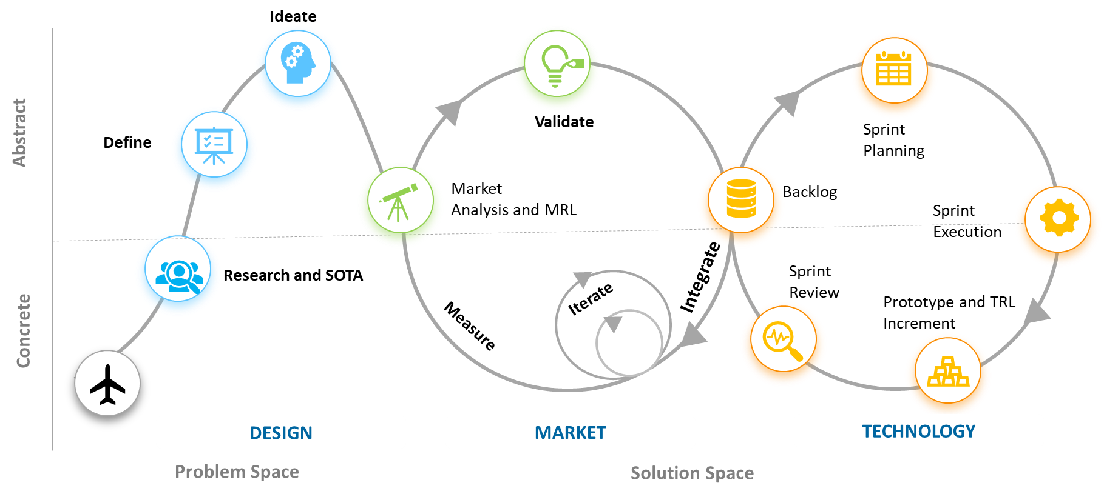
Figure 1: Division into problem and solution space in “ecosystem approach” to exploitation.
In the past EU framework programmes, some efforts were already done in this direction, for example setting RIA – Research & Innovation Actions, as a new instrument, in a hope that these would combine harmoniously. However, RIAs, placed in a same project, require different mixes of motivations, skills and abilities that are not often found, and combining these in a more flexible way in an ecosystem (e.g., by “call for innovation sprint”, or cascading grants for customization and early adoption) could be potentially beneficial. It is also important to note that research & innovation often operate on different timescales, e.g., 2-5 years for research projects and 3-6 months for innovation projects.
Research and innovation, academia and industry, and any cybersecurity stakeholder communication and collaboration, is continuous, dynamic, and parallel, rather than steps fixed in a linear timeline in a work package or project. Relationship between exploitable results and innovative market products and services is not one-to-one and subsidizing various “exploitation paths” would also increase chance to cross so-called Valley of Death between research and market. Effective use of use case studies from research projects, and their transformation into business cases and early deployment and references should form part of collaborative activities.
In other words, market would give answer to why (desirability) to do more research in specific market segments or which challenges are priority, while research would focus on technology push, answering how it is possible to solve those challenges, with possible different alternatives (Figure 2).

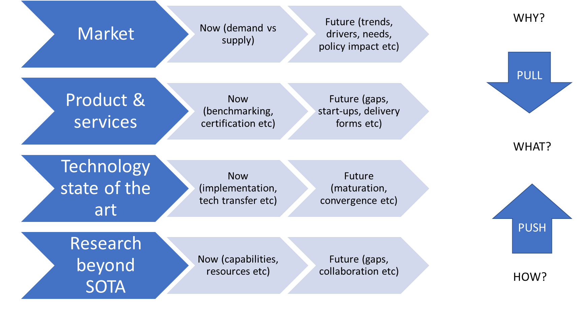

Figure 2: Mapping between how and why to do cybersecurity research in EU.
Besides these general strategic issues and recommendations, there are specific tactical considerations (selection of methodology and processes) and operational (specific actions and execution of process steps) issues from CONCORDIA task T5.1 that can be used after the project ends.

Examples of these during the fourth year of the project are the following:
- Receive input (via surveys) from partners for critical activities of this task such as declaration of exploitable results, important technology built, available or reachable incubators and accelerators, business models, etc. Efforts in this line are further discussed in Section 2.3 and clustering activities for market and research assessment in Section 2.4.
- Perform activities on activating the start-up ecosystem, including the organization of a webinar on EU Cybersecurity Start-Up Ecosystem, in Section 2.5.
- Offer discussions on industrial strategy, including increasing technology adoption and maintain the Industrial Strategy Committee (ISC) active and engaged with the exploitation efforts of the project. The ISC has been collecting ideas on how to achieve the expected outcomes from this task, as well as discussing, filtering, providing advice on and prioritizing the received input from partners and key stakeholders outside the project. Efforts in this line are further discussed in Section 2.6.
- Receive input (via surveys) from partners for declaration of the exploitation paths considered for each exploitable result. Efforts in this line are further discussed in Section 2.7.
- Address any issues rising from the impact of COVID-19, in Section 2.9.
- Consult with other pilots, and external key stakeholders for extracting new insights and capturing important trends outside the project, as well as incentives for knowledge sharing on threat intelligence. Efforts in this line are further discussed in Section 2.8.
- Finally, compile a list of recommendations and next steps on cybersecurity strategy from the point of view of market readiness, start-up ecosystem, innovation and exploitation in Section 2.10.

Exploitable Results

Exploitable Result (ER) is considered any form of tangible or intangible project result:
- Intangible result: technical or business consulting, system integration capacity, etc.
- Tangible result: software component, tool, prototype, service suite, etc.

Such items are candidates to become CONCORDIA ERs. Each ER has an assigned owner that serves as the main contact point. Also, when possible, the partners were asked to briefly discuss the level of maturity of the declared ER, and even use a Technological Readiness Level (TRL) encoding to declare the maturity of the ER. The list of collected ERs is reviewed by the ISC every six months, during the regular biannual meetings.

The last round of input was requested by the partners to be in a cumulative fashion, i.e., we the partners were to report cumulatively across all four years of the project their ERs, TLR achieved when they were finished, etc. This input was received by end of November 2022 from 29 partners and revealed a total of 50 ERs. A brief analysis of the declared items follows. Most ERs declared are software and services (~72%), with other ERs such as reports, processes, etc., completing the other ~28%.

In general, we had the following breakdown on 6 types of ERs declared:
- Software: 28 (some software ERs were declared as service as well)
- Service: 8 (some service ERs were declared as software as well)
- Certification: 2
- Report: 6
- Process: 2
- Course: 2
- Dataset: 2

In particular, we had software ERs being declared such as the following:
- QUIC Flowmon Probe plug-in
- DDoS Clearing House
- Threat Intelligence Platform for Telco (TIP)
- Financial Threat Intelligence Platform
- Threat Modelling Framework for mobile network
- Passwordless Auth. & Identity Verification Solution (KYC) Solution
- deNAT: Detection of IoT models behind a home NAT
- Flowmon to MISP integration
- Patient Data Platform
- Gorille Cloud
- Mobile Anomaly Detection
- Industrial-grade BC / IoT system for the Automotive supply chain
- Cyber Attack Detection in Industrial Control Systems
- DeepStream: Autoencoder-based stream temporal clustering
- Security in Aerial Ad-Hoc Networks
- KYPO Lite
- SECAdvisor
- ISO 15118-2 Protocol Stack ready for PnC
- (Blockchain) Payment Channel as a Service Based on Decentralized Web

Furthermore, we had services ERs being declared such as the following:
- Centralized Clearing House (CCH)
- Certified Cybersecurity Consultant - C3 by CONCORDIA
- Financial Threat Intelligence Platform
- Certification scheme for Cybersecurity MOOCs
- Federated Learning as a Service
- Patient Data Platform
- Reference architecture for e-health pilots
- Reference architecture for Automotive pilots
- Industrial-grade BC/ IoT system for the Automotive supply chain

Finally, we had other types of ERs being declared such as the following:
- Course “Becoming a Cybersecurity Consultant”
- Cybersecurity Threat Landscape (technical aspects)
- Methodology for developing and deploying courses for professionals
- CADeSH Dataset: Collaborative Anomaly Detection for Smart Homes
- Teach-the-Teachers in high-school Methodology and Guidelines
- Diversity & Cybersecurity Industry Webinar
- Course on IoT security
- News Dataset
- Ministerial Decree (Legislation)

These ERs were collected from 19 industrial and 10 academic partners. A slight majority (60%) of ERs that reported Technical Readiness Levels (TRL) are still in their early stages of maturity (TRL1-4), covering different industrial sectors and pilot tasks. On the other hand, all declared ERs that were reported with specific technical readiness, have been elevated with respect to technical readiness by the time the project is completed (M51). In fact, this readiness gets the declared ERs closest to the market (TRL7-9). To this point, we find 24% increase in the ERs that are closest to the market by end of the project, compared to the beginning. Next, we outline some interesting breakdowns on maturity, industry involved, and CONCORDIA task related to their definition and applicability.

Current/Starting Technical Maturity:
- TRL1-4: 30
- TRL5-6: 7
- TRL7-9: 5

Final Technical Maturity:
- TRL1-4: 16
- TRL5-6: 7
- TRL7-9: 17

Industries involved:
- Telco
- Finance
- Operators of Essential Services / Digital Service Providers
- E-health
- Automotive
- Any industry sector (60% of ERs declared they are applicable to any sector)

CONCORDIA Tasks involved / applicable:
- T2.1, T2.2, T2.3, T2.4
- T3.1, T3.2, T3.4
- T5.3

Clustering Activities

After the initial clustering of ER, done in Y3, a strategy has been changed towards “exploitation path” kind of clusters, due to a limited information provided by the ER about the future needs and individual exploitation plans.
In the fourth year, so called “exploitation paths” clusters have been developed, based on the initial CONCORDIA innovation methodology (Deliverable D6.3) and the adopted European Innovation Council (EIC) funding instruments terminology, also outlined in Figure 3.

The proposed methodology for the ecosystem innovation management steps were described in deliverable D6.3 as a spiral, from an idea generation and identification, concept development, evaluation all the way to implementation. Assessment touchpoints that were envisaged (idea or concept verification points or stage-gate workshops) were implemented with the previously described CONCORDIA innovation/exploitation board (consisting of ISC members) meetings. List of ideas and concepts with low TRL, coming from the poster session at the CONCORDIA Open Door event, was not done on a yearly basis, but is considered in the year 4.

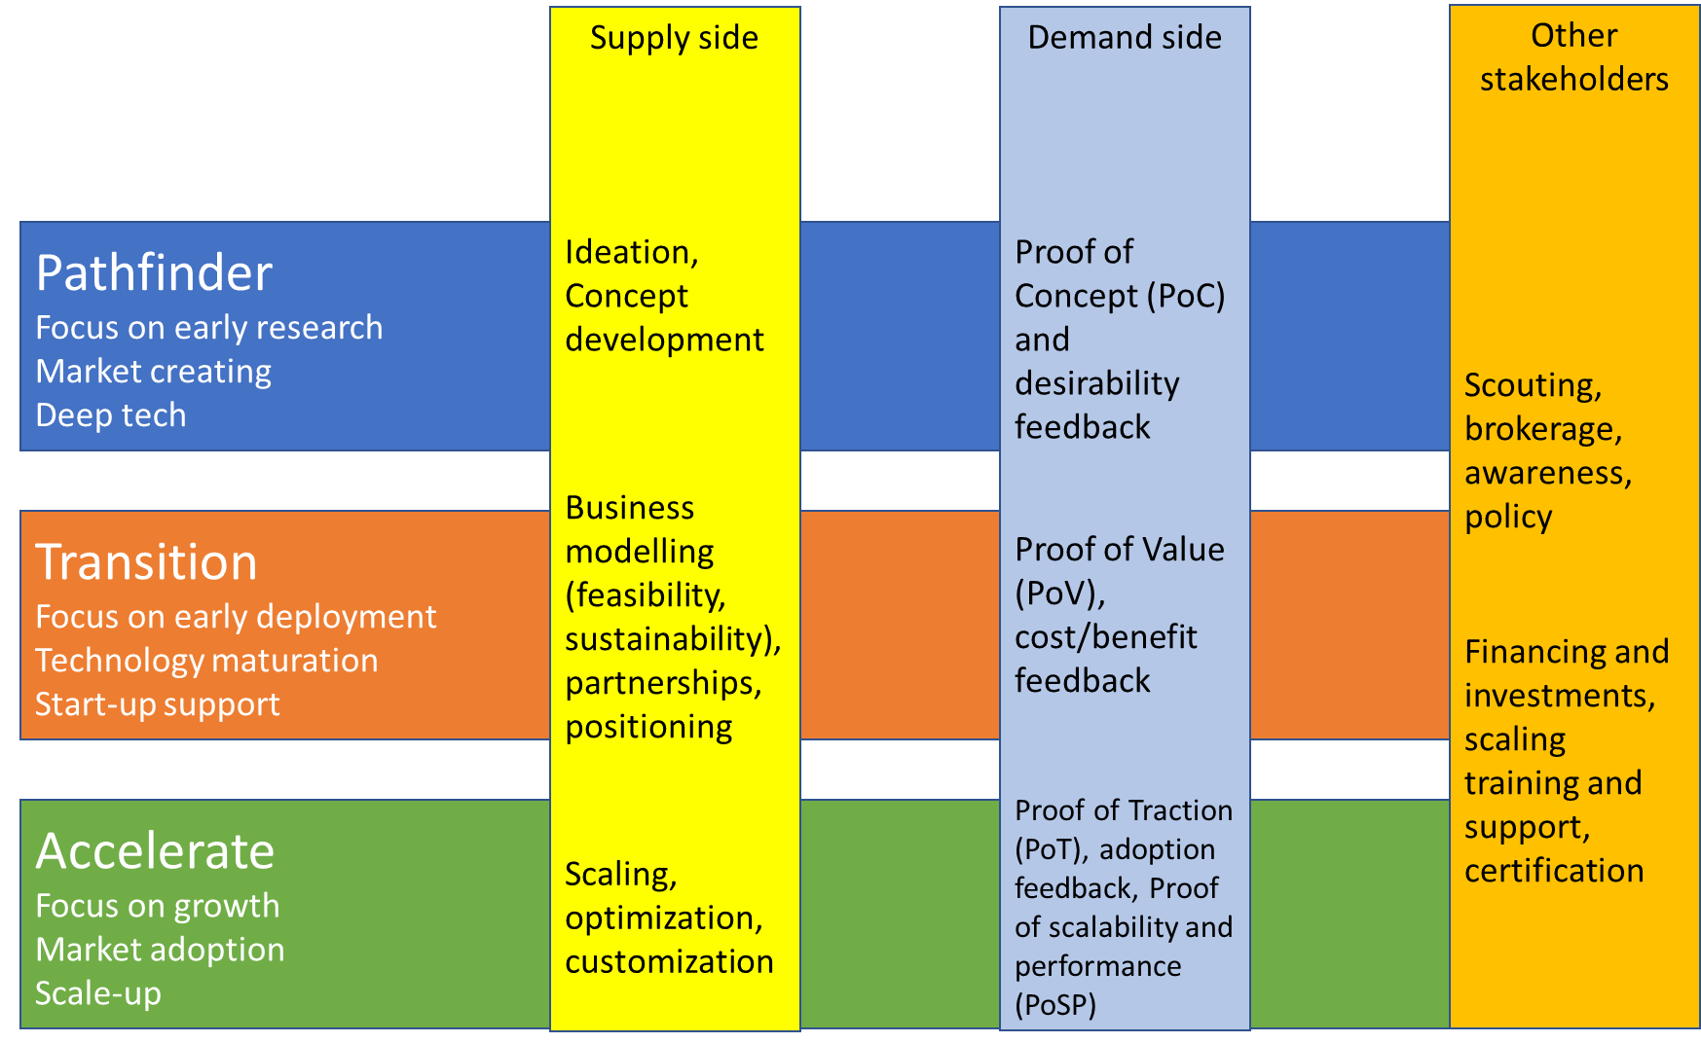
Figure 3: Exploitation paths for ER with different maturity.

Start-up Ecosystem

The methodology for data collection of relevant incubators and accelerators reachable by the consortium followed the same process as the one reported in D5.3 and D5.4 and is omitted from this deliverable for brevity. We achieved a new higher number of 50 relevant entities by end of Y4, in comparison to 32 by end of Y3, and 26 by end of Y2.

In Y4 of the project, CONCORDIA also continued its collaboration with ECSO on start-up activities and enhanced this effort with additional collaboration with the other 3 pilot projects (even if some had finished their regular execution), not only on start-ups, but also on SME issues.

Webinar: EU Cybersecurity Start-Up Ecosystem

The highlight of this effort was the webinar organized by CONCORDIA called “EU Cybersecurity Start-Up Ecosystem” on March 10th, 2022. This webinar was also organized in this context by leaders of WP5, Aljosa Pasic from ATOS and Nicolas Kourtellis from Telefonica I+D, with support from the CONCORDIA coordinator. Although some speakers have been contacted in 2021, preparation activities started in January 2022 with organization of agenda, definition of topics, logistical and marketing issues, such as registration through CONCORDIA web portal (https://www.concordia-h2020.eu/eu-cybersecurity-start-up-ecosystem/. Marketing campaign was executed with the help of CONCORDIA dissemination team that organized LinkedIn and twitter campaign. Other channels have also been used, such as newsletter and distribution to specific communities.

In total 45 participants registered for the event, although actual participation oscillated during different presentations. In terms of type of organizations that participants come from, the majority was from startups/scaleups, followed by investors (understood in a wide sense, that includes incubators, accelerators, or other types of funding).
Opening of webinar and CONCORDIA introduction was done by Gabi Dreo (Coordinator of CONCORDIA project) that explained how this pilot project for CC (cybersecurity community) grew over three years and how important is also to have support for startups, as a part of a larger ecosystem. This presentation was followed by welcome message by the EC by Martin Ubelhor (European Commission DG CONNECT Unit H1) that also mentioned context of establishing the European Cybersecurity Industrial, Technology and Research Competence Centre (ECCC) and the Network of National Coordination Centers (NCCs). Next presentation was about difficult road from research to startup and support services for cybersecurity security startups in a research environment. Presentation was done by Friederike Schneider (Cube 5). The Cube 5 incubator supports security startups and people interested in starting a business at Horst Görtz Institute for IT Security, which is an institute at Ruhr university in Bochum. It offers startup networking and know-how, support in business model development and building a company.

Tuan Trinh presented EIT Digital Management Agenda 2022: Cybersecurity Ecosystem Building. Tuan is Interim Node Director of EIT Digital node in Hungary and he started with an introduction to EIT in general, and EIT Digital in particular. This innovation and entrepreneurial education organization is also investing in strategic areas to accelerate the market uptake and scaling of startups. There are also support services for stand-ups (future start-ups), such as entrepreneurial courses for engineers or mentoring, while the main program for scale-ups is Innovation Factory which invests in growing and new ventures in strategic focus areas, one of them being cybersecurity (as a part of Digital Tech area).

One of the start-ups that profited from EIT digital support is Security Forge and the next presentation, titled “Benefits of cybersecurity ecosystems for start-ups”, by Antonio La Marra (Co-founder, and CEO of Security Forge), showed how different ecosystems and communities at local, national and EU level, have their advantages.

Next presentation (Figure 4) was from Gonzalo Perez Rodriguez (Wayra) who gave perspective from corporate investment angle. Wayra offers investment and interface between entrepreneurs and Telefonica network of partners, adding value to the ecosystems. It contains different initiatives, such as Wayra Hubs where they invest in startups and that currently has more than 400 startups in portfolio, with more than 100 of them working with Telefónica. Wayra X, Wayra Next Trend, Wayra Perks and Wayra Builder are other parts of this way of corporate engagement and strategy. Gonzalo also compared investments across different geographies and phases and presented few success stories from cybersecurity portfolio.

One of EU cybersecurity success stories has been presented by Ingrid Söllner (TEHTRIS), whose presentation focused on growth and funding for EU cybersecurity start-ups. TEHTRIS is existing since 2010 so officially it could qualify as a scaleup. It recently won funding and investments through the EIC Fund for start-ups and small companies to develop and scale up cybersecurity innovations, and Ingrid also mentioned support from the European Champions Alliance (ECA), a non-for-profit initiative that supports European Tech aligned with EU values and vision of digital sovereignty. TEHTRIS contributes to the digital sovereignty of Europe in different ways and Ingrid also mentioned need for procurement procedures that take into account EU origin of cybersecurity companies, something that is also linked to label “Cybersecurity made in EU” by ECSO.

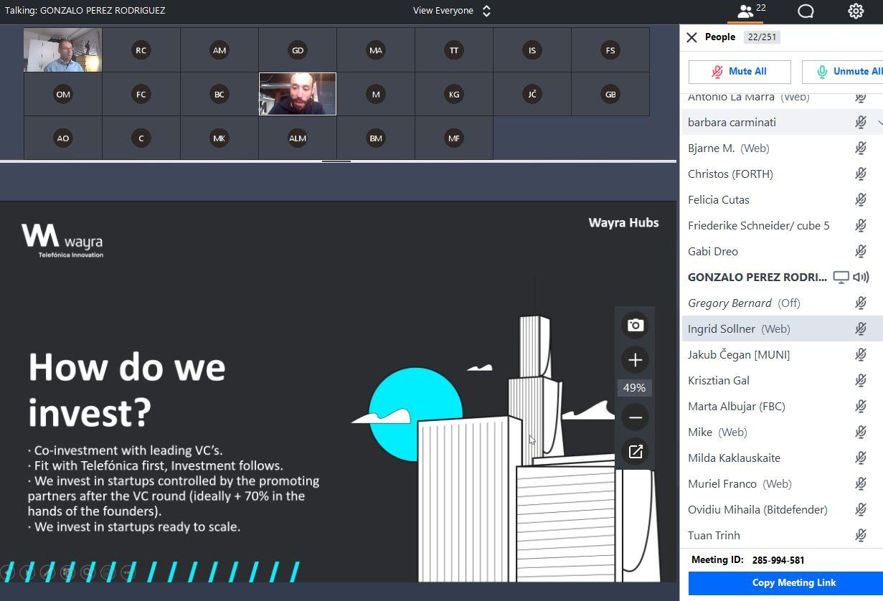
Figure 4: Screenshot from Wayra’s presentation during the Webinar.
SecurIT is a new project addressing the development and the integration of innovative security solutions. Urszula Sobek (FundingBox) presented project and open calls related to specific test beds. The first open call has deadline on 26 April 2022 at 17:00 CEST and up to 88K€ to develop security solution.

There are 2 types of instruments: prototyping and demonstration instruments, that target different technology readiness levels (TRL), so it is an opportunity to mature existing prototypes.

Panel “ECCC and start-ups: challenges and road ahead” was moderated by Aljosa Pasic, (ATOS) and included Ovidiu Costel Mihaila (Bitdefender), Barbara Carminati (Università degli Studi dell'Insubria) and Milda Kaklauskaite (ECSO). Barbara gave introduction on difficult challenge related to women in cybersecurity entrepreneurship. They remain underrepresented as entrepreneurs since only 30 % of start-up entrepreneurs are women, but in science and technology is even worse, with only 5-15% of high-tech business is owned by women. Ovidiu presented brief history of Bitdefender, which was originally family company founded in Romania, and now is one of the leaders in cybersecurity segment. In this journey access to market is probably the most challenging issue, according to Ovidiu. It is also important to have community role and support in assessment of good ideas before starting with the entrepreneurship, for example scientific support to investors that often have a lack of cybersecurity know-how or are too risk-averse for advanced cybersecurity ideas. Milda presented ECSO activities, such as Cyberinvestor days, that already had 11 editions in various EU member states. The next event was taking place on the 5th April 2022, 10:00 CET in The Hague, the Netherlands and also giving European Cybersecurity STARtup Award. In addition, ECSO and the Women4Cyber Foundation announced the launch of the special Women4Cyber STARtup Award to give international recognition to the cybersecurity companies founded or co-founded by women. At the end of this panel session, there was also suggestion to make this format, where different perspectives about cybersecurity startup ecosystem come together, a kind of regular event.

Several themes and topics were mentioned or could be identified through different perspectives and presentations, such as the link between startups investments and EU digital sovereignty, or the alignment of priorities in EU investment in cybersecurity startups with EU cybersecurity industrial strategic agenda. It is clear that cybersecurity startup landscape and context is very different from the other tech segments, and that special attention has to be given to the increase of this way of exploiting results of EU-funded research. Lack of entrepreneurship culture among cybersecurity researchers, but lack of cybersecurity understanding among generic type of investors, has also been mentioned. Idea to continue with some sort of event, that brings together different stakeholders and perspectives from EU cybersecurity startup ecosystem, will be proposed to the other members of CC (cybersecurity community) from the remaining pilot projects, ECSO, EIT Digital and other ecosystems and organizations that are linked to cybersecurity and startups.

Industrial Strategy

Technology Adoption

We further discuss strategy to increase impact and improve uptake of security research results thanks to an ecosystem approach, based on experiences from CONCORDIA. The following should read like a position paper with many assumptions that still need to be validated, but also as a recommendation section based on a collaborative research and exploitation procedures piloted in CONCORDIA. The main emphasis is on co-delivery, where delivery of cybersecurity product refers to a whole value network needed for product or service launch: training providers, support and maintenance, testing and assurance, certification, etc.

While market-oriented filtering, such as ranking by ISC, is usefully to filter out poorly conceived research concepts or propositions, the challenge is also to identify ER that could get to market faster thanks to the ecosystem, as well as those assets that would, thanks to the ecosystem, reach “break-even” point faster.

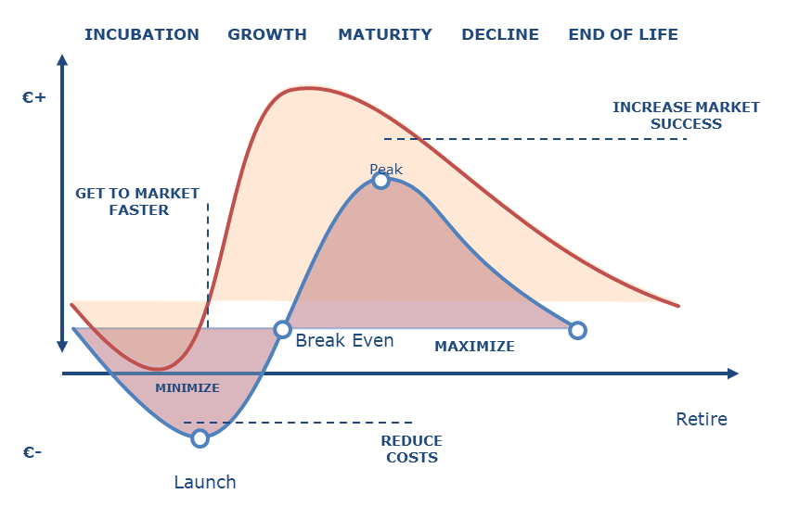
Figure 5: Assumptions about advantages of ecosystem for the exploitation of results.

In Figure 5, we depict these two assumptions, next to the hypothesis of increased market success. Use of open course community, or students from a university, in software maintenance for example, would reduce cost, therefore leading to move of break-even point. Similar would happen with testing and assurance needed for the certification of cybersecurity products.

Training, including use of cyber-ranges, and support services would also be developed in the ecosystem. These are essential for the market and of great importance to end users. In summary both technical and market maturity would improve in an ecosystem. On the other hand, application domains that may not be ready to adopt new developments due to need for customization (e.g., intrusion detection that needs to capture and analyze industry specific protocols) would be easily tested in a protected environment. Technology transfer from one to another domain would be easier, leading to a further scalability and stability effects.

Ecosystem support services, some of which have been described before, would also contribute to technology adoption. Trusted introducer, for example, or incentives for data sharing, have been examples in CONCORDIA project. Economic studies that justify investments, independent assessments and observatory, matchmaking communication support etc, are just few more examples (see Figure 6).

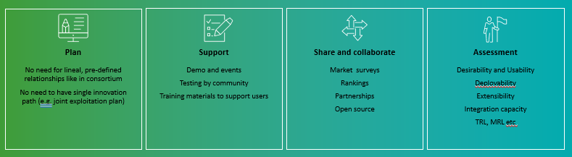
Figure 6: Examples of ecosystem support services.

It is also necessary to identify and understand the barriers that constrain technology transitions to market (Table 1), and this can also be addressed better in an ecosystem, with early feedback. Collecting evidence to assess the readiness of technology to be deployed in operational environments (unlike the current subjective TRL reporting in EU projects) would also minimize the risk of research to market. The combination of different perspectives would deliver also more competitive products and services.

Potential Barriers | Recommendations
ER needs deployment in an operational domain | Use testbed and virtual labs from CONCORDIA with realistic simulations and deployment models (virtualized, cloud-based, mixed approach)
Difficulty to find users or data that would increase TRL | Take advantage of the CONCORDIA end-users in an ecosystem  Create and improve incentives for demand side stakeholders
No business plan and/or feasibility/market studies done | Use support services to start market study and business plan early in the project  Take advantage of the CONCORDIA exploitation activities and workshops  Evaluate potential partnerships with other partners from the ecosystem
Difficulty in technology transfer | Involve legal support from ecosystem  Use templates and best practices from other partners  Consider the marketplace/matchmaking or the creation of a spin-out
Start-up or spin-off launching difficulty | Use incubators, investors, or other stakeholders from the ecosystem  Partnership for access to market or joint exploitation schemes
No engagement by supply side industrial teams | Privileged role in ecosystem for industrial stakeholders willing to exploit potential innovations  Think of transferring use case to business case at an early stage of the project (e.g., pitch sessions for CxO level decision makers in the same way start-ups searches for investors)
No further investment | Take advantage of co-programming activities to influence future calls  Consider research based on the feasibility studies
Multiple owners of ER | Clearly identify and assign IPR to all CONCORDIA partners  Set up roles and responsibilities of each partner involved  Request legal advice
Table 1: Some problems and barriers encountered in CONCORDIA

Industrial Strategy Committee (ISC)

Following this direction towards contributions of the CC to the ECCC, the CONCORDIA ISC was formed earlier-on in Y2, to take-on, among others, the responsibilities of the exploitation and innovation subcommittee as defined in the new task T5.1 of the GA. The ISC meets twice per year to review the potential of technology built within the project’s technical work packages and use case pilots, and assess technical progress made from the partners towards the exploitation of the technology built. Furthermore, the committee is due to identify novel ideas worthy of support by the consortium in different ways. For example, some projects may need help with patenting and other IPR protection, PR and other media support, guidance in developing business plans, etc. The committee is also responsible for formalizing the exploitation strategy based on these technology results.

The committee’s initial formation has 22 members (1 from each industrial partner at the time) and 1 chair (from ACS partner). The committee has met in the following times:
- July 2020
- December 2020
- June 2021
- November 2021
- June 2022 (meeting minutes in Annex A)
- October 2022 (meeting minutes in Annex A)
This formation is re-assessed when new industrial members join CONCORDIA.

Among the ongoing tasks of the committee were the following:
- Define and adapt (within the context of the project) what ERs are, as explained in subsequent subsection.
- Redefine the important dimensions that should be collected from partners regarding ERs.
- Redefine the important dimensions that should be collected from partners regarding the incubators and accelerators available within or associated with the consortium.
- Perform assessment and ranking of collected ERs, to select Key ERs with high ROI.
- Open or maintain channels of communication with said entities.
- Draft recommendations to the EC regarding exploitation and incubation.

ER ranking into KERs

The ISC performed a ranking of 23 selected ERs from the list of all declared ERs, to assess which ERs will be the Key ERs for Y4. The ISC focused on tangible ERs such as the ones defined as software and/or service. The ISC assessed each ER on the following four dimensions, on a scale from 1 to 5:
- Market Demand or Market Readiness Level (based on knowledge of market)
- Innovation Potential (based on declared value proposition canvas if available, or knowledge of state of art)
- Technical Maturity (based on declared TRL, knowledge of ER and the state of art space)
- Network effect (why it should be done/promoted in CONCORDIA instead of another EU project, OR if the ER would benefit greatly by interacting with the CONCORDIA community and beyond)

The overall results for all selected ERs were the following:

Exploitable Result | A | B | C | D
QUIC Flowmon Probe plug-in | 3.91 | 3.55 | 4.09 | 3.00
CCH Service | 4.30 | 3.50 | 4.30 | 4.10
DDoS Clearing House | 4.36 | 3.91 | 4.36 | 4.55
Threat Intelligence Platform for Telco (TIP) | 3.67 | 4.11 | 3.78 | 4.11
Financial Threat Intelligence Platform | 3.89 | 3.89 | 3.78 | 4.11
Threat Modeling Framework for mobile network | 4.18 | 3.82 | 4.00 | 3.91
Passwordless Auth. & Identity Verification Solution (KYC) Solution | 4.00 | 3.82 | 4.00 | 3.27
deNAT: Detection of IoT models behind a home NAT | 3.09 | 3.82 | 3.09 | 3.18
Flowmon to MISP integration | 3.73 | 3.36 | 3.91 | 3.55
Patient Data Platform | 4.11 | 3.67 | 3.44 | 3.89
Federated Learning as a Service | 3.50 | 4.20 | 3.70 | 3.70
Gorille Cloud - BY CYBER-DETECT | 3.78 | 3.56 | 3.78 | 3.22
Reference architecture for Automotive pilots | 3.50 | 3.50 | 3.40 | 3.10
Mobile Anomaly Detection | 4.10 | 3.80 | 3.80 | 3.60
Industrial-grade BC / IoT system for the Automotive supply chain | 3.44 | 3.67 | 3.56 | 3.22
Cyber Attack Detection in Industrial Control Systems | 3.56 | 3.80 | 2.60 | 3.11
DeepStream: Autoencoder-based stream temporal clustering | 3.00 | 3.50 | 2.80 | 2.67
Security in Aerial Ad-Hoc Networks | 3.45 | 3.91 | 3.55 | 3.18
Certified Cybersecurity Consultant - C3 by CONCORDIA | 4.36 | 3.64 | 4.00 | 4.00
KYPO Lite | 4.27 | 3.82 | 4.45 | 4.27
SECAdvisor | 4.10 | 3.50 | 3.56 | 3.40
ISO 15118-2 Protocol Stack ready for PnC | 4.13 | 3.89 | 3.67 | 3.00
(Blockchain) Payment Channel as a Service Based on Dec. Web | 2.44 | 3.78 | 3.00 | 3.00

The top five for each dimension were marked with red colour. In some cases, we observed a tie, and therefore top 6 were marked. We have 1 ER that marks high (top 5) in all 4 dimensions: DDoS Clearing House Service. Also, 2 ERs mark high in 3 of the 4 dimensions: a) Centralized Clearing House Service, and b) KYPO Lite.
Overall, using this ranking process, the ISC has found the 5-6 Key ERs of CONCORDIA for Y4 and across the duration of the project, and will support and promote them further to be shown to key stakeholders, as well as for demo events and help getting out in the EU cybersecurity market.

Exploitation Paths

To simply reporting, in year Y4 partners have been asked to put their exploitation path in a simple excel file, with an option to go in more details for each of their exploitable results. In this way we hoped to reach larger number of project partners and to collect a minimum information from each partner to fulfil their obligations related to the exploitation.

From 67 partners, 19 returned their excel sheet with the indication of the preferred exploitation path. Since some partners declared more than one result, these partners are responsible for 24 results (Figure 7).

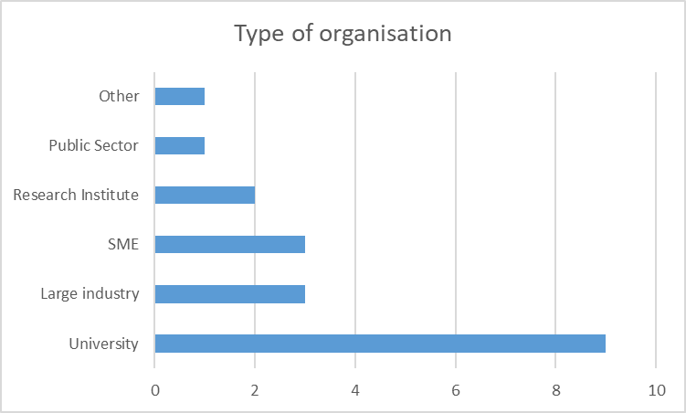
Figure 7: Breakdown of organization types.
Several exploitation paths have been proposed, and with the exception of start-ups and maturing of an existing technology, all other paths have been reported. Most of these paths are envisaged for the short term, up to 3 years after the project ends (Figure 8). Many ERs (including papers, software, dataset) are released in open-source or are open access.

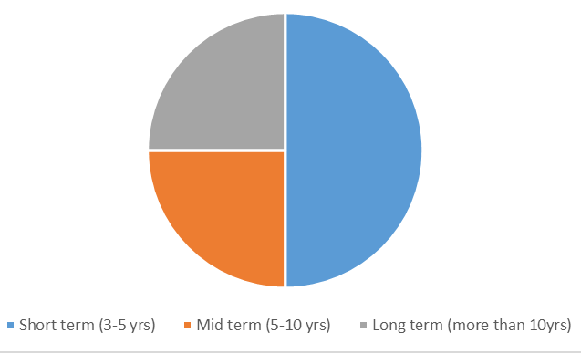
Figure 8: Breakdown of exploitation path scope.
As seen in Figure 9, there are more detailed comments from some partners. For example, one partner would like to build a plan to extend its educational offer at master and bachelor levels, with new courses and labs in the cybersecurity domains, with specific reference to cloud-edge infrastructures and ML/AI. Another partner would like to further establish itself as a major player in the security and trustworthiness of ICT, or a major technology transfer center operating in conjunction with several major European industrial partners.

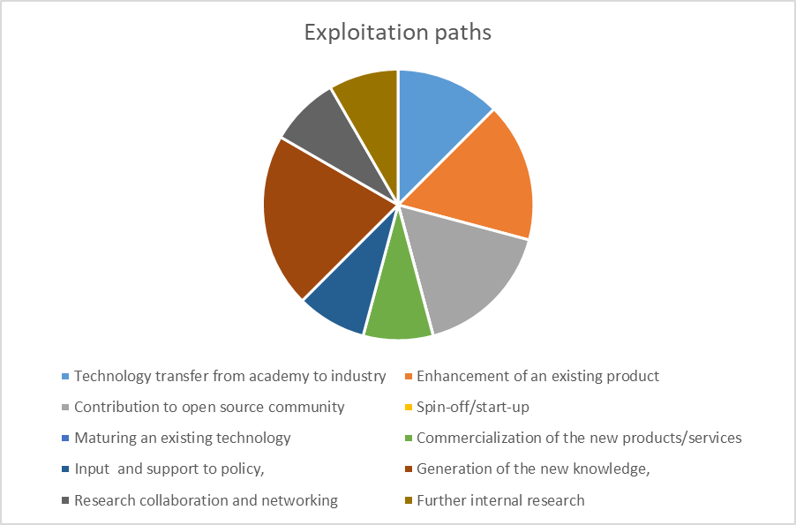
Figure 9: Different exploitation paths pursued in CONCORDIA.
One of CONCORDIA KERs is the DDoS Clearing House, which, for example foresees a not-for-profit exploitation model at this point and not a profit-driven one. The Clearing House will be deployed as a production service by the Dutch Anti-DDoS Coalition in the coming months, hopefully before the end of CONCORDIA.

Finally, the knowledge, research collaborations, and networking achieved during the project are mentioned by many to prepare and conduct new research in terms of new proposals and projects both at national and international levels in the topics of CONCORDIA.

As shown in Figure 10, while some partners claim internal exploitation, as they are end users, others already started to look for end users outside the consortium, to address technology adoption. This evidence is something that we used in our definition of market readiness. However, at the last ISC meeting the market readiness definition was discussed, as it has demand perspective (market demand or user traction) and supply perspective (support services, training, marketing etc.). This can therefore be considered as the input to MRL, but not as the valid indicator for it.

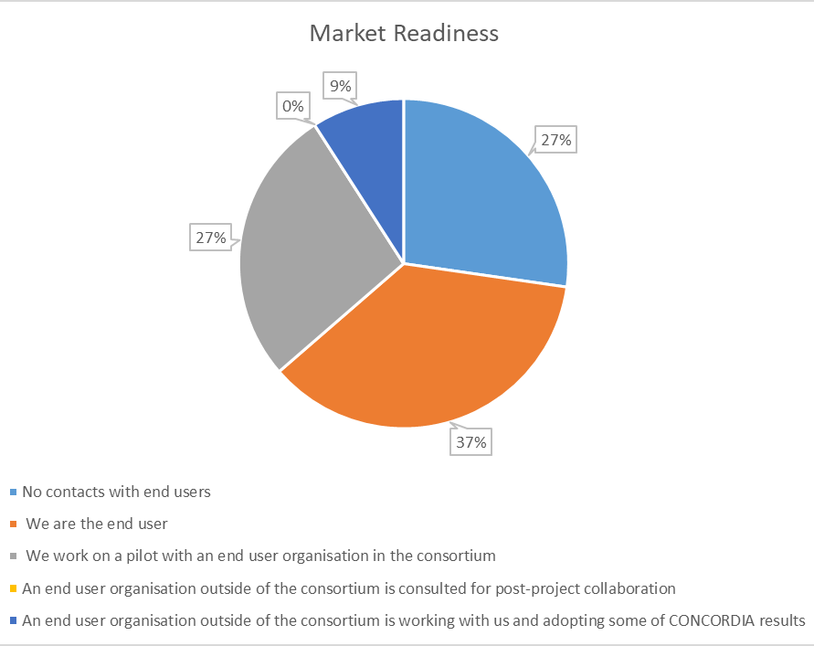
Figure 10: Market readiness breakdown of partners in CONCORDIA.

Finally, as shown in Figure 11, only two types of barriers were perceived by partners: lack of funding for the further maturation of ERs and access to market.

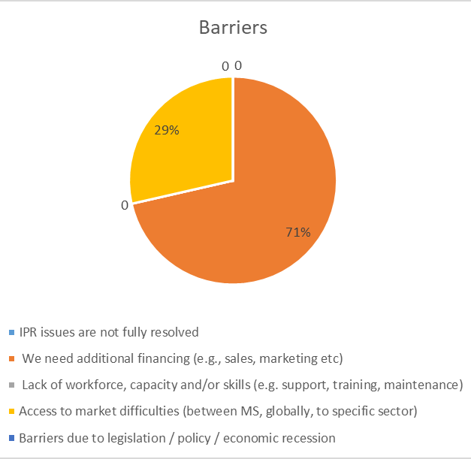
Figure 11: Breakdown of market barriers.

Promotion of Results

We perform continuous monitoring of the cybersecurity sector via participation to key events in industrial and academic meetings, as well as demonstration and innovation days organized by CONCORDIA or other cybersecurity initiatives (e.g., Cyberwatching.eu). This activity is executed in collaboration with partners in WP3 (T3.4).

Furthermore, to communicate our conclusions from the exploitable results (ERs) collection effort, and ISC prioritization of key exploitable results (KERs), we participated in events targeting potential users. At COD event in October, for example, we hosted a session where interested partners pitched their low level TRL ERs (typically concepts and research works) and received feedback from interested key stakeholders. Furthermore, partners with KERs had the opportunity to demonstrate their technology with demos and other means. We also regularly participate in conferences, industrial fora, and meetings to promote KERs, and keep potential early adopters engaged with the project and involved in the CONCORDIA ecosystem. While full list of events attended or prepared by T5.1 is reported in T5.2, we can mention the organization of the webinar "EU Cybersecurity Start-Up Ecosystem", or promotion done within ECSO WG2 on Market Deployment, Investments, and International Collaboration Members. All Key Exploitable Results have been presented at the 12th Edition Market-Driven Innovation, while some KER organized specific promotional events (e.g., CONCORDIA Workshop on Collaborative DDoS Mitigation at Villa Jongerius in Utrecht, the Netherlands).

Next, we outline a full list of activities relevant to the task’s goals, as well as demonstration of internal collaboration between CONCORDIA partners, or external collaboration with the other three pilot projects and key stakeholders:

- CONCORDIA Webinar "EU Cybersecurity Start-Up Ecosystem" – March 10, 2022, online
  - https://www.concordia-h2020.eu/news/webinar-eu-cybersecurity-start-ups-today-and-tomorrow/
- Seminar: Building a Roadmap for the ECCC – March 11, 2022, online
- CONCORDIA e-Health Workshop– March 16, 2022, online
- Privacy Symposium Venice – April 5-7, 2022
  - https://sites.grenadine.co/sites/iot/en/2022-privacy-symposium-conference/schedule/8809/
- CONCORDIA and CyberSec4Europe: European Cybersecurity Collaboration in Action – April 7, 2022
- ENISA Cybersecurity Certification Conference 2022 – June 2-3 2022, Athens and online
  - https://www.enisa.europa.eu/events/enisa-cybersecurity-certification-conference-2022/agenda
- Two meetings of cross-pilot focus group on cyber-threat intelligence in June and July, online
- Several meetings with ECSO working groups and task forces, online
- EU-Western Balkans Consultations on Digital Growth and Cyber Resilience, June 27, 2022, Sarajevo
  - https://eucyberdirect.eu/events/eu-western-balkans-consultations-on-digital-growth-and-cyber-resilience-what-role-for-cyber-diplomacy
- Governance Mesh Approach for Cybersecurity Ecosystem, presentation and paper at Diligence conference organized by pilot project ECHO, September 28, 2022, Plovdiv Bulgaria & online
  - https://digilience.org/programme/
- CONCORDIA Open Door Event, October 26-27, 2022, Munich and online
  - https://opendoor.concordia-h2020.eu/2022/program.html
- CONCORDIA Innovative Research and Best Poster Pitches, October 27, 2022, Munich
- 12th Edition Market-Driven Innovation. Presentation: Collaborative Process of Ranking Results in Cybersecurity Innovation Ecosystem, November 9, 2022, Berlin and online
  - https://www.marcusevans.com/conferences/marketdriveninnovation/delegate/agenda
- European Cybersecurity Market Analysis Conference 2022, moderating market trend and cloud security panel, November 24, 2022, Brussels and online
- ECSO WG2 on Market Deployment, Investments and International Collaboration Members Meeting, 18th October 2022, The Hague, and online
- Online Thematic Workshop: From information sharing to analysis center, Dec 1st, 2022, online

Impact from COVID-19 Pandemic Crisis

As explained in D5.4, the pandemic affected or even interrupted the work of several CONCORDIA teams, either academic or industrial, and hindered or even stopped their technical progress. This situation eased out in this year (Y4). The impact of COVID-19 is detailed more clearly in the corresponding deliverables due in M51, and we encourage the reader to check those for more details. Overall, there was a marked effort by all partners to push the ERs and their maturity so that they can be demonstrable to key stakeholders, or even worthy of pushing to an incubator / accelerator to hit the market.

Overall, the CONCORDIA partners were able to react to the Task 5.1 calls for:
- Defining (or adapting) their ER
- Providing more information about their ER’s novelty and value
- Helping T5.1 with assessing the landscape of technology built within the project.
Due to these efforts, we succeeded in collecting a record total number of ERs (50), and more incubators and accelerators in reach of the consortium (50) than last years.

Next Steps & Recommendations
The ecosystem exploitation approach that we piloted in CONCORDIA should give chance to educate researchers in business issues and the process of innovation, which would eventually increase the number of cybersecurity start-ups in EU. We argue that co-programming and co-design in an ecosystem approach (see Figure 12) that already existed in a form of e.g., joint road mapping, could be extended to joint exploitation and co-delivery of results (e.g., cyberthreat intelligence, open SOC software repository, joint drills, and exercises etc).
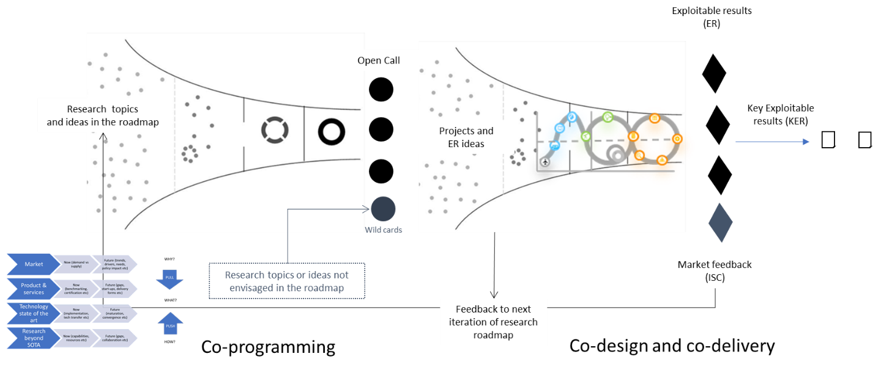

Figure 12: Co-programming, co-design and co-delivery
Based on the previous analysis and presentation to the Industrial Strategy Committee (ISC), there have been several recommendations for post-project “research to industry” technology transfer strategy and a roadmap for the industrial community building:
- Identify degrees of overlapping and interconnections, as well as the existence of related resources (e.g., testbeds, datasets), practices (e.g., awareness building, certification of skills) or specialized know-how & technologies in these communities.
- Industrial community (see also work of ENISA and other existing initiatives) should have EU market landscape (demand versus supply) for the selected cybersecurity segments, that can be expanded in the future. These community reports should be based on community feedback and not (only) on professional market analyst reports.
- Creation of new local, regional, national and (European) sectorial cybersecurity community hubs to attract and pull together diverse ideas, perspectives, and resources, and address the most relevant challenges for these new communities.
- Formal acknowledgement of these new “community hubs” by NCC/ECCC, with the integration into the overall ecosystem governance.
- Adaptation of methodologies, when necessary, to community-centric collective processes, e.g., move “innovation radar” or readiness assessment, from organization subjective assessment to community-based assessments.
- Map cybersecurity community governance to NCC and ECC governance (rules, norms, actions, procedures).
- Use existing and new instruments (e.g., Digital Europe program, or Multi-Country Projects (MCPs) instrument) to further enhance interlinking, collaboration, and cooperation of different community hubs, to support expanding, sustaining and improving of existing hubs, and to launch joint projects including R&D, technology transfer, or capacitation projects.
- Enable community decision procedures for several innovation-related assessment e.g., ranking of key exploitable results, acknowledgment of market readiness level
- Enable community decision making process regarding the further evolution of ecosystem e.g., creation of sub-working groups or clusters of projects/results.
- Perform regular community alignment exercises for objectives, challenges, roadmaps etc. Examples are alignment of industrial with research agenda, alignment of objectives from regional hubs (and with national or EU hubs), alignment of between hubs specialized in technology (e.g., IoT cybersecurity) and sectorial hubs (e.g., Industry 4.0 Hub).
- Align industry-led sprints (prototyping and minimum viable product) in solution-space to research-led design in problem-space (from ideation and concept to development).
- Co-programming sessions for prioritization of research roadmap and open calls.
- Co-design sessions for build-up of new proposals (presentation of ideas, market needs, customer requirements, etc.).
- Co-delivery planning sessions for solutions that stretch over value chain (SECaaS with consulting, managed operations, SW owner and other partners).
- Analyze suitability of existing R&D and innovation instruments and especially duration of the projects and the suitability of other schemes applied in EU-funding (e.g., cascade funding with open calls, pre-commercial procurement, etc.)
- Analyze the most suitable avenues to finance cybersecurity community hubs support and coordination (note: maybe to mention 3M euros tender in 2022).
- Analyze existing investments in EU cybersecurity start-ups, elaborate segmentation and clustering of these investments and identify gaps and opportunities.
- Analyze investors in EU cybersecurity, etc.

While some existing structures, such as “triple helix” and even “quadruple and quintuple helix”, support cooperative innovation models, building upon the idea that value creation is done by putting together different assets and skills, we must acknowledge that cybersecurity is not “business as usual”. Cybersecurity is a journey, not a destination and ecosystem structure and governance procedures need to address not only innovation processes, but also others, such as management of capacity building resources ranging from federated cyber-range platforms to research testbeds. Lack of hierarchy between the collaborating partners require specific agreements and mechanisms of coordination, as well as the willingness of the parties involved in ER to give up, at some stage, total control of the process and results.

Governance in the ecosystem exploitation procedures must live and cope with an apparent paradox: while there is a global inter-dependency in cyber defense and need for the collaboration at a global scale, EU cybersecurity ecosystem must also rely on national and regional actors, and links to the smallest local SME, in order toto really have an impact. From strategic to operational level, global to local, many sub-networks, cross-communities, and infra-clusters feed the overall structure that evolves and adapts over time.

Efforts on Dissemination and Communication

This section reports on the work executed in task T5.2 on Dissemination and Communication activities concerning the CONCORDIA project's dissemination and communication strategy. The reported effort is organized in the following three sections:
1. The description of goals and objectives of this Task (Section Error! Reference source not found.).
2. The strategy to achieve these goals (Section Error! Reference source not found.).
3. The description of communication and dissemination activities performed in the fourth year of the project (Section Error! Reference source not found.).
The goals of the dissemination and communication task (Section 3. 1) and the strategy (Section 3.2) have been already defined and described in D5.3 but we decided to include them here as well for completeness.

  - Objectives of this Task (T5.2)

Dissemination and communication activities are essential for the CONCORDIA project and a dedicated task was designated for their implementation. The purpose of T5.2 and its main challenge, is to boost the impact of CONCORDIA project through dissemination and communication. In order to address this challenge effectively, the T5.2 uses the strategic approach based on the following logic (Error! Reference source not found.). Firstly, the general communication and dissemination goals were defined. These goals are aligned to the project objectives, and they serve as the main guiding principles for our dissemination and communication. Secondly, specific communication and dissemination objectives were defined in order to implement the general goals. Thirdly, the communication and dissemination strategy were built in order to achieve the objectives.
Figure 1: CONCORDIA dissemination and communication logic
Whereas the general dissemination and communications goals remain the same during the whole project, dissemination and communication objectives can be updated in order to consider internal evaluations, reviewers’ recommendations, phase of the project or the context in general.
Dissemination and communication objectives of the project were focused especially on publicity and branding during the first year of the project. The objectives were updated during the next two years of the project in order to reflect the dissemination phase of the project (see Error! Reference source not found.) and the reviewers’ recommendations. We started with the Closing phase of the project (see Error! Reference source not found.). During this phase, we still performed regular communication and dissemination activities. In addition, we started with the activities specific to this phase. This particularly meant providing a summarization of our results and focusing on what was delivered in the project.
Involvement in communication activities and work on the communication goals of the project is a common task of all partners. A communication group oversees coordinating and implementing strategic communication activities. The group is led by Masaryk University (MUNI) and has three members who deal with the communication activities and three members from other tasks who provide insight and help with coordination.
Dissemination and communication goals:
We defined four general dissemination and communication goals, which are aligned with the CONCORDIA objectives. These goals are aligned to the project goals, and they serve as the main guiding principles for our dissemination and communication. They remain the same during the whole project.

Table 1: CONCORDIA Communication Goals
Goal | Description
1 | To build and to position the CONCORDIA brand to strengthen trust and raise awareness about the project.
2 | To enhance the impact of CONCORDIA’s outcomes by spreading knowledge and disseminating project results through all relevant channels to the outside world.
3 | To exploit consortium communication potential by internal dissemination, gathering content about members activities and actively fostering their engagement.
4 | To participate in building a common brand and in coordinated communication activities with the other cybersecurity pilots (SPARTA, ECHO and CyberSec4Europe).

Dissemination and communication objectives:
In order to achieve the goals, we defined specific objectives that will be executed by the project. These communication objectives defined below in Error! Reference source not found. can be updated during the project to support communication goals appropriately.

Table 2: CONCORDIA Dissemination and Communication Objectives (DCO)
DCO | Name | Description | When
1 | Project website | We will create and regularly iterate the project website (www.concordia-h2020.eu). It will serve as a single-entry point to all the information about the project (project’s presentations, deliverables, events, papers and publications, news, software updates etc.) and will support all our communication goals. We expect more than 5,000 accesses per year worldwide. | M2 creation /  continuous updates
2 | Content Marketing | We will focus on the preparation of our own unique content with the purpose to show what we do and enhance the impact of our results. Especially we will focus on producing blog posts, newsletters, infographics, videos and webinars.  The number of unique materials generated is counted as KPI-DC-3 and downloads of them are counted as KPI-DC-4 (500). | M6–M51
3 | Social Media | We will actively use social media channels (Twitter, LinkedIn and Facebook) to promote our results, increase trust and build community. The activity will be monitored based on the total number of views and likes (15,000 as KPI-DC-10). | M1-M51
4 | Campaigns | We will lead communication campaigns – planned and coordinated communications activities focused on boosting the impact of concrete outcome (e.g., event, software, deliverable). | M15-M51
5 | Events | We will participate in relevant events in order to build our brand and share our results. | M1-M51
6 | Publicity | We will exploit all relevant communication opportunities which will occur during the project to support our communication goals. We will focus on media relations, and we will also engage in cybersecurity initiatives, education activities, targeted focus groups with EU officials, policymakers, ECSO and cPPP officials and other stakeholder organizations. | M1-M51
7 | CCN communication activities | We will participate in coordinated communication activities with the other pilots (ECHO, SPARTA, CyberSec4Europe). This includes meetings, group calls, chairing the coordination communication group for six months every two years, preparation of events, and creating relevant content. | M1-M48  - chairing the coordination communication group for six months every two years (start M1-M6)
8 | Visual Identity | We will prepare and constantly apply a CONCORDIA visual identity in order to build our brand. Specifically, this means the logo and various types of templates. | M1-M3 preparation  M3-M51 application
9 | Offline activities | We will prepare printed materials (e.g., banners, posters and flyers) to raise awareness regarding the project and build the CONCORDIA brand by delivery of key messages to our target audiences. | M1-M51
10 | Internal communication | We will spread knowledge within the consortium, and we will actively foster the consortium members and our partners to engage in dissemination and communication activities. We will provide regular internal instructions for our partners which accurately describe what to do to support our goals while keeping communications consistent. | M1-M6  preparation,  M6-M51 regularly updates and reminders

Communication phases:
CONCORDIA communication and dissemination activities are, in general, divided into five distinctive phases, as explained in Error! Reference source not found.: the starting phase of the project, the phase where publicity about the project is increased, the phase for disseminating project results, the closing phase where the project is finishing, and finally, the phase after the project’s termination, in which we further promote the CONCORDIA’s results to influence the definition of the future cybersecurity roadmap of EU. In every phase, we adjust our dissemination and communication objectives in order to reflect the phase specifics.
Table 3: CONCORDIA Communication Phases.
Phase | Description | Time | Dependencies
I. Starting phase | The purpose of this phase is to prepare the basic starting points for the successful implementation of communication activities. Especially, preparation of basic communication channels, the formation of a communication group and specification of communication strategy. | M1-M6
II. Publicity  phase | The purpose of this phase is to increase publicity of the project and support the building and positioning of the CONCORDIA brand. We use a wide range of communication tactics and focus on professionals and the general public. We try to communicate with them in particular the basic facts about the project and our key messages. | M6-M15 | Cooperation of Consortium
III. Dissemination phase | At this phase, in addition to strengthening our brand, we will focus primarily on sharing project results and increasing their impact. | M15-M36 | Technical and scientific  achievements of the project and Cooperation of Consortium
IV. Closing phase | This phase will build on the activities of the previous ones and, moreover, its purpose will be to promote the cybersecurity roadmap (Task 4.4) and summarize the overall results and benefits of the CONCORDIA project. | M36-M51 | Technical and scientific  achievements of the project and Cooperation of Consortium
V. After project phase | During this phase, we will ensure that the website will stay alive for at least three (3) years after the completion of the project. This way all available material will be available to future projects and whoever is interested in the outcomes of CONCORDIA. The social media channels will also be active because the results of the project can also be found through those channels as well through internet search engines. | Three years

  - Strategy to Achieve Task Objectives

In order to achieve our goals, we focus on strategic planning. Our communication strategy answers the following questions:
- What do we want to communicate?
- To whom do we communicate?
- How do we communicate?
Therefore, our dissemination and communication strategy consists of three parts which are interconnected and based on our dissemination and communication goals and objectives.
- CONCORDIA narrative, key messages and content
- Target audiences
- Dissemination and Communication tactics

Figure 2: CONCORDIA dissemination and communication strategy
    - CONCORDIA Narrative, Key Messages, and Content

This section describes what we will communicate. The core of this part is our narrative which summarizes the brand story of our project, this narrative is then delivered in key messages and in our content. Figure 4 represents the simple scheme of this hierarchy.

Figure 3: Hierarchy of CONCORDIA dissemination and communications outputs

CONCORDIA narrative:
CONCORDIA narrative is the overreaching leitmotiv for our dissemination and communication activities. Its purpose is to maintain brand identity consistency in our communications. The narrative can be summarized as follows: European cybersecurity competencies are fragmented. Our mission is to lead their integration to build the European Trusted, Secure and Resilient Ecosystem for Digital Sovereignty of Europe.

Key messages:
CONCORDIA communications group uses two types of key messages. The first type are key messages which are coined for every communication campaign according to its audience and the objective of the campaign (e. g. call to participation/action or messages to raise awareness). These key messages are not listed here. The second type are key messages about the project itself. Their purpose is consistency in communication about the project identity. These key messages are listed in the Table 5.

Table 4: CONCORDIA key messages
Topic | Message
Who we are and what is our purpose | We are a dedicated consortium of more than 50 partners. Our purpose is to lead the boosting of Europe’s cybersecurity future.
What we do | We are leading the integration of Europe’s excellence cybersecurity competencies into a network of expertise to build a secure, resilient and trusted ecosystem in Europe.
Why it matters | The cybersecurity ecosystem will be one of the pillars of Europe’s future. We need to be secure and resilient against cybersecurity threats which are increasingly relevant to our whole society and also to the life of each of us.
What is our relation to other cybersecurity pilots | We are one of several Horizon 2020 projects, all of which share the purpose to help the EU retain and develop the cybersecurity technological and industrial capacities necessary to secure its Digital Single Market and to strengthen Europe’s cybersecurity and place Europe in a leading position in cybersecurity.
How we differ from other cybersecurity pilots | - We comprehensively interconnect academia, SME, CERTs, public bodies, policymakers and moreover we have engaged several strong industry partners to ensure the lasting impact of our work.  - CONCORDIA is the first competence network which takes a holistic, scalable and technology-adaptive data-centric approach to cybersecurity.  - We are developing solutions like Threat Intelligence for Europe, DDoS Clearing House as building blocks of a European cybershield.  - We are developing innovative cybersecurity solutions with the industry in five vertical sectors.  - We are building a comprehensive European cybersecurity educational ecosystem.
What are the benefits of the CONCORDIA? | Creating a European cybersecurity competence network will bring many benefits. In fact, it will:  - Unite the fragmented European cybersecurity landscape which will lead to better cooperation and better use of research results.  - Bring innovation into research, education, policy, roadmaps and governance.  - Increase industry impact by actively considering its problems.  - Develop industrial pilots and next-generation cybersecurity solutions.  - Launch Open Calls to allow entrepreneurs and individuals to stress their solutions with the development.  - Devise a cybersecurity roadmap to establish technology, socio-economic, legal and privacy directions for Europe.  - Provide expertise to European policymakers and industry.  - Improve quality of life through advanced and safer services in Telecommunications, e-Health, Finance and e-mobility.  - Enhance Europe’s digital sovereignty.
Call to action | Follow us on:  - Website: https://www.concordia-h2020.eu  - Twitter: https://twitter.com/concordiah2020  - LinkedIn: https://www.linkedin.com/in/concordia-h2020/  - Facebook: https://www.facebook.com/concordia.eu/
Content:
Three main categories of content were identified for CONCORDIA. These categories consist of topics on which we focus in our communications.

Table 5: CONCORDIA content
Category | Topics
Facts about the project | This covers many topics which are not directly related to our results. For example, our successes, introducing of project partners, “backstage” information, planned actions, consortium internal events, etc.
Project results | Most of our content is focused on the results of work from WP1, WP2, WP3, WP4, WP5 and W6.
Reactions to context | In addition to the planned content of the first two categories, we will focus on production of content that will react to ongoing events relevant to the CONCORDIA project.

    - Target Audience

This section describes our target audience. Since CONCORDIA project has a large scope the simplification of segmentation is needed. The most relevant target audience groups were defined in relation to project objectives.

Community of cybersecurity professionals
Cybersecurity community at European level is the crucial target audience for CONCORDIA. Whether decision-makers or practitioners, they can benefit from CONCORDIA multidisciplinary approach to cybersecurity since it deals with a wide range of tasks (technical, legal, societal, economical). We will focus on building trust with the cybersecurity community and sharing of our results.

CONCORDIA stakeholders
The subsystem of the cybersecurity community is CONCORDIA stakeholders,
a cybersecurity subjects who have already relation with CONCORDIA. Task 4.6 is focused on this audience.

Scientific community:
We address the scientific community to enhance the impact of CONCORDIA’s multidisciplinary research outcomes. Targeted dissemination and communication activities are performed by the traditional means (conferences, workshop, papers) and communication group also disseminate the results to the cybersecurity community and to other relevant audiences.

Private sector
The private sector is the end costumer of CONCORDIA. Whether it’s start-ups, SMEs or big industries, they all can strongly benefit from CONCORDIA outcomes. Targeted communication will be achieved via cooperation with specialized tasks (e. g. T5.1 Exploitation and Incubators). Communication with the private sector will build on existing relationships and informal communication channels. It will also be supported by media relations, social media, content marketing and printed materials.
Public bodies and cybersecurity initiatives
Our goal is to establish cooperation with public bodies and cybersecurity initiatives at European level in order to become CONCORDIA stakeholders. As in the private sector, we want to present our results to these entities and at the same time, we want to participate in their communication activities. National cybersecurity authorities, ENISA, ECSO, ECHO, SPARTA, CyberSec4Europe, Cyberwatching, etc. are particularly relevant.
Media and the general public
Media are mainly intermediary for reaching other target audiences. Our approach to the media is based on a selection of the most promising outcomes with a strong story. We will share them with specialized media at first. If relevant we will also address the mainstream media at European and national level to reach the general public in order to demonstrate the benefits of our project for everyday life.
Consortium members
We address the consortium members and partners to support the image of CONCORDIA’s brand, to enhance the impact of CONCORDIA’s outcomes and to exploit consortium communication potential.

    - Dissemination and Communication Tactics

This section describes which communication tactics (channels, methods and materials) we use to deliver our messages to the defined target audiences. Of course, not all communications tactics are relevant to all audiences in every case. Therefore, they need to be carefully chosen in order to fulfil the objective of the concrete communication action.

Project website (www.concordia-h2020.eu):
This is a single-entry point to all the information about the project (project’s presentations, deliverables, events, papers and publications, news, software updates, etc.). This channel is relevant to all our target audiences and all our communication goals. The project website will also be propagated by all other channels. Website’s traffic will be monitored via Google Analytics.

Social media:
These are in general relevant to all our target audiences, and they will primarily support the building of the CONCORDIA’s brand, raising public awareness and enhancing the impact of CONCORDIA’s outcomes. We will use these channels:
- Twitter: https://twitter.com/concordiah2020
- Facebook: https://www.facebook.com/concordia.eu/
- Linkedin: https://www.linkedin.com/company/concordia-eu/

Media
Media are in general powerful channel for reaching our audiences. We will use press releases to inform these media about our most promising outcomes.

Channels of cybersecurity initiatives and projects:
These channels (e.g., Cyberwatching.eu platform, social media channels of cybersecurity projects, their websites) are very relevant for CONCORDIA since they have an audience which is important for our project. Therefore, we will actively ask for support by other projects and initiatives.

Consortium members and partners owned media:
There is huge potential in partners’ owned media (their websites, social media channels, bulletins, events, etc.) for spreading the knowledge and project results. These media have the potential to help us reach our communication goals and address multiple audiences.

Cyber Competence Network (CCN) pilots coordinated channels:
CCN communication channels (website, Twitter, media relations, materials, etc.) are important tools for coordinated communications about CCN and they can also boost the communication activities of each pilot.

Internal communication channels:
Such channels will be used to transfer knowledge and project results within the consortium and also to gather the content about consortium members activities and foster their engagement. The main communication channels of CONCORDIA are:
- Email (Email mailing lists)
- Synchronized file repository (GIT, Confluence)
- Audio/video conferences
- Physical face-to-face meetings.
They are described in more detail in the Project Handbook (Deliverable D6.1).

Printed materials:
Items such as roll ups, banners, posters, flyers, etc., are a complementary communication channel designed to raise awareness of the project and build its brand by delivery of project key messages to our target audiences.

Visual identity:
By visual identity is meant especially the logo and templates for presentations, printed materials and posters. Visual identity is an essential tool for brand building, as it represents one of its most visible external representations. Together with our narrative and key messages, visual helps us to be consistent in our communication activities.

Content marketing forms:
We will use different forms to deliver our content. Especially relevant are blog posts, news items, texts, videos, infographics, white papers, deliverables, presentations and webinars. This list is not restrictive. On the contrary, we can use also other content form if it makes sense in given context.

Communication campaigns:
Communication campaigns are important communication tactic of CONCORDIA project. Coordinated communication activities in given period will boost a concrete topic much better than individual promotional acts. Our approach is based on using various forms of contents and all relevant channels to promote selected topic (e.g., event invitation, software release, important article).

Figure 4: CONCORDIA campaigns approach

  - Dissemination and Communication Activities

This section describes the dissemination and communication activities carried out during the fourth year of the CONCORDIA project. It is structured according to our dissemination and communication objectives, which were mentioned in the previous paragraphs.

    - CONCORDIA Website

The CONCORDIA website (www.concordia-h2020.eu) is the main entry point to all the information about the project and also one of the main dissemination channels. Our target audiences will gain access to CONCORDIA results, publications, news, weekly blog articles and new tools developed in the context of this project through the website. During the fourth year of the project, the website content has been constantly enriched, and new content was added to the Assets tab. The current version of the homepage is presented in Figure .

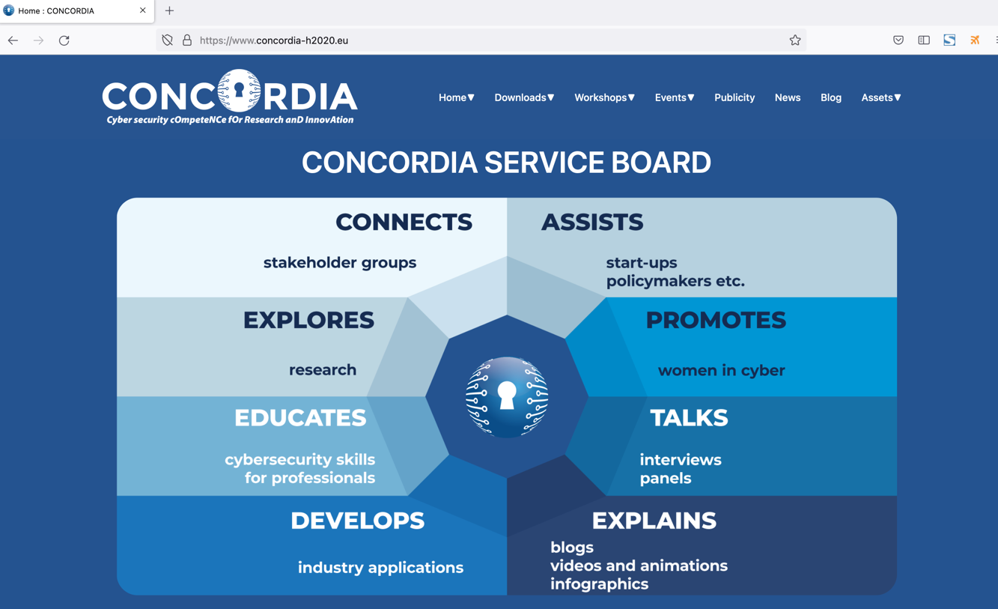
Figure 6: CONCORDIA website (homepage)
More information on how the website has been implemented, the various sections offered to the visitor and some more technical details are included in the deliverable D5.1: Website and Social Media presences, which is listed under the Publications sections. In this section, we will provide some statistics for the fourth year of the project (2022).

Website Visitors and Trend:
The users that were served by the CONCORDIA website per day during the fourth year of the project can be seen in the Figure. We can see that more than 21000 users were recorded in this period. This means that we had an approximate of more than 60 visits per day. Three spikes are detected to the plot. The first and the second spike refer to “Become a Cybersecurity Consultant” course and its promotion, and lastly the third one to the CONCORDIA Open Door Event 2022. The figure also presents that these visitors created almost 29K sessions against the website which resulted in 51K served webpages. This is about 150 webpages per day.

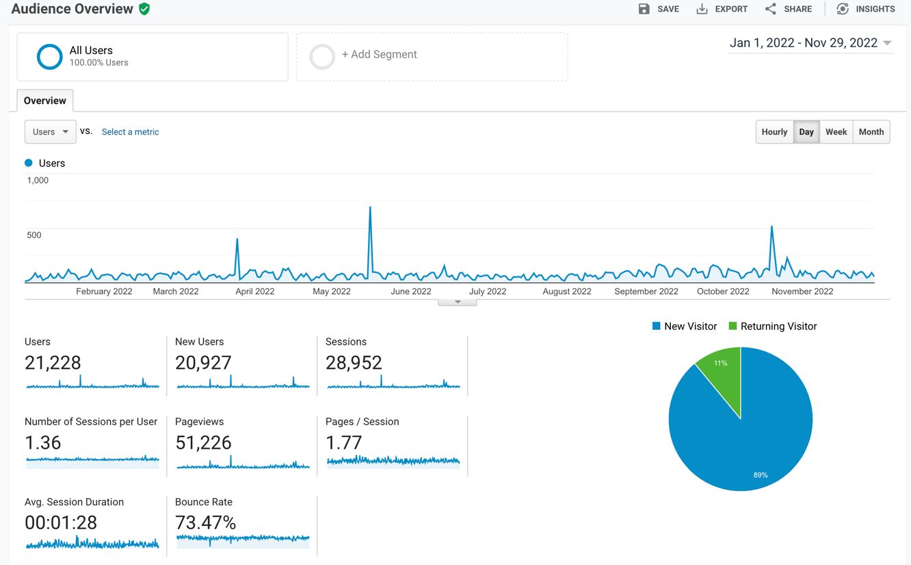
Figure 7: Users per week that visited the CONCORDIA website. With red circles we marked the CONCORDIA workshop on Education for Cybersecurity professionals and the COD2022 event

Figure presents the most popular pages of the website during the reporting period. Naturally, the most visited page is the welcome page followed by Become a Cybersecurity Consultant page, the program of the CONCORDIA Open Door Event 2022, the Consortium page, the blog “Threat Intelligence sharing: What kind of intelligence to share?”. It seems that the visitors were interested to learn more about the CONCORDIA consortium (who are they?), blogs and information about everything that involves the “Become a Cybersecurity Consortium” course.
Additionally, in Figure we show the geographic origin of visitors who requested all the previously mentioned pages from the CONCORDIA webserver. Most visitors come from US and Germany, followed by visitors in China, Indonesia, Greece, France and Italy.
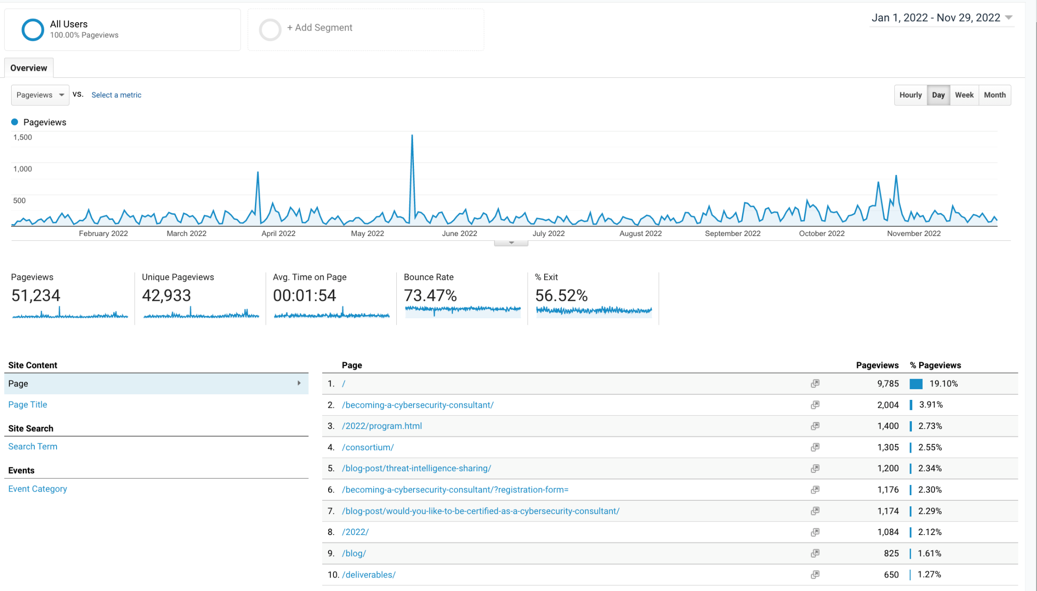
Figure 8: CONCORDIA pages with the most page views

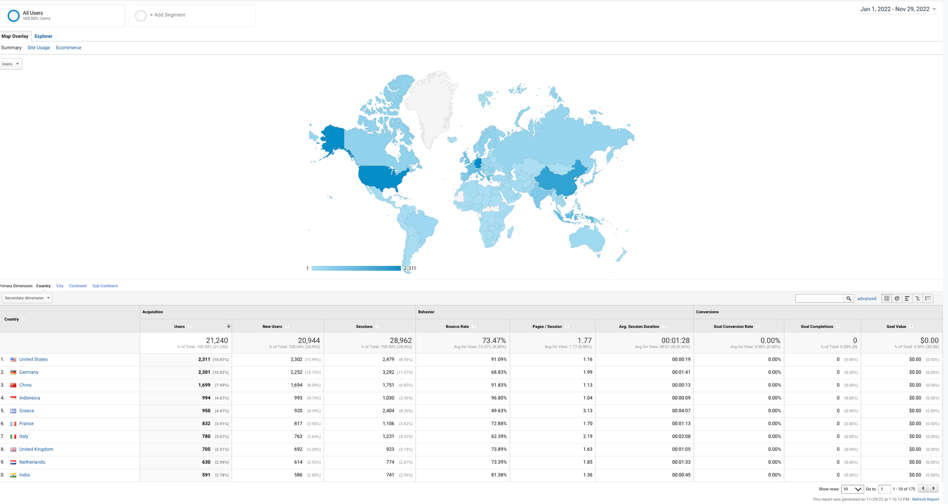
Figure 9: Top 10 countries visiting the CONCORDIA website

    - Content Marketing

We have focused our communication on production of our own unique content since the second year of the project. The purpose is to show what we do and enhance the impact of our results. However, we did not resign from our communication goals since content production is effective way how to build reputation in organic way.

Blog posts:
We regularly deliver blog posts to our target audience. Our blog posts cover a wide range of topics since they are written by CONCORDIA partners with different backgrounds in cybersecurity. We focus on what we do and where are the benefits in our blog posts. The blog posts are intended for cybersecurity professionals in general. Since the last review we have published 40 blog posts and we have 130 blog posts in total on our website.

Table 6: CONCORDIA Blog posts
Topic | Link
The market for lemons on the market for ideas | https://www.concordia-h2020.eu/blog-post/the-market-for-lemons-on-the-market-for-ideas/
The long-standing problem of email attacks | https://www.concordia-h2020.eu/blog-post/the-long-standing-problem-of-email-attacks/
CONCORDIA’s Incident Clearing House: a Closer Look | https://www.concordia-h2020.eu/blog-post/concordias-incident-clearing-house-a-closer-look/
Who should I trust when I seek the truth? | https://www.concordia-h2020.eu/blog-post/who-should-i-trust-when-i-seek-the-truth/
To Share, or Not to Share, that is the trust question | https://www.concordia-h2020.eu/blog-post/to-share-or-not-to-share-that-is-the-trust-question/
Look back at the CONCORDIA Open Door 2021 | https://www.concordia-h2020.eu/blog-post/look-back-at-the-concordia-open-door-2021/
Anomaly detection for industrial control systems (ICS) | https://www.concordia-h2020.eu/blog-post/anomaly-detection-for-industrial-control-systems-ics/
Cyber Threat Modelling for Telco | https://www.concordia-h2020.eu/blog-post/cyber-threat-modelling-for-telco/
Patient profile for remote health services | https://www.concordia-h2020.eu/blog-post/patient-profile-for-remote-health-services/
Healthcare Cloud Security Explained | https://www.concordia-h2020.eu/blog-post/healthcare-cloud-security-explained/
Benefits of Ecosystem approach to Cybersecurity Threat Intelligence Sharing | https://www.concordia-h2020.eu/blog-post/benefits-of-ecosystem-approach-to-cybersecurity-threat-intelligence-sharing/
Understanding the needs of youth: Teaching Cybersecurity & Cybersafety to high-school students | https://www.concordia-h2020.eu/blog-post/understanding-the-needs-of-youth-teaching-cybersecurity-cybersafety-to-high-school-students/
Blockchain-based Privacy Enforcement in the IoT domain | https://www.concordia-h2020.eu/blog-post/blockchain-based-privacy-enforcement-in-the-iot-domain/
5G Cybersecurity: How EU Policy framework ensures Cybersecurity and National Security of Member States? | https://www.concordia-h2020.eu/blog-post/5g-cybersecurity-how-eu-policy-framework-ensures-cybersecurity-and-national-security-of-member-states/
Would you like to be certified as a cybersecurity consultant? | https://www.concordia-h2020.eu/blog-post/would-you-like-to-be-certified-as-a-cybersecurity-consultant/
Anomaly Detection with Privacy-preserved Peer-to-peer Federated Learning | https://www.concordia-h2020.eu/blog-post/anomaly-detection-with-privacy-preserved-peer-to-peer-federated-learning/
On the Cybersecurity Planning and Investments: An Approach with Economic Bias | https://www.concordia-h2020.eu/blog-post/on-the-cybersecurity-planning-and-investments-an-approach-with-economic-bias/
Countermeasures and Research Actions | https://www.concordia-h2020.eu/blog-post/countermeasures-and-research-actions/
Smart home and remote health service, use case in CONCORDIA | https://www.concordia-h2020.eu/blog-post/smart-home-and-remote-health-service-use-case-in-concordia/
Visualization helps clear the fog of Cyberwar | https://www.concordia-h2020.eu/blog-post/visualization-helps-clear-the-fog-of-cyberwar/
Preparing for a Quantum Era | https://www.concordia-h2020.eu/blog-post/preparing-for-a-quantum-era/
Initial analysis on the Russo-Ukrainian War corpus on Twitter | https://www.concordia-h2020.eu/blog-post/initial-analysis-on-the-russo-ukrainian-war-corpus-on-twitter/
The ethical contextualization of trust | https://www.concordia-h2020.eu/blog-post/the-ethical-contextualization-of-trust/
On the Security Assessment of the Cloud | https://www.concordia-h2020.eu/blog-post/on-the-security-assessment-of-the-cloud/
Towards an integrated platform for skills in cyber built on the European Cybersecurity Skills Framework | https://www.concordia-h2020.eu/blog-post/towards-an-integrated-platform-for-skills-in-cyberbuilt-on-the-european-cybersecurity-skills-framework/
New shape of health care with Edge devices | https://www.concordia-h2020.eu/blog-post/new-shape-of-health-care-with-edge-devices/
An experience of becoming a Certified Cybersecurity Consultant (C3 by CONCORDIA) | https://www.concordia-h2020.eu/blog-post/an-experience-of-becoming-a-certified-cybersecurity-consultant-c3-by-concordia/
KYPO cyber range platform: technology & education | https://www.concordia-h2020.eu/blog-post/kypo-cyber-range-platform-technology-education/
CONCORDIA and Cyber Diplomacy | https://www.concordia-h2020.eu/blog-post/concordia-and-cyber-diplomacy/
Push the button: Our updated DDoS testbed in action at CONCORDIA Open Door 2022 | https://www.concordia-h2020.eu/blog-post/push-the-button-our-updated-ddos-testbed-in-action-at-concordia-open-door-2022/
Ethereum’s P2P network monitoring and Sybil Attack Prevention | https://www.concordia-h2020.eu/blog-post/ethereums-p2p-network-monitoring-and-sybil-attack-prevention/
Cybersecurity: Why adopting Gorille® in your EDR? | https://www.concordia-h2020.eu/blog-post/cybersecurity-why-adopting-gorille-in-your-edr/
First CONCORDIA workshop on collaborative DDoS mitigation | https://www.concordia-h2020.eu/blog-post/first-concordia-workshop-on-collaborative-ddos-mitigation/
How Quantum Computing Will Change Encryption Forever | https://www.concordia-h2020.eu/blog-post/how-quantum-computing-will-change-encryption-forever/
Spamley web app: studying the cognitive aspect behind the phishing problem | https://www.concordia-h2020.eu/blog-post/spamley-web-app-studying-the-cognitive-aspect-behind-the-phishing-problem/
CONCORDIA Mobile Threat Modelling Framework | https://www.concordia-h2020.eu/blog-post/concordia-mobile-threat-modelling-framework/
News on CONCORDIA Finacial Pilot | https://www.concordia-h2020.eu/blog-post/news-on-concordia-finacial-pilot/
Summer School on real-world crypto and privacy in Šibenik 2022 | https://www.concordia-h2020.eu/blog-post/summer-school-on-real-world-crypto-and-privacy-in-sibenik-2022/
A proposal for a Cybersecurity Skills Certification Framework | To be published
CONCORDIA’s take on Threat Intelligence | To be published

Videos:
We continued with video production during the fourth year of the project on CONCORDIA YouTube channel. We produced 43 videos this year and the overall number of views is 10 346.
Our videos are focused on topics relevant to scope of CONCORDIA project. Significant part of our video production is part of the campaign called #CONCORDIADelivers. These videos are short and accessible summarizations of CONCORDIA outcomes with the recommendations for further actions. Also, more then 10 videos remain unpublished (they will be released during the last month of the project).

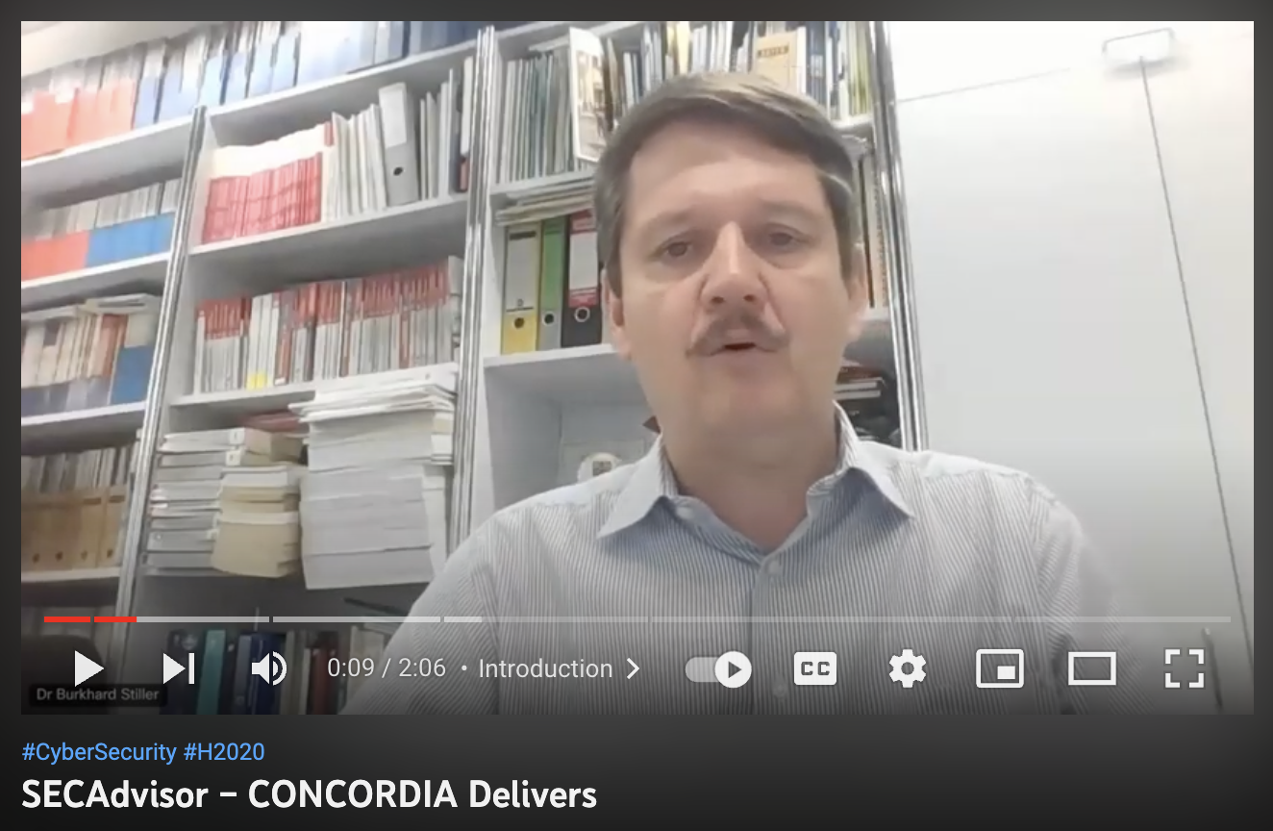
Figure 10: CONCORDIA Stories Example
(https://www.youtube.com/watch?v=DbZ9vHYJ-LU)

Infographics:
We created 35 infographics since the last review. They cover various topics which are relevant for CONCORDIA project. This year we focused especially on CONCORDIA Road Map, Cybersecurity Consultant and Certification and CONCORDIA Open Door Event 2022.
The infographics, except the ones for COD 22 event, can be found on CONCORDIA website (https://www.concordia-h2020.eu/dissemination-material/). It is also important to notice that about 20 infographics will be used at the end of the project to promote CONCORDIA outcomes.

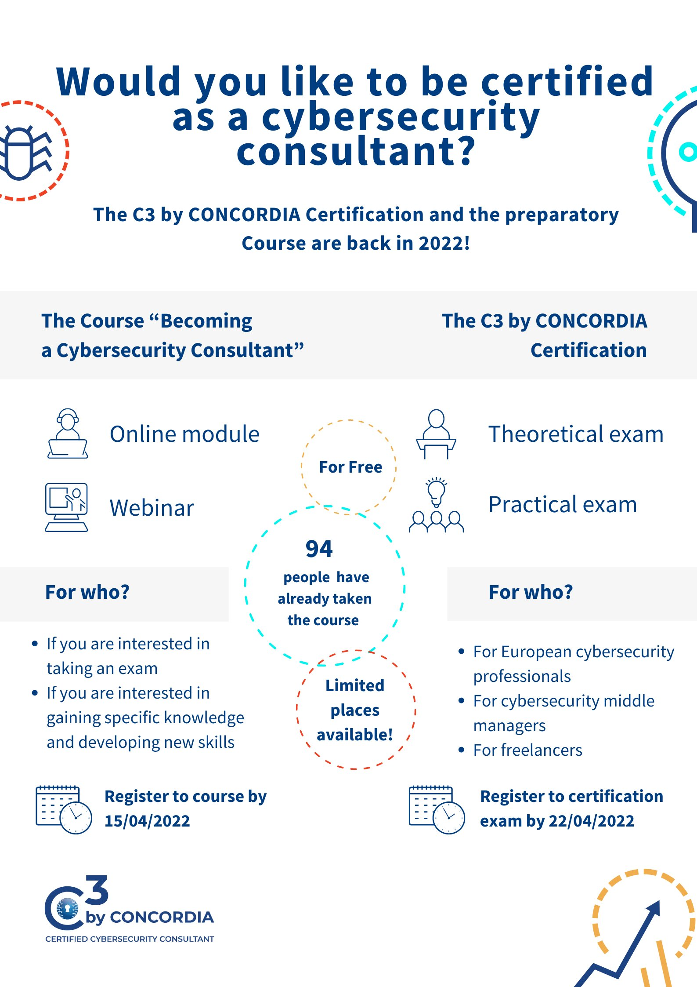

Figure 12: CONCORDIA infographics example
CONCORDIA women:
In cooperation with task 4.5 (Women in Cybersecurity) we regularly promote women in CONCORDIA. We have published 30 content posts focus on the women in cyber topic since the last review.

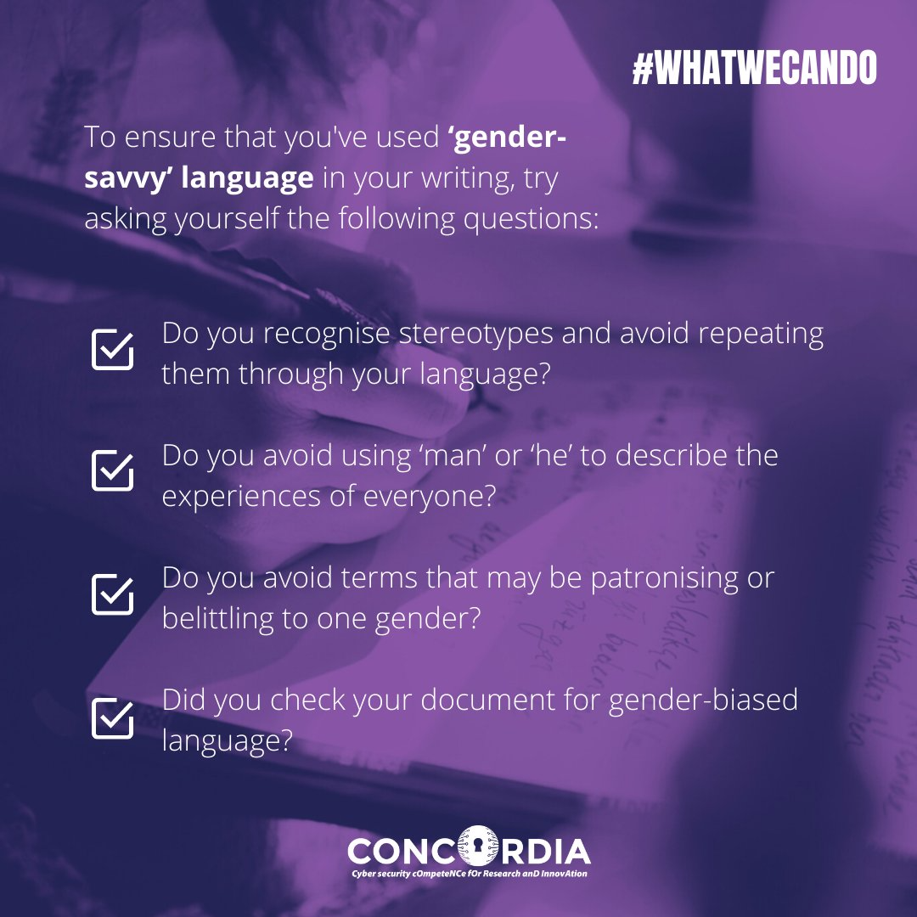

Figure 13: Example of women in cyber content

Promotional content:
We support CONCORDIA outputs by the production of promotional content. We regularly promote CONCORDIA research papers produced by Work Package 1. We also focus on other outputs (e.g., CONCORDIA courses, Service catalogue and our newsletters).

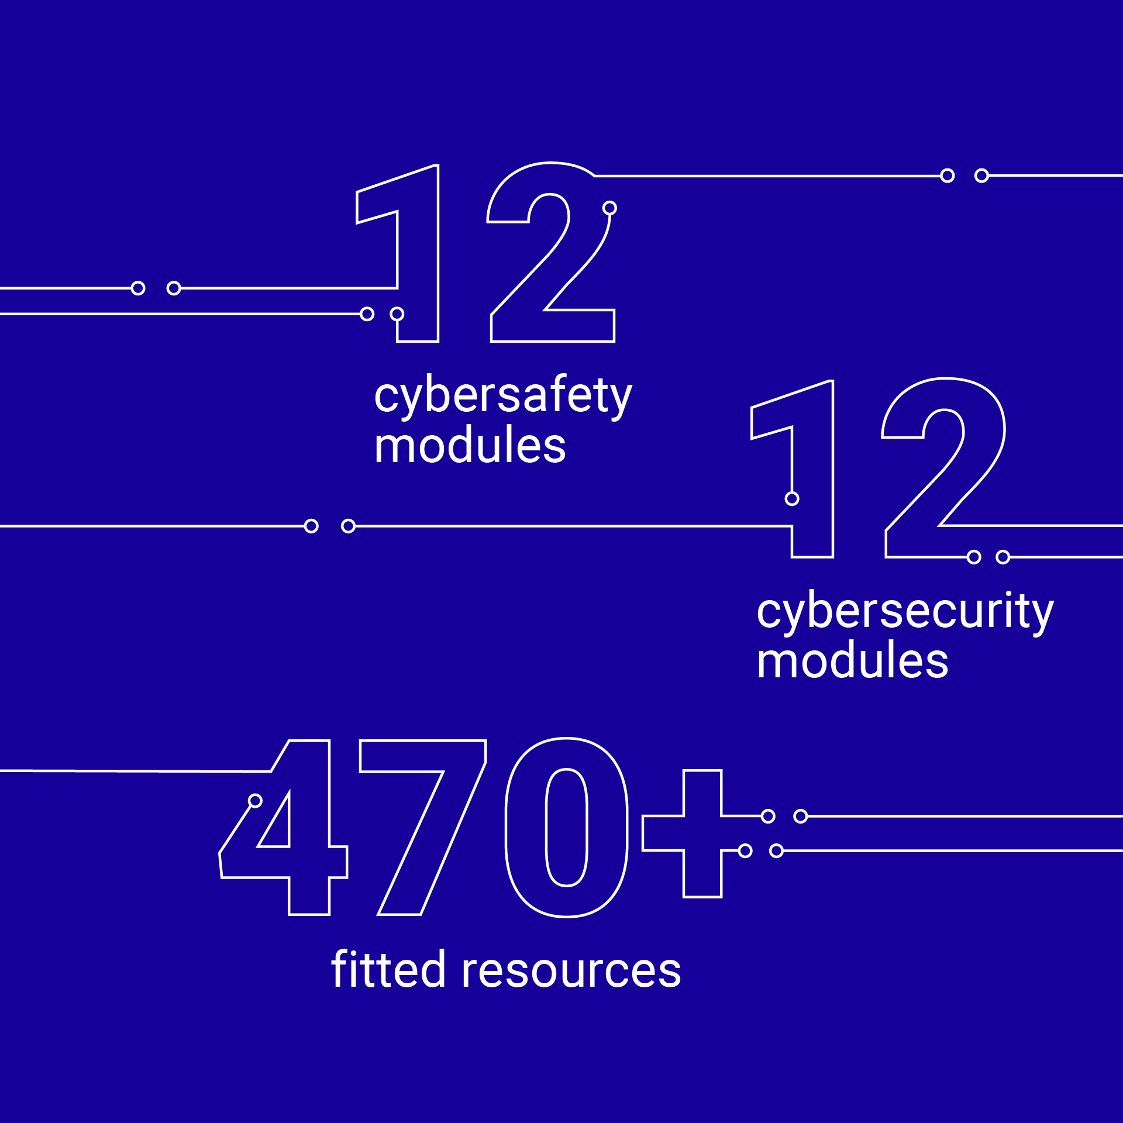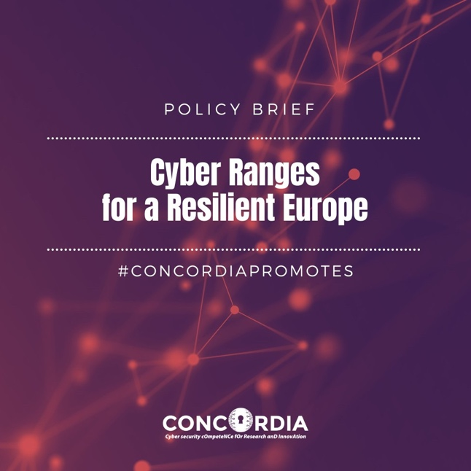

Figure 14: Examples of CONCORDIA promotional content

Ad hoc content:
Finally, we produced various types of ad hoc content in order to raise awareness about relevant events (international days, surveys, competitions etc.).

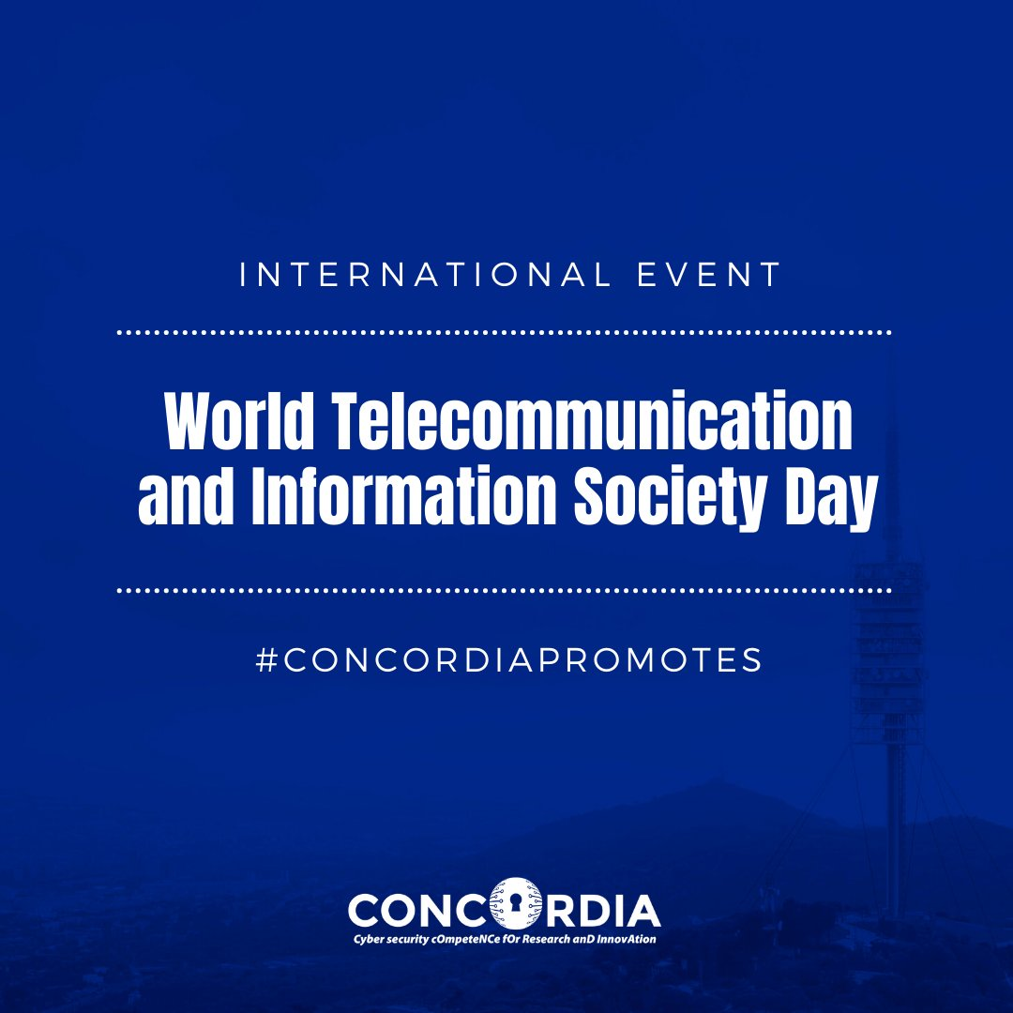

Figure 15: Example of ad hoc content output

    - Social Media

CONCORDIA’s presence is established in Twitter, LinkedIn and Facebook. Initial information can be found in the deliverable named “D5.1: Website and Social Media presences”. In this section we will provide only the report on the social media activity that were performed since the last review. KPI-DC-10 for total views and likes in social media is defined as the sum of total likes on LinkedIn, reactions on Facebook and engagements on Twitter. Communication group does not have access to any type of social media management software. Therefore, we are limited in reporting and analysis only to very basic tools which are offed by social media platforms for free.

LinkedIn:
Our LinkedIn network grew during the fourth year of the project. It enlarged from 2 221 connected accounts to 2 583. We have also 2 770 followers on LinkedIn, so from the last report number increased by 467. We published 301 posts on our LinkedIn channel and they in total achieved 3 402 likes and 138 932 impressions. The data were obtained using the LinkedIn site for posts and activity management.

Table 7: LinkedIn activity
Months | Posts | Likes | Impressions
M36-M38 | 91 | 692 | 24 394
M39-M41 | 91 | 873 | 31 783
M42-M44 | 49 | 612 | 30 502
M45-M47 | 70 | 1 225 | 52 253
M36-M47 | 301 | 3 402 | 138 932

Twitter:
Currently, we have 1 767 followers on our profile. There were 304 original posts published, which had in total 12 552 engagements and 819 K impressions. We also used Twitter Ads as an additional tool for promotion of CONCORDIA promising outcomes, webinars and COD22 as a result the engagements were significantly increased (2, 700 +).
The data were obtained via Twitter Analytics.
Months | Posts | Engagements | Impressions
M36-M38 | 91 | 3 723 | 292 777
M39-M41 | 90 | 2 754 | 196 087
M42-M44 | 49 | 1 013 | 17 969
M45-M47 | 74 | 5 062 | 312 970
M36-M47 | 304 | 12 552 | 819 807

Table 8: Twitter activity
Facebook:
Currently, we have 393 followers on our project profile. There were 290 posts published which, in total, achieved 1 824 reactions and achieved a reach of 24 922. The data were obtained via Facebook Insights.

Table 9: Facebook activity
Months | Posts | Reactions | Reach
M36-M38 | 88 | 608 | 6 284
M39-M41 | 86 | 413 | 5 819
M42-M44 | 47 | 229 | 6 877
M45-M47 | 69 | 574 | 5 942
M36-M47 | 290 | 1 824 | 24 922

    - Campaigns

We started with the concentrated communication activities on different topics during the second year and we continued in with them since then. In every campaign, we use our website, social media channels and content marketing. We also use direct mails, internal communications, media relations and cooperation with other subjects if it is relevant. The following table contains a list of our communication campaigns.

Table 10: CONCORDIA Campaigns 2022
Name | Date | Goal
CONCORDIA Road map | January | To increase awareness about the CONCORDIA Road map
CONCORDIA Legal perspective | February | To increase awareness of CONCORDIA Legal and Strategic activities.
CONCORDIA Women – What we can do | 1. 3. – 10. 3. | To increase awareness and motivate to action.
Cybersecurity Consultant course and certification | March | To promote the course and to motivate to register.
Horizons Results Booster cooperation campaign | March – April | To promote outcomes of the HRB project group (policy brief, video, and webinar).
Cyber Range Webinar | April – May | To support registrations to Cyber Range webinars
Cybersecurity Consultant course and certification promo II. | May | To promote the course and to motivate to register.
CONCORDIA Open Door 2022 | September – October | To attract participants.
#CONCORDIADelivers | October – Till the end of the project | To maximize the impact of CONCORDIA outcomes and demonstrate the value delivered by the project.

    - Events

The following table includes a list of 60 events – conferences, webinars, presentations, workshops, and other events where CONCORDIA was present through participation of its partners. The events are of different types and the table presents the title, type of event, date it was performed and location in the world. Scientific events for representation of research papers are listed in Deliverable D1.4. Communication group also cooperated on preparation of CONCORDIA Open Door event 2022. More information about this event can be found in deliverable D4.10.

Table 11: CONCORDIA Events 2022
Title | Event | Date | Place
"CONCORDIA Project key exploitation results" | 2nd Joint Workshop – Dynamic Countering of Cyber-attacks | Feb 8th, 2022 | Online
"CONCORDIA DDoS Clearing House" | 2nd Joint Workshop – Dynamic Countering of Cyber-attacks | Febr 8th, 2022 | Online
Standards in the HORIZON | 2nd Joint Workshop – Dynamic Countering of Cyber-attacks | Feb 8th, 2022 | Online
Career Path towards Cybersecurity | ECSM 2022 Campaign | Feb 10, 2022 | Online
Career Path towards Cybersecurity | ECSM 2022 Campaign | 15 March 2022 | Online
A Cybersecurity Skills Certification Framework by CONCORDIA | 13th AHWG Plenary Meeting, ENISA | 27 April 2022 | Online
Presentation | Open Cybersecurity Awareness Day | 17 JUNE 2022 | Athens
Women in Cyber | Thessaloniki International Fair 2022 (TIF 2022) | 10-18 SEPTEMBER 2022 | Thessaloniki
Career Path towards Cybersecurity | ECSM 2022 Campaign | 06 OCT 2022 | Online
Securing DNN’s from Extraction Attacks | University of Edinburgh | Oct 24-25 | Edinburgh
Roadmap System Security & DNN Model Stealing Attacks | Bosch | Oct 17, 2022 | Online
Threat Modeling, Roadmap dissemination | Mixed (VW, Continental, CISPA, Deutsche Bahn) | Oct 8-14, 2022 | Germany
Threat Models/Moving Target Defenses | USENIX Security Conf | Aug 9-13, 2022 | US
Data Centric Security | IFIP Workshop & IEEE DSN Conference | June 22-29, 2022 | US
Software/Security Testing | DB, Phillips | June 13, 2022 | Germany
How to design your hands-on cybersecurity training: a webinar | Webinar on Cyber Ranges | May 31 | Online
ML Model Stealing Prevention | SEB, Nordsbank, AXA | May 27, 2022 | Online
Discussions on T1.3 | Sandpit Israel Govt | May 24-26, 2022 | Israel
T4.4 Roadmap | VW, IBM, Lufthansa Group | May 11, 2022 | Online
Data Security | Microsoft, Amazon, VMWare | April 12-15, 2022 | US
Security Testing | DoD CNPS – Computing Enabled Networked Physical Systems Group@ DoD/NERC/NIST | April 6-8, 2022 | Online
T1.3/T4.4 Roadmap | MEDINA Project | April 4, 2022 | Online
T4.4 CONCORDIA Roadmap | EU-UK Stakeholders Group (Airbus, Thales, BAE, BT, IBM, Raytheon, Saab Aerospace, Volvo) | March 31, 2022 | Online
Security Metrics | Stakeholders event | March 24, 2022 | Aarhus, Denmark
Threat Modelling | TU Graz | March 21, 2022 | Austria
T4.4 Roadmap | EC Inter-Pilot Roadmap Group | March 11 & 14, 2022 | Online
T4.4 Roadmap | EU Patent Office, Turing Institute | Feb 23, 2022 | Online
T4.4 Roadmap | NSF US-EU Cybersecurity Collaboration Accelerator Program, | Feb 12, 2022 | Online
T4.4 Roadmap | British Telcom & Lloyds | Jan 31, 2022 | UK
Formal Verification of Secure ML | Kings College London | Jan 24, 2022 | UK
IFIP Workshop on Securing Autonomous Systems | Online | Jan 20-21, 2022 | UK
Seminars on Security Testing | CISPA Heimholtz Center for Information Security, Max Plank Institute-Bochum | Jan 14, 2022 | Online
Women in Cyber | CONCORDIA Open Door 2022 | 26-27/10/2022 | Munich
The European Cybersecurity Community | CONCORDIA Open Door 2022 | 27/10/2022 | Munich, online
Career Path towards Cybersecurity | ECSM 2022 Campaign | 17/10/2022 | Online
Career Path towards Cybersecurity | ECSM 2022 Campaign | 14/11/2022 | Online
Education | COD 2022 | 27/10/2022 | Munich, online
CONCORDIA Education outputs | ARES – ETACS workshop | 23/08/2022 | Vienna, online
CYBER CHALLENGES FOR THE PRIVATE SECTOR - a Skills perspective  (Roadmap - Education chapter) | Conference National Defence Institute (IDN, Portugal) on the European Security and Defence College framework (ESDC) | 27/09/2022 | online
BRINGING CYBER INTO SOCIETY: INTEGRATION OF CYBER SECURITY IN THE EDUCATION CURRICULUM  (presentation of the Teach-the-teachers methodology) | Workshop | 21/10/2022 | Chisinau, Republica of Moldavia  +  online
Monitoring du Réseau Pair à Pair Ethereum et prévention d’attaque Sybil | Journées d’étude pluridisciplinaire jeunes chercheurs sur les Crypto-monnaies et autres monnaies alternatives numériques | 28-29/06/2022 | Lyon, France
Ethereum’s Peer-to-Peer Network Monitoring and Sybil Attack Prevention | CONCORDIA Workshop on Blockchain and Distributed Ledger Technologies | 13/04/2022 | online
CONCORDIA introduction | First CONCORDIA Workshop on Collaborative DDoS Mitigation | 15/09/2022 | Utrecht, the Netherlands
Collaborative DDoS mitigation and the DDoS Clearing House | First CONCORDIA Workshop on Collaborative DDoS Mitigation | 15/09/2022 | Utrecht, the Netherlands
Collaborative DDoS mitigation – where are we now and the way forward | First CONCORDIA Workshop on Collaborative DDoS Mitigation | 15/09/2022 | Utrecht, the Netherlands
CONCORDIA presentation | Open door of the Faculty of Electrical Engineering and Computer Science | 30/11/2022 | Maribor, Slovenia
CONCORDIA project presentation | Webinar "EU Cybersecurity Start-Up Ecosystem" | March 10, 2022, online | online
CONCORDIA and CyberSec4Europe: European Cybersecurity Collaboration in Action | Privacy symposium, | April 7, 2022, | Venice
Cybersecurity Certification panel | ENISA Cybersecurity Certification Conference 2022 | June 2-3 2022 | Athens, online
CONCORDIA project presentation | EU-Western Balkans Consultations on Digital Growth and Cyber Resilience, | June 27 2022 | Sarajevo
Governance Mesh Approach for Cybersecurity Ecosystem, presentation and paper | Digilience conference organized by pilot project ECHO | September 28, 2022, | Plovdiv, online
Presentation Collaborative Process of Ranking Results in Cybersecurity Innovation Ecosystem, | 12th Edition Market-Driven Innovation | Nov 8, 2022 | Berlin, online
Panel on cloud security | European Cybersecurity Market Analysis Conference 2022, | Nov 24 2022 | Brussels
First CONCORDIA workshop on collaborative DDoS mitigation | First CONCORDIA workshop on collaborative DDoS mitigation | Sep 15, 2022 | Utrecht, NL
Security Assurance Meets Software Engineering: Bridging the Gap Between Certification and Software Development | The China-Europe International Symposium on Software Engineering Education (CEISEE 2022) | November 25, 2022 | Online
Data Sovereignty and Data Governance: The Role of Open Science and Open Data | The 1st Italian Conference on Big Data and Data Science | September 21, 2022 | Milan, Italy
Your data are under attack: From Denial of Service to disinformation, the new frontiers of cybercrime | Post Degree Course in Criminalità informatica e investigazioni digitali | November 25, 2022 | Online
Bridging the Gap Between Certification and Software Development | CONCORDIA WP1 Meeting | June 28, 2022 | Munich, Germany
A Multi-Dimensional Certification Scheme for Modern Services | The 1st Conference on System and Service Quality | November 25, 2022 | Milan, Italy

    - Publicity

This section describes publicity results and activities since the last review of the project, in specific it describes publicity outputs and announcements and cooperation activities.

Publicity outputs and announcements:
This section summarizes CONCORDIA announcements (website news items, press releases etc.) that we have published since the last review and communication activities that helped to increase the publicity of the project.

Table 12: Publicity outputs and announcements
Topic | Link
The future of Threat Intelligence and Information Sharing for Financial Services | https://www.concordia-h2020.eu/news/the-future-of-threat-intelligence-and-information-sharing-for-financial-services/
NECS – PHD WINTER SCHOOL 2022 | https://www.concordia-h2020.eu/news/necs-phd-winter-school-2022/
Cybershare Academy for Schools | https://www.concordia-h2020.eu/news/cybershare-academy-for-schools/
Cybershare Academy for School 2021 – Update | https://www.concordia-h2020.eu/news/cybershare-academy-for-school-2021/
New releases of KYPO CRP significantly improve user experience and fix Log4Shell | https://www.concordia-h2020.eu/news/new-releases-of-kypo-crp-significantly-improve-user-experience-and-fix-log4shell/
Reducing the economic impact of DDoS attacks through anti-DDoS coalitions | https://www.sidnlabs.nl/en/news-and-blogs/reducing-the-economic-impact-of-ddos-attacks-through-anti-ddos-coalitions
5th IEEE International Workshop on Smart and Sustainable Mobility and Logistics in Smart Cities (SSMLS 2022) | https://www.concordia-h2020.eu/news/5th-ieee-international-workshop-on-smart-and-sustainable-mobility-and-logistics-in-smart-cities-ssmls-2022/
CONCORDIA Project has completed its fourth review | https://www.concordia-h2020.eu/news/concordia-project-4th-review/
CONCORDIA and the importance of information sharing for the future ofthe European Cybersecurity Ecosystem | https://www.concordia-h2020.eu/wp-content/uploads/2022/02/WS_CONCORDIA_20210209.pdf
Developing and running a testbed for the DDoS Clearing House | https://www.sidnlabs.nl/en/news-and-blogs/developing-and-running-a-testbed-for-the-ddos-clearing-house
DDoS fingerprints and the future of a secure internet | https://emagazine.one-conference.nl/2022/ddos-fingerprints-and-the-future-of-a-secure-internet/
Push the button: Our updated DDoS testbed in action at CONCORDIA Open Door 2022 | https://www.sidnlabs.nl/en/news-and-blogs/push-the-button-our-updated-ddos-testbed-in-action-at-concordia-open-door-2022
Webinar – EU cybersecurity start-ups today and tomorrow | https://www.concordia-h2020.eu/news/webinar-eu-cybersecurity-start-ups-today-and-tomorrow/
Diversity & Cybersecurity: Women in Cybersecurity Industry | https://www.concordia-h2020.eu/news/diversity-cybersecurity-women-in-cybersecurity-industry/
The map of courses for professionals got updated | https://www.concordia-h2020.eu/news/the-map-of-courses-for-professionals-got-updated/
#8 Stakeholders’ Newsletter | https://www.concordia-h2020.eu/news/8-stakeholders-newsletter/
How to design your hands-on cybersecurity training? CONCORDIA will help you! | https://www.concordia-h2020.eu/news/how-to-design-your-hands-on-cybersecurity-training-concordia-will-help-you/
Save the Date: CONCORDIA Open Door 2022 | https://www.concordia-h2020.eu/news/save-the-date-concordia-open-door-2022/
CONVERGENCE NEXT 2022 | https://www.concordia-h2020.eu/news/convergence-next-2022/
How to design your hands-on cybersecurity training: a webinar | https://www.concordia-h2020.eu/news/how-to-design-your-hands-on-cybersecurity-training-a-webinar/
CONCORDIA Women’s Awards 2022 | https://www.concordia-h2020.eu/news/concordia-womens-awards-2022/
CALL FOR APPLICATIONS ERCIM STM WG 2022 Award for the Best Ph.D. Thesis on Security and Trust Management | https://www.concordia-h2020.eu/news/call-for-applications-ercim-stm-wg-2022-award-for-the-best-ph-d-thesis-on-security-and-trust-management/
Cyber Ranges for a Resilient Europe – A policy brief | https://www.concordia-h2020.eu/news/cyber-ranges-for-a-resilient-europe-a-policy-brief/
Summer School on real-world crypto and privacy in Šibenik 2022 | https://www.concordia-h2020.eu/news/summer-school-on-real-world-crypto-and-privacy-in-sibenik-2022/

Cooperation activities:
The project and its activities gained publicity also thanks to the support of other entities during the last year of the project. Within social media, there is regular cooperation of entities dealing with cybersecurity in Europe (especially ENISA, ECSO, Sparta, ECHO, CyberSec4Europe, C4IioT and SPIDER H2020). CONCORDIA also supports the communication activities of these entities.
It is essential to emphasize our cooperation with the EC communication team. In addition to supporting social media and coordinating communication activities within the Cyber Competence communication group, we also contributed to the Cybersecurity and Digital Privacy newsletter regularly. The EC newsletter has
a large audience which is very relevant for CONCORDIA.
CONCORDIA also cooperates with Cyberwatching platform – a European observatory of research and innovation in the field of cybersecurity and privacy. The two projects cooperate on social media level by promoting each other and CONCORDIA has also its profile on the platform and use it to promote project activities – https://cyberwatching.eu/projects/1484/concordia.
CONCORDIA also applied to the Horizon Booster – Horizon Results Booster (https://www.horizonresultsbooster.eu), a new package of organized services with a goal to maximise the impact of R&I public investment and further amplify the added value of H2020 projects.
CONCORDIA was the leader of the project group consisting of three horizon projects (CONCORDIA, SPIDER, FORESIGHT) focusing on cyber ranges. The project group completed two modules – A and B.
Module A was focused on identifying and creating the portfolio of R&I project results. Module B dealt with the design and execution of the prepared plan – it consisted of training, video creation, policy brief, and organization of the webinar called Training the EU workforce of tomorrow: Cyber ranges in practice (https://www.cyberwatching.eu/projects/1484/concordia/news-events/training-european-workforce-tomorrow-cyber-ranges-practice).
The webinar was chaired by Csaba Virag, Director of Capacity Building at Talgen Cybersecurity and Chair of the Cyber Range Focus Group at the European Cyber Security Organisation (ECSO). It was highly interactive, and it got good feedback.

Announcements:
This section summarizes CONCORDIA announcements (website news items, press releases etc.) that we have published since the last review.

    - CCN communication activities

CONCORDIA participated in coordinated activities of the CCN communication group (consists of CONCORDIA, ECHO, SPARTA and CyberSec4Europe). That means realization of CCN communication plan which includes usage of shared social media, websites and events. We also collaborated with
Directorate‑General for Communications Networks, Content and Technology (DG CNECT).
The main CCN comms group output was the CONVERGENCE NEXT event (https://cybersec4europe.eu/event/convergence-next/). It focused on the future of the community, the European Cybersecurity Competence Centre and looked at the key issues for cybersecurity in the future. CONCORDIA contributed with promotional and coordination support and also its representant were part of event panels and talks. Then the group activities were decreased due to the fact that pilots were in closing stages or were finished mid of 2022.

    - Visual identity
We created many new visual outputs to support CONCORDIA activities during the last year of the project. Usually we prepare pictures, headers, apply our logo, icons, etc. – these are small, but necessary applications. Specifically, we would like to mention creative conceptions of visuals for Cybersecurity Roadmap for Europe, CONCORDIA Open Door 2022 or for #CONCORDIADelivers campaign.

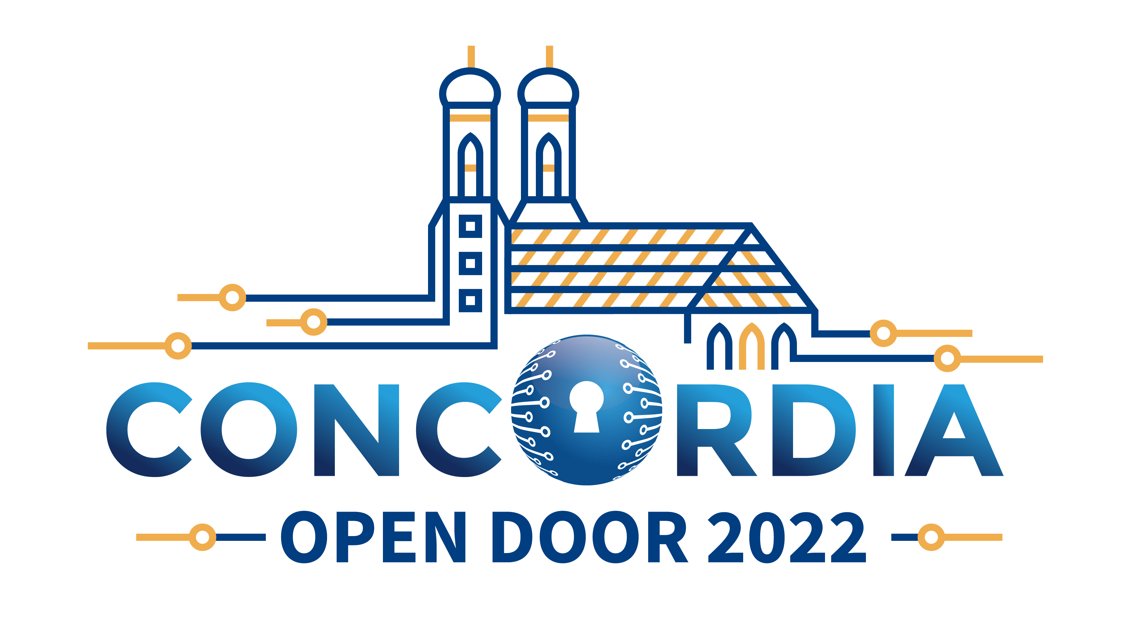

Figure 16: Example of visual for #CONCORDIADelivers Campaign and CONCORDIA Open Door 2022

    - Offline Activities

Offline activities were partly influenced by the COVID-19 situation since the usage of printed materials is usually connected with the event's participants. However, the communication team supported other tasks and prepared documents ready for printing. Specifically, we prepared eight documents that simplified interaction with the CONCORDIA Cybersecurity Roadmap for Europe (https://www.concordia-h2020.eu/roadmap/). We also prepared A manual to design hands-on cybersecurity exercises (https://crp.kypo.muni.cz/news/field_manual). The communication team also supported the organization of the CONCORDIA Open Door Event 2022 with the necessary materials. Finally, we will also prepare a printable brochure for the #CONCORDIADelivers.

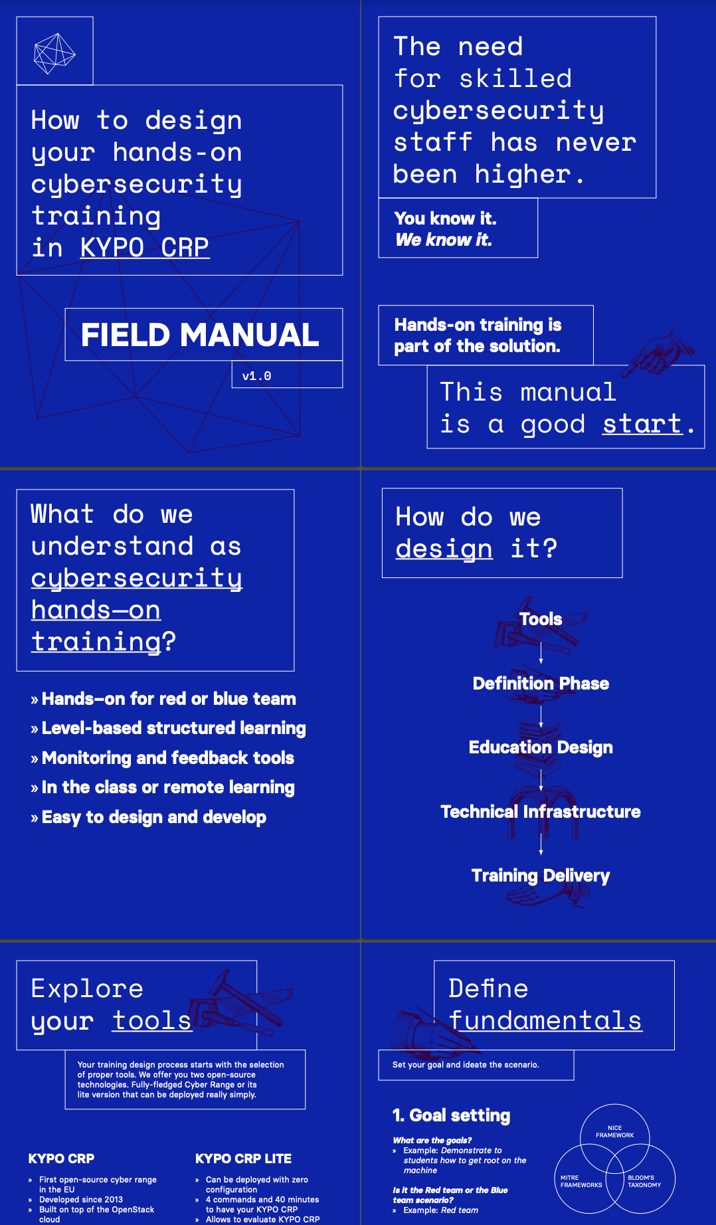

Figure 17: Part of manual to design hands-on cybersecurity exercises

Internal communication

    - Internal communication
Communication group was also focused on internal communication during the last year of the project. We regularly shared any important news with the consortium, and we also maintain dedicated website in Confluence to provide centralized source information about our communication activities. We also provided instructions to make our communication consistent. We also created a manual for preparing CONCORDIDelivers videos. Internal communication activities are also performed in cooperation with task 6.1 (more information is available in deliverable D6.7 Final management report).

    - Dissemination and communication activities performed by other tasks
It is important to highlight those activities which were reported in previous paragraphs are not the only communication and dissemination activities performed by the CONCORDIA project. Communication group (T5.2) leads the communication and dissemination and it is responsible for its coordination and planning. The below table (Table 13) provides an overview of the dissemination and communication activities of other project tasks that are directly involved in communication activities.

Table 13: Dissemination and communication in consortium
Task | Activity
WP1 tasks | Produce scientific papers and deal with dissemination to the scientific community. More information is available in Work Package 1 in Deliverable D1.4.
T5.1 | Deals with communication activities targeted to start-ups. It creates a community mailing list, produces its own newsletter. More information on this is part of the previous chapter in this deliverable.
T4.5 | Focuses on communication activities related to workforce diversity. It produces various types of content, including webinars. Communication group closely cooperates with the task 4.5. More information is available in Deliverable D4.6.
T4.6 | Deals with communication activities targeted to CONCORDIA stakeholders. Among other things, it creates a community mailing list, produces his own newsletter and organizes the CONCORDIA Open Door Event. More information is available in Deliverable D4.10.
T6.1 | Deals with governance of the project which relates to the internal communication activities. More information is available in Deliverable D6.7.

  - Next Steps on Dissemination and Communication

CONCORDIA communication and dissemination activities during the project are divided into five distinctive phases (see the Error! Reference source not found.). The goal of the After-project phase is to ensure that the website will stay alive for at least three (3) years after the completion of the project. The website was iterated to make CONCORDIA outcomes simply accessible as well as a relevant contact person to promote further networking.
The social media channels will also be active because the project results can also be found through those channels and internet search engines. All final campaign communications can be found using the #CONCORDIADelivers hashtag.

Efforts on Certification and Standardization

Objectives of Task (T5.3)

This task focuses on the certification and standardization activities of the project. The objective of the task is to ensure alignment with the technologies to be developed (WP1), as well as the pilots (WP2). To this end, the project monitored continuously the evolving certification, standardization and best practices landscape, in order to timely identify other initiatives that may be linked to the CONCORDIA areas of interest. Within this task (and in collaboration with relevant tasks of WP3 and WP4) initial engagements/liaisons with the respective governing organizations were developed and the achievements resulting from the related WPs were promoted to external stakeholders in the appropriate fora.

Strategy to Achieve Task Objectives

CONCORDIA is a project where different organizations come together to:
- Devise a cybersecurity roadmap to identify powerful research paradigms, to do hands-on experimental validation, prototype and solution development in an agile way to quickly identify successful but also unsuccessful potential product development.
- Develop next-generation cybersecurity solutions by taking a holistic end-to-end data-driven approach from data acquisition, data transport and data usage, and addressing device-centric, network-centric, software- and system-centric, data- and application-centric and user-centric security.
- Develop sector-specific (vertical) and cross-sector (horizontal) industrial pilots with building incubators.

Also, in terms of focus areas, the CONCORDIA project deals with a variety of subjects related to security in devices, network, software, data and users covering various sectors (Telecom, Finance, Transport, E-Health, Aerospace) and services.

Certification is not a one–fits–all practice. For each of the objectives and focus areas, the need for certification must be identified and individually addressed. Moreover, to find the way that Certification fits the needs of the task and solution, the outcomes of this task and solution should have reached a certain level of maturity (such that a certification scheme could have a positive value and recognition to the interested parties).

In order to achieve all the above, the following strategy was devised and followed from the beginning of the project:
Certification:
  - Step C1: Identification of the certification needs per task.
  - Step C2: Design and implementation of related certification activities per relevant task (as identified from step C1).
  - Step C3: Internal and external collaboration to promote the certification task results to stakeholders.
Standardization:
  - Step S1: Mapping the standardization needs for the realization of the project work (explained in further details in Section 4.3.2 on Standardization).
  - Step S2: Identification of standardization potential, contributions, involvement or needs.
  - Step S3: Provision of support for the implementation of step S2 as needed.

In Section 4.2.1, the actions performed regarding the Certification activities are described, in Section 4.2.2, the actions performed regarding the Standardization activities are described, and in Sections 4.3.1 and Section 4.3.2 the results of these actions up to this point, respectively, are described.

Certification
Certification is the third-party attestation related to products, processes, systems, persons or bodies. Whereas attestation, is the issue of a statement, based on a decision following review, that fulfilment of specified requirements has been demonstrated. Depending on the subject of certification, different international standards provide the related best practices (ISO 17021, ISO 17024, ISO 17025, etc.)

Step C1. Identification of the certification needs per task.

As mentioned in the beginning of Section 4.2, the CONCORDIA project addresses a variety of topics and industry sectors. In order to identify the certification needs, (the realization of step C1 mentioned above) an individual approach had to be adopted. This approach consisted of the following activities:
- Individual discussions with different task leaders, in order to identify the certification potential.
- Reviews of all deliverables to be created by the project during this final year of the project.
- Discussions with relevant stakeholders (either within the relevant Observer Group or outside).
- Participation in Cybersecurity Certification Events and Conferences.

From the combination of the collected information from the activities mentioned above, ideas and areas (related to certification) were identified and put forward for discussion with the relevant WP / Task Leaders and Partners of the project.

More information regarding the activities and results of these efforts can be found in Section 4.3.

Standardization
      - Terms and definitions

Before introducing the subject of standardization, it is deemed necessary to provide two simple definitions regarding the terms Standard and Standards Developing Organizations (SDO) in the context of the CONCORDIA project:
- Standard: “A standard (French: Norme, German: Norm) is a technical document designed to be used as a rule, guideline or definition. It is a consensus-built, repeatable way of doing something.”
- SDO: “An SDO is an organization that facilitates the development of standards and publication of standards. SDOs include: National Association of Standardization and Certification (ANCE), ASTM International (ASTM), International Society of Automation (ISA), National Fire Protection Association (NFPA), Underwriters Laboratories (UL), ULC Standards” and various others .
Considering the above definitions, for the CONCORDIA project, some of the types of documents referred to as Standards are :
- International Standards: An International Standard provides rules, guidelines or characteristics for activities or for their results, aimed at achieving the optimum degree of order in a given context. It can take many forms. Apart from product standards, other examples include test methods, codes of practice, guideline standards and management systems standards. In the results of the Standardization subtask described below, such standards are identified from various Standards Development Organizations like International Organization for Standardization (ISO), International Electrotechnical Commission (IEC), Institute of Electrical and Electronics Engineers (IEEE) and others.
- Standards: Documents issued by Standards Development Organizations following their individual procedures. In the results of the Standardization subtask described below, such standards are identified from Standards Development Organizations like Underwriters Laboratories (UL), Society of Automobile Engineers (SAE), ASTM International (ASTM), National Aeronautics and Space Administration (NASA) and others.
- Technical Specifications: A Technical Specification addresses work still under technical development, or where it is believed that there will be a future, but not immediate, possibility of agreement on an International Standard. A Technical Specification is published for immediate use, but it also provides a means to obtain feedback. The aim is that it will eventually be transformed and republished as an International Standard. In the results of the Standardization subtask described below, such specifications are identified from Standards Development Organizations like ISO and IEC.
- Technical Reports: A Technical Report contains information of a different kind from that of the previous publications. It may include data obtained from a survey, for example, or from an informative report, or information of the perceived “state of the art”. In the results of the Standardization subtask described below, such reports are identified from Standards Development Organizations like ISO, IEC and American National Standards Institute (ANSI).
- Guides: Guides give rules, orientation, advice, or recommendations relating to international standardization and conformity assessment. In the results of the Standardization subtask described below, such guides are identified from Standards Development Organizations like IEC and the International Association of Drilling Contractors.
- Special Publications: A type of publication issued by National Institute of Standards and Technology (NIST). Specifically, the SP 800-series reports on the Information Technology Laboratory’s research, guidelines, and outreach efforts in computer security, and its collaborative activities with industry, government, and academic organizations.
- Recommendations: The International Telecommunication Union (ITU) - Radiocommunication Sector (ITU-R) Recommendations constitute a set of international technical standards developed by the Radiocommunication Sector (formerly CCIR) of the ITU. They are the result of studies undertaken by Radiocommunication Study Groups on various subjects. The ITU-R Recommendations are approved by ITU Member States. Their implementation is not mandatory; however, as they are developed by experts from administrations, operators, the industry and other organizations dealing with radiocommunication matters from all over the world, they enjoy a high reputation and are implemented worldwide.

      - Step S1. Mapping the standardization needs for the realization of the project work

As mentioned in the beginning of Section 4.2, the CONCORDIA project addresses a variety of topics and industry sectors. In order to identify the standardization needs, (the realization of step S1 mentioned above) an stepped approach had to be adopted. This approach consisted of the following activities:

- Data Collection
The effort regarding the collection of data on standardization efforts relevant to the CONCORDIA project has started from the first year of the project. Specifically, as described in the three previous reports on exploitation, dissemination, certification and standardization, an annual survey was conducted involving all partners in order to collect the following information, per work package, per task and per partner:
- The key topics that each partner is /or will be involved in during their participation in the project, per Task.
- The standards each Partner is already using for the performance of each Task.
- The standards each Partner is planning on using for the performance of each Task.
- The standardization activities that each Task member is part of.
- Whether some of the outputs and activities could contribute to standardization efforts under development, or where likely candidates to be included in such efforts and
- The interest of partners to participate in specific standardization efforts.

Activities a. – d. were carried out every year, from the beginning of the project. Activities e and f started after the second year of the project.

The results related to standardization related activities are included in Section 4.3.2.

Results on Certification and Standardization

    - Certification
      - Certification of Cybersecurity Skills under Task 3.4

One of the aims of Task T3.4 is to “provide a certification framework for professional courses; going beyond professionals and industry to address the wider society by engaging new generations and “teaching the teacher”. To facilitate the above goals, the need arose for the development of a framework (the CONCORDIA Cybersecurity Skills Certification Framework) in the context of Cybersecurity to ease the process of delivering, obtaining, securing and verifying of certificates for well-defined Cybersecurity skills.

        - The CONCORDIA Cybersecurity Skills Certification Framework

The purpose of the CONCORDIA Cybersecurity Skills Certification Framework is to define the rules under which the relevant Cybersecurity Certification Schemes shall operate. The CONCORDIA Cybersecurity Skills Certification Framework contains the best practices regarding certification in the area of Cybersecurity based on the knowledge and experience of the CONCORDIA partners. An initial version of the framework was produced during the second year of the project. The project partners decided to validate the provisions and requirements of the CONCORDIA Cybersecurity Skills Certification Framework, through the design and subsequent implementation of one Certification Scheme for Cybersecurity Skills. Specifically, it was decided that a Certification Scheme for Cybersecurity Skills would be created and it would be piloted at least 3 times (details regarding the certification scheme’s design and implementation are provided in section 4.3.1.1.2. below).
The results of these pilot applications of the Certification Scheme for Cybersecurity Skills would help in the improvement and validation of the CONCORDIA Cybersecurity Skills Certification Framework.
After the third pilot application of the Certification Scheme for Cybersecurity Skills, the improvements, feedback from the participants and the experience of the project team were combined and a final draft version of the CONCORDIA Cybersecurity Skills Certification Framework was created.
The final draft version of the CONCORDIA Cybersecurity Skills Certification Framework was presented to the ENISA ad-hoc working group on Cybersecurity Skills, during their regular meeting on the 4th of May 2022.
The feedback received was incorporated in the final draft version and the final Version 1.0 of the CONCORDIA Cybersecurity Skills Certification Framework was produced and published in the CONCORDIA website in September 2022. (>…………………………)
Moreover, the CONCORDIA Cybersecurity Skills Certification Framework and relevant implementations and outcomes were presented as case study of the ECSF (the European Cybersecurity Skills Framework) during the 1st ENISA Cybersecurity Skills Conference. The conference tool place in Athens, Greece on the 20th and 21st of September of 2022. The information, agenda and presentations of the conference can be found at: https://www.enisa.europa.eu/events/european-cybersecurity-skills-framework-ecsf-2022/cybersecurity-skills-building-a-cybersecurity-workforce-event-presentations.
The main characteristics of the CONCORDIA Cybersecurity Skills Certification Framework, v1.0 are the following:
- The CONCORDIA Cybersecurity Skills Certification Framework is based on the requirements included in the international standard used by conformity assessment bodies operating certification of persons – ISO 17024.
- The requirements of ISO 17024 are generic and are applicable to any subject. The CONCORDIA team split the requirements of the standard into the basic governing principles and proposed new requirements adapted to the needs of Cybersecurity Skills.
The following figure includes the “cybersecurity skills” requirements proposed by the CONCORDIA Cybersecurity Skills Certification Framework, v1.0.

CONCORDIA Cybersecurity Skills Certification Framework

Impartiality
8 reqs.

Responsiveness
5 reqs.

Confidentiality
8 reqs.

Responsibility
5 reqs.

Competence
18 reqs.
The CONCORDIA Cybersecurity Skills Certification Framework is the a European first and already discussions have taken place with two different projects (REWIRE and CyberSecPro. The aim of the discussions was for them to use the CONCORDIA Cybersecurity Skills Certification Framework, in order to construct their own Cybersecurity skills certification schemes. Especially for the REWIRE project, it has been agreed that the four certification schemes to be developed by the project within 2022, will be based on the CONCORDIA Cybersecurity Skills Certification Framework. The CyberSecPro project has just started so there is an initial agreement but not yet any concrete plans.

        - The development of a Cybersecurity Skills Certification Scheme

As mentioned before, it was decided by the project partners to validate the provisions and requirements of the CONCORDIA Cybersecurity Skills Certification Framework, through the design and subsequent implementation of one Certification Scheme for Cybersecurity Skills. The overall activities that were implemented within this context are depicted below:

- Implementation of a Feasibility study: The purpose of this study was to describe the need that the Certification Scheme would fulfil, to identify existing efforts and to define the exact profile of the proposed certification. The results of this study were included in a document available at the CONCORDIA website (https://www.concordia-h2020.eu/wp-content/uploads/2020/06/CONCORDIA-SkillsFeasibilityStudy-forpublication.pdf.). The document contains an analysis of the market situation, of the available skills frameworks and concludes with the identification of possible gaps in Cybersecurity Skills Certification Schemes.
- Selection of a Cybersecurity Skills Certification Scheme: The feasibility study mentioned above revealed gaps – important cybersecurity roles that were missing (Cybersecurity Skills) Certification Schemes. In order to decide upon which of these roles a Certification Scheme would be created by the CONCORDIA project and analysis and an online survey were conducted. The results of these two actions led the project team to select the role of the Cybersecurity Consultant. Based on the CONCORDIA Cybersecurity Skills Certification Framework, the basis of a certification scheme is the Role Profile, which in the case of the Cybersecurity Consultant had not been formulated before. To create the role profile, an analysis of existing guidance and a specialized workshop was conducted (https://www.concordia-h2020.eu/news/participate-in-the-definition-of-the-european-cybersecurity-consultant-profile/). The combined results of these actions produced a document called “Cybersecurity Consultant Role Profile”.
- Implementation of the Scheme: A certification scheme for skills, based on the international best practices of ISO 17024, comprises of the following documents: The certification scheme, the examination databank, a declaration of honour for the certified professionals and various templates of required documents e.g., certificate, etc. The documents for the Certification Scheme for the Cybersecurity Consultant - C³ by CONCORDIA, (i.e. the certification scheme, the exam databank for the theoretical exam, the activities for the practical exam, the templates for the grading and the certification, the template for the certificate, the notification emails etc) have been completed. The Certification Scheme for the C³ by CONCORDIA can be found at https://www.concordia-h2020.eu/wp-content/uploads/2021/11/Concordia_Certification_SchemeC3_v1.pdf. Since the databank is used actively to support the Certification Scheme no screenshot or other evidence of existence is included in this deliverable.
- Piloting the Certification scheme: The scheme was piloted twice within 2021 and twice within 2022. The objectives of the pilots were to validate the scheme, the operational methods, perform a quality evaluation of the databank, establish the appropriateness of the tools used for the assessment, identify opportunities for improvement and shortcomings and provide feedback on the CONCORDIA Cybersecurity Skills Certification Framework. The fist pilot was implemented during May and June of 2021. This first pilot of the certification scheme was carried out after the completion of the relevant training course (https://www.concordia-h2020.eu/becoming-a-cybersecurity-consultant/). The results of the pilot are included in a Report, which was attached as Annex B of the 3rd year report on exploitation, dissemination, certification and standardization. The rest of the pilots were carried out in November 2021, June 2022 and November 2022. The objectives for piloting the certification scheme remain the same, with the addition that in these iterations, and in order to test the affinity and validity of the certification scheme and process, a number of professionals were allowed to participate event without having completed the relevant CONCORDIA Cybersecurity Consultant Course. Annex B contains statistical information on the participation and results of the various pilot iterations.
- Issuing Certificates: The Certification Scheme for the C³ by CONCORDIA describes the principles and the method through which the relevant Certificates are issued. The contents of the Certificates are aligned with the minimum requirements as set by international standards (e.g., ISO 17024). For the C³ by CONCORDIA Certificates it was decided to store the information of the certificate in the EduCTX based on blockchain technology. EduCTX is a platform for managing students’ micro-credentials (i.e., certificates), which is a solution already proven in pilot based-environment established among multiple academic institutions (e.g., University of Maribor, University of Applied Sciences Bielefeld, University of Sarajevo and soon Brno University of Technology). This system allows for the easy and reliable validation and storage of a given certificate. The responsible partner for this implementation in the context of the CONCORDIA project is the University of Maribor. Annex B contains statistical information on the issued certificates of the various pilot iterations.
- Improvement: After each pilot, a quality review was implemented by the relevant committee described in the Certification Scheme, taking into consideration the results, the feedback of the organizing partners during the implementation of the pilot and the feedback of the participants during the various phases. From this review opportunities for improvement and corrective actions were identified and implemented.

      - CONCORDIA’s Cybersecurity Roadmap for Europe

The activities of Task 4.4 include the realization of the “Cybersecurity Roadmap for Europe by CONCORDIA”. The document was originally presented in its first draft form in 2020. It was agreed that the document will be updated annually based on the current state of play. The final version will be delivered in month 48. More information regarding the roadmap can be found in 2022’s version of D4.4.Y4 deliverable.

The roadmap amongst others, identifies six holistic dimensions of observation, namely (i) Research and Innovation, (ii) Education and Skills, (iii) Legal and Policy, (iv) Economics and Investments, (v) Certification and Standardization and (vi) Community Building.

Especially in the area of Certification, Chapter 8.2., within the year 2022, the roadmap has been updated based on the current information derived from:
- Discussions with relevant stakeholders
- Participation in events and conferences
- Review of new publications
- Discussions within the project team

The relevant chapter of the Roadmap includes:
- An introduction to certification
- A description of challenges faced by Certification
- Short term aims
- Mid term aims
- Long term aims.
- The effect of COVID-19 on Certification

Since the information included in the previous version of the document was gathered until November 2021, the update to the relevant entries was important since a series of developments transpired within 2022. Some of the relevant events and publications are shown in the following list. :

- The ENISA Cybersecurity Certification Conference 2022 was held in June (2nd and 3rd) 2022.
- On the 27th October, ENISA in collaboration with the European Commission organised, for the eighth consecutive year, the Trust Services Forum. On the 28th October, D-TRUST in cooperation with TÜViT and ESMT held the fourteenth CA-Day.
- On the occasion of the official presentation of the European Cybersecurity Skills Framework (ECSF), ENISA hosted a 2-day conference on “Cybersecurity Skills - Building a Cybersecurity Workforce”, during which various communities will present how they are helping to grow the cybersecurity workforce. The conference took place on 20th and 21st of September 2022.
- On the 15th of September 2022, the Commission presented a proposal for a new Cyber Resilience Act to protect consumers and businesses from products with inadequate security features.
- ENISA organized a webinar on Cybersecurity skills - Using the European Cybersecurity Skills Framework to sustain cybersecurity workforce, on the 5th of April 2022.
- On 2-3 December 2021, the EU Agency for Cybersecurity (ENISA) hosted the 2021 edition of the Cybersecurity Certification Conference as a hybrid event, physically organized in Athens, Greece but which could be attended online across the globe. In doing so ENISA responded to broad stakeholders’ demand for updates and information while at the same time enabling active participation on the implementation of the EU Cybersecurity Certification Framework.
- The Rolling Plan 2022 was endorses by members of the European Multi-Stakeholder Platform on ICT standardization and was published on the 27th of April 2022.
- On the 21st of April 2021, COM(2021) 206 final was published. The document contained a Proposal for a Regulation of the European Parliament and of the Council laying down harmonized rules on Artificial Intelligence (Artificial Intelligence Act) and amending certain Union legislative acts.
- On the 30th of June 2022, C(2022) 4388 final was published. The document contained a communication to the Commission on the European Commission digital strategy - Next generation digital Commission.
- On the 28th of November 2022, the European Council has formally adopted the Digital Operational Resilience Act (DORA), which aims to make sure the financial sector in Europe is able to stay resilient through a severe operational disruption. This is the final step in the legislative process.
- On the 13th of May 2022, a political agreement was reached between the European Parliament and EU Member States on the Directive on measures for a high common level of cybersecurity across the Union (NIS 2 Directive) proposed by the Commission in December 2020.
- On the 18th of October 2022, COM(2022) 551 final was issued. The document contains a Proposal for a Council recommendation on a coordinated approach by the Union to strengthen the resilience of critical infrastructure.
- On the 22nd of March 2022, COM(2022) 122 final was issued. The document contains a proposal for a regulation of the European Parliament and of the Council laying down measures for a high common level of cybersecurity at the institutions, bodies, offices and agencies of the Union.

Also, developments have taken place also in the area of Standardization (which is closely linked to Certification) which also helped in shaping the information contained in the Roadmap. (More information on the inputs to standardization can be found in Section 4.3.2.).

      - The Cybersecurity Certification Observers Group

During 2021, the CONCORDIA Certification Group was created.
The objectives behind the creation of the Certification Group were the following:
- review the proposed schemes and certification frameworks,
- provide feedback and
- help in the creation of guidelines for a Cybersecurity Certification framework that covers all other areas (skills, processes, products and services).

In February 2022, the CONCORDIA Certification Group reviewed the CONCORDIA Cybersecurity Skills Certification Framework and provided feedback that was taken into consideration for the creation of the final draft of the CONCORDIA Cybersecurity Skills Certification Framework.

During the meeting of the CONCORDIA Certification Group of the 4th of May 2022, it was decided to discuss, review and provide feedback as a project to the consultation on the Cyber Resilience Act. The consultation was planned to be open until the end of May 2022 and feedback was possible to be provided though a dedicated questionnaire and a file (which could be added as attachment).
The rationale behind this decision was that the proposed CRA touched on subjects related to Cybersecurity Certification and thus are of interest and within the scope of this Group.
After intense collaboration between the project partners, responses to the consultation were extracted as well as a document containing some additional comments on the proposal. The feedback was submitted by the Coordinator of the project and an acknowledgement was received on the 25th of May 2022.

Finally, as part of the provision of feedback on proposed schemes and certification frameworks, a joined workshop between the projects CYRENE and A4CEF and specific experts of the CONCORDIA project on the subject of Cybersecurity Certification of ICT products, processes and services is planned to be implemented latest until early January 2023.

      - CONCORDIA Open Door Event – 2022

On the 26th and 27st of October 2022, the COD2022 took place in Giesecke+Devrient HQ, in Munich, Germany.
On the first day, a panel discussion was held on the subject Education and Skills for European Cybersecurity.
During the discussion, the developments regarding the CONCORDIA Cybersecurity Skills Certification Framework and the Cybersecurity Consultant Certification Scheme were presented. More information can be found at the relevant WP4 deliverable and at the COD2022 microsite.

      - Cross-pilot Activities in the Area of Certification

The following activities have been carried out in collaboration with other pilots.

Activity 1: Certification of Cybersecurity MOOCs
As a result of the CCN group in education, collaboration potential was identified in the field of certification in education. Specifically, after the initial exploratory discussions within the activities of the Cyber Competence network Group for Education, a cooperation potential was identified between two pilots: CONCORDIA and CyberSec4Europe. CyberSec4Europe has created a list of quality assurance criteria for MOOCs with an emphasis on Cybersecurity whereas CONCORDIA has already implemented a certification scheme for Cybersecurity Skills and has created a draft Cybersecurity Certification Framework. Taking these into consideration, the two projects have decided to collaborate in order to implement the following actions:
  - Action 1: Conduct Survey on refined requirements for a Certification Scheme for the MOOC and Cyber ranges needed in Education and Training
  - Action 2: Based on the results of the surveys, decisions regarding the implementation of a joined scheme certification will be taken.
  - Action 3: Design and implement advanced Certification Scheme (if practicable).
The above-mentioned activities have yielded the following results:
  - A survey was designed to collect responses regarding the value of a possible certification scheme for Cybersecurity MOOCs and the relevant criteria that could be included. The survey was launched at the beginning of 2021 and collected responses until the end of May 2021.
  - The provided responses were analysed and initial results and conclusions were drawn.
  - The results and preliminary conclusions were presented in a joint presentation and subsequent publication in the 6th IEEE European Symposium on Security and Privacy, Cybersecurity Certification Workshop.
  - Individual interviews with volunteers were carried out to clarify some of the issues discovered during the analysis of the responses.
  - The results of the interviews were consolidated and a chapter for the book “Cybersecurity Teaching in Higher Education” was created and submitted. The book is expected to be published by Springer.
Annex C of this document contains more information and extracts regarding the relevant effort.

Activity 2: The REWIRE Project
The Cybersecurity Skills Alliance – New Vision for Europe – REWIRE project develops a Blueprint for the Cybersecurity industry and a concrete European Cybersecurity Skills Strategy. It brings together 25 partners from academia and VET, cybersecurity industry, non-cyber industries, certification partners and umbrella organizations. Its work builds upon four pilot projects: CONCORDIA, SPARTA, ECHO, CyberSec4Europe implemented with the support of the European Union’s Horizon 2020 research and innovation programme.
The project includes areas related to certification of skills and will built upon the results of all projects.
Specifically, WP4 Blueprint Toolbox – Tools directly connected to education, training and certification includes the creation of a Cybersecurity Skills Certification Scheme Core, relevant qualification standards and for a sample of Roles, it will provide the piloting of the Schemes and Standards. Finally, the project will provide a Cybersecurity Skills Assessment Recommendation (in relation to the theoretical and practical assessment of cybersecurity skills within a certification activity). On this latter deliverable, collaboration has already started from September 2022 between the CONCORDIA and the REWIRE project. Specifically, the Cybersecurity Skills Assessment Recommendation (Deliverable R4.5.6.) used as a basis the CONCORDIA Cybersecurity Skills Certification Framework and has expanded the requirements for theoretical and practical assessment of skills with further recommendations on methods and proposals on structure. The deliverable is expected to be issued by the end of December 2022.

      - Collaboration Activities with Other Projects

The collaboration with the projects CYRENE and A4CEF is continuing. There is a plan for the implementation of a joint workshop between the projects on the subject of Cybersecurity Certification of ICT products, processes and services. The workshop is planned to be implemented latest until early January 2023.

    - Standardization
      - Standardization Efforts from within the Project

As mentioned in the Section 4.2.2. the project team researched the different existing public and proprietary standards (in their various stages of development) and documented the results in the Sheet Index_Standards of the relevant file that is available on the project’s repository. The objective was to identify standards related to cybersecurity covering various aspects and inform accordingly the partners of the CONCORDIA project. This activity was carried out in the beginning of the project (and the results were included in the previous yearly report) and was repeated this year (and the results are included within this report).

Number of identified:
- Standards Developing Organizations (SDOs): 37
- Standards: 555
- Standards in preparatory stages (Draft, Pending, etc.): 98

The identified standards during this preliminary research covered the area of cybersecurity from various aspects:
- Technical (e.g., Guidelines for Securing Wireless Local Area Networks (WLANs))
- Introductory (e.g., Ships and marine technology--Cyber safety)
- Sector Specific (e.g., Road Vehicles -- Cybersecurity engineering)
- Technology specific (e.g., Securing Manufacturing Industrial Control Systems: Behavioural Anomaly Detection NISTIR 8219), etc.

The inputs of the partners regarding Standardization as described above were consolidated, and one document was created.

Table 16 summarizes the contribution of the partners in various standardization efforts. The table includes the following fields:
Partner: The CONCORDIA partner participating in the identified standardization effort.
SDO: Standards Developing Organization under which the standardization activity is taking place.
Title of committee or standard: The title of the committee or the standard where the partner is involved. It could be a working group, a specific committee or a specific document.
Type of participation: There are different types of participation e.g..,. contributor, follower, editor, co-editor, convener, observer etc. The type of participation depends on the SDO and its relevant processes.

Table 16: Standardization efforts where CONCORDIA partners are participating
Partner | SDO | Title of committee or standard | Type of participation
CAIXA | Cloud Security Alliance (CSA) | Financial Sector WG | Contributor
CAIXA | ENISA | ENISA’s Financial experts Working Group | Member
CAIXA | European Savings and Retail Banking Group | ESBG Cloud Certification Working Group | Member
CAIXA | Financial Services Information Sharing and Analysis Center (FS-ISAC) |  | Member
CAIXA | Payment Security Support Group and Card Fraud Prevention (EPC) |  | Member
Industrial Systems Institute/Research Center ATHENA | Internet Engineering Task Force (IETF) | 6TISCH Working Group RFC draft Zero - Touch Secure Join Connect, 6TiSCH secure minimal architecture | Observer - Provide Possible implementation of the protocol
Jacobs University Bremen | IETF | TEEP | Following WG progress
Jacobs University Bremen | IETF | NETMOD - specification draft-ietf-netmod-rfc6991-bis | Editor
Jacobs University Bremen | IETF | RATS | contribution to WG discussions
Jacobs University Bremen | IETF | SUIT | following WG progress
Jacobs University Bremen | IETF | NETCONF/YANG | contributing to WG documents
Jacobs University Bremen | IETF | TEEP | following WG progress
Jacobs University Bremen | IETF | RATS | contribution to WG discussions
Jacobs University Bremen | IETF | SUIT | following WG progress
Jacobs University Bremen | IETF | NETCONF  /YANG  various revisions (e.g. ipsecme-yang-iptfs, sfc-nsh-integrity, avtcore-multi-party-rtt-mix etc) | contributing to WG documents
Jozef Stefan Institute | IEEE | P2933 | Co-chair  Clinical IoT
Jozef Stefan Institute | RISC-V International | Security Horizontal Committee (security) | Following the relevant activities
Jozef Stefan Institute | RISC-V International | Trusted Execution Environment Task Group (tech-tee) | Following the relevant activities
RISE Research Institutes of Sweden AB | IETF | “Use Cases for Authentication and Authorization in Constrained Environments”. RFC 7744 | Author
RISE Research Institutes of Sweden AB | IETF | “Object Security for Constrained RESTful Environments (OSCORE)”. RFC 8613 | Author
RISE Research Institutes of Sweden AB | IETF | “Group Communication for the Constrained Application Protocol (CoAP)”, draft-ietf-core-groupcomm-bis-07, CoRE Working Group | Author
RISE Research Institutes of Sweden AB | IETF | “Group OSCORE - Secure Group Communication for CoAP”, draft-ietf-core-oscore-groupcomm-16, CoRE Working Group | Author
RISE Research Institutes of Sweden AB | IETF | “Observe Notifications as CoAP Multicast Responses”, draft-ietf-core-observe-multicast-notifications-05, CoRE Working Group | Author
RISE Research Institutes of Sweden AB | IETF | “Profiling EDHOC for CoAP and OSCORE”, draft-ietf-core-oscore-edhoc-05, CoRE Working Group | Author
RISE Research Institutes of Sweden AB | IETF | “ Key Update for OSCORE (KUDOS)”, draft-ietf-core-oscore-key-update-03, CoRE Working Group | Author
RISE Research Institutes of Sweden AB | IETF | “Cacheable OSCORE”, draft-amsuess-core-cachable-oscore-05, CoRE Working Group | Author
RISE Research Institutes of Sweden AB | IETF | “Proxy Operations for CoAP Group Communication”, draft-tiloca-core-groupcomm-proxy-07, CoRE Working Group | Author
RISE Research Institutes of Sweden AB | IETF | “OSCORE-capable Proxies”, draft-tiloca-core-oscore-capable-proxies-04, CoRE Working Group | Author
RISE Research Institutes of Sweden AB | IETF | “Discovery of OSCORE Groups with the CoRE Resource Directory”, draft-tiloca-core-oscore-discovery-12, CoRE Working Group | Author
RISE Research Institutes of Sweden AB | IETF | “Key Provisioning for Group Communication using ACE”, draft-ietf-ace-key-groupcomm-16, ACE Working Group | Author
RISE Research Institutes of Sweden AB | IETF | “Key Management for OSCORE Groups in ACE”, draft-ietf-ace-key-groupcomm-oscore-15, ACE Working Group | Author
RISE Research Institutes of Sweden AB | IETF | “Admin Interface for the OSCORE Group Manager”, draft-ietf-ace-oscore-gm-admin-07, ACE Working Group | Author
RISE Research Institutes of Sweden AB | IETF | “Notification of Revoked Access Tokens in the Authentication and Authorization for Constrained Environments (ACE) Framework”, draft-ietf-ace-revoked-token-notification-03, ACE Working Group | Author
RISE Research Institutes of Sweden AB | IETF | “Ephemeral Diffie-Hellman Over COSE (EDHOC) and Object Security for Constrained Environments (OSCORE) Profile for Authentication and Authorization for Constrained Environments (ACE)”, draft-ietf-ace-edhoc-oscore-profile-00, ACE Working Group | Author
RISE Research Institutes of Sweden AB | IETF | “Group OSCORE Profile of the Authentication and Authorization for Constrained Environments Framework”, draft-tiloca-ace-group-oscore-profile-09, ACE Working Group | Author
RISE Research Institutes of Sweden AB | IETF | “Protecting EST Payloads with OSCORE”, draft-selander-ace-coap-est-oscore-05, ACE Working Group | Author
RISE Research Institutes of Sweden AB | IETF | "EST-coaps: Enrollment over Secure Transport with the Secure Constrained Application Protocol". RFC 9148 | Author
RISE Research Institutes of Sweden AB | IETF | "The Object Security for Constrained RESTful Environments (OSCORE) Profile of the Authentication and Authorization for Constrained Environments (ACE) Framework". RFC 9203 | Author
RISE Research Institutes of Sweden AB | IETF | “CBOR Encoded X.509 Certificates (C509 Certificates)”, draft-ietf-cose-cbor-encoded-cert-04, COSE Working Group | Author
RISE Research Institutes of Sweden AB | IETF | “Traces of EDHOC”, draft-ietf-lake-traces-03, LAKE Working Group | Author
RISE Research Institutes of Sweden AB | IETF | “Use Cases for Authentication and Authorization in Constrained Environments”. RFC 7744 | Author
SIDN | IETF | DNSOP WG | Contributor
SIDN | IRTF | MAPRG | Contributor
Siemens | OASIS | STIX | Member
Siemens | OASIS | OpenC2 TC | Member
Siemens | OASIS | CACAO TC | Member
Telecom Italia (TI) | ETSI | TC CYBER | Observer
Telecom Italia (TI) | GSMA | Fraud and security Architecture Group | Contributor
Telecom Italia (TI) | NGMN | Security Competence Team | Observer
Telefonica I+D | OSM | Open Source MANO | TID leads the initiative and is one of the main contributors
Telefonica I+D | IETF | WG: TEEP, RATS, ACME, I2NSF | Participation
Telefonica I+D | ETSI | NFV ISG | Chair of the Network Operator Council
Telefonica I+D | ETSI | TC CYBER | Active contributions to the TC
Telefonica I+D | 3GPP | SA3, RAN Plenary | Participation
Telefonica I+D | ETSI | SAI | TID is founding member and participant
Telefonica I+D | O-RAN | TSC/EB/WGs | Members of TSC and EB
Telefonica I+D | ETSI | RIS ISG | Participation
Telefonica I+D | ODL | Open Daylight | Telefonica has made several contributions to this open-source SDN framework, and have a position at its Advisory Board
Telefonica I+D | CORD | OpenCORD | TID is a member of the Technical Steering Team for CORD
TÜV TRUST IT | CEN - CENELEC | CEN/CLC/JTC 13 "Cybersecurity and Data Protection"  prEN 17640 | Expert
TÜV TRUST IT | ISO | - ISO/IEC JTC 1/SC 27 "Information security, cybersecurity and privacy protection"  ISO 27017 | Co-editor
TÜV TRUST IT | ISO | - ISO/IEC JTC 1/SC 27 "Information security, cybersecurity and privacy protection"  ISO 27109 | Expert
TÜV TRUST IT | ISO | - ISO/IEC JTC 1/SC 27 "Information security, cybersecurity and privacy protection"  ISO 27001 | Expert
TÜV TRUST IT | ISO | - ISO/IEC JTC 1/SC 27 "Information security, cybersecurity and privacy protection"  ISO 27005 | Expert
Università degli Studi di Milano (UMIL) | CEN/CENELEC CWA | Workshop on "Requirements and Recommendations for Assurance in Cloud  Security (RACS)”. | Contributor
Università degli Studi di Milano (UMIL) | ETSI | Cloud Standard Coordination | Contributor
Università degli Studi di Milano (UMIL) | OASIS | eXtensible Access Control Markup Language (XACML) | Contributor
University of Oslo | OASIS (oasis-open.org) | Open Command and Control (OpenC2) TC | Member
University of Oslo | OASIS (oasis-open.org) | Collaborative Automated Course of Action Operations (CACAO) for Cyber Security TC | Secretary
University of Passau | DKE AK 351.3.7 | Security Anforderungen an signaltechnische Einrichtungen | Member
University of Patras | International Telecommunication Union-T | X.series | Observer, possible contribution

In addition to the above mentioned contributions, the following ones have been identified as standardization related outcomes:

IEEE Access, Volume 10, 2022
Title: Standardizing Smart Contracts.
Authors: Vittorio Capocasale⯐ and Guido Perboli✧
⯐Department of Control and Computer Engineering, Polytechnic University of Turin
✧Department of Management and Production Engineering, Polytechnic University of Turin
Date of publication: 29 August 2022
Digital Object Identifier: 10.1109/ACCESS.2022.3202550
(Note: This publication provides guidelines and insights on the proper management of smart contracts. This work can be a valuable resource for future standards on smart contracts.)

Women Securing the Future with TIPPSS for Connected Healthcare. Women in Engineering and Science. Springer, Cham.
Title: Architecting and Evaluating Cybersecurity in Clinical IoT
Authors: Tanja Pavleska⚪
⚪ Laboratory for Open Systems and Networks, Jožef Stefan Institute, Ljubljana, Slovenia
Date of publication: 31 May 2022
Digital Object Identifier: 10.1007/978-3-030-93592-4_2

Note: this publication relates to the standard P2933 IEEE standard which is in a final stage of publication. The title is “Standard for Clinical Internet of Things (IoT) Data and Device Interoperability with TIPPSS – Trust, Identity, Privacy, Protection, Safety, Security” and more information can be found at https://standards.ieee.org/ieee/2933/7592/.

      - Individual Calls for Contribution

Through the identification of the key topics that each partner is involved or interested in, monitoring of various standardization efforts was performed by the project team. Having the key topics in mind, individual calls for contributions were sent to targeted partners in those cases where an opportunity for contribution was identified.
e.g., PWI ISO 27017 (Information technology — Security techniques — Code of practice for information security controls based on ISO/IEC 27002 for cloud services).
ISO/IEC DIS 27011 (Information security, cybersecurity and privacy protection — Information security controls based on ISO/IEC 27002 for telecommunications organizations)
CEN/WS IPCI "Improvement of information processing in crisis management of critical infrastructures for computer assisted data gathering, display and reporting"

CONCORDIA’s Cybersecurity Roadmap for Europe

As mentioned already in Section 4.3.1.3. one of the six dimensions of “Cybersecurity Roadmap for Europe by CONCORDIA” in related to Certification and Standardization. Information about the contributions to Certification is included in section 4.3.1.3. and in the following paragraphs, information regarding the contributions to Standardization is provided.

Especially in the area of Standardization, within the year 2022, the roadmap has been updated based on the current information derived from:
- Discussions with relevant stakeholders
- Participation in events and conferences
- Review of new publications
- Discussions within the project team
- A contribution by the project AI4HealthSec, on the identified standardization gaps against the requirements of the NIS Directive and the recommendations of the relevant NIS Cooperation Group.

The relevant chapter of the roadmap includes
- An introduction to standardization
- A description of challenges faced by standardization
- Short term aims
- Midterm aims
- Long term aims
- The effect of COVID-19 on Standardization

Since the information included in the previous version of the document was gathered until November 2021, the update to the relevant entries was important since a series of developments transpired within 2022. Some of the relevant events and publications are shown in the following list:

- Joint Communication the EU’s Cybersecurity Strategy for the Digital Decade, JOIN/2020/18 final – 16/12/2021
- On the 15th of September 2022, the Commission presented a proposal for a new Cyber Resilience Act to protect consumers and businesses from products with inadequate security features.
- For the 6th time, the European Standards Organisations CEN, CENELEC and ETSI, joined forces with ENISA, the European Union Agency for Cybersecurity, to bring you a virtual Cybersecurity Standardisation Conference on ‘European Standardisation in support of the EU cybersecurity legislation’. The conference tool place on the 15th of March 2022.
- The Rolling Plan 2022, was endorses by the member of the European Multi-Stakeholder Platform on ICT standardization and was published on the 27th of April 2022.
- On the 2nd of February 2022, COM(2022) 31 was issued. The document was entitled as Communication from the Commission to the European Parliament, the Council, the European Economic and Social Committee and the Committee of the Regions an EU Strategy on Standardisation Setting global standards in support of a resilient, green and digital EU single market.

This list should be looked at in conjunction with the developments reported in 4.3.1.2 on certification.

Conclusions

According to the initial project objectives of Work Package 5, the main goal was to enhance the impact of CONCORDIA’s outcomes through strategic exploitation, together with community building, dissemination, and standardization. In terms of exploitation, WP5 developed and implemented a comprehensive plan that aligned with the partners' commercial and research interests, helping the project reach its objectives and bringing the CONCORDIA partners' cybersecurity-related technology to the EU market. Additionally, WP5 was dedicated to strong dissemination and communication through a variety of tactics and to multiple audiences. The standardization activities within WP5 further increased the impact of CONCORDIA by transferring project results to relevant industry standardization and best practice working groups.

This document is divided into three parts: Exploitation, Dissemination & Communication, and Certification & Standardization. Each part presents the objectives, activities, and results achieved during the fourth year of the project, as well as the impact of the COVID-19 pandemic crisis. The document also outlines the next steps to be taken after the end of the project

During the 4th year CONCORDIA focused on disseminating and communicating the value of the project through the produced content provided by the consortium, as well as the outcome of the collaboration with external stakeholders. The outcomes of the coordinated efforts of the partners have contributed to the strengthing of trust and raising awareness about the project through Concordia's website, videos, and blog posts; social networks; content marketing; events and conferences; communication campaigns, Publicity, CCN communication activities, etc.

The CONCORDIA partners in order to boost CONCORDIA’s deployment of its novel technics and implement profitable business models have reached many incubators and accelerators, identifying 32 exploitable results. Although the pandemic continued during the 4th year, CONCORDIA managed to organize physical meetings like the Open Door 2022. Additionally, the growing communities in social media (Twitter and LinkedIn) continued to demonstrate their ability to build their audience without face-to-face meetings.
Moreover, the certification and standardization activities of CONCORDIA have enabled the transfer of project outcomes to the corresponding industry standardization and best practice working groups.

In conclusion, the strategy, activities, and results for each individual task presented in this report show that the consortium has successfully accomplished all the (KPIs) responding to WP5.

Annex A: Meeting Minutes for June and November 2021 Meetings of ISC

Meeting date: 17.06.2021
Meeting occasion: Internal Strategy Committee Semi-annual meeting (T5.1)
Meeting location: online
Meeting Agenda:
- Introduction
- Discussion on data collected up to mid 2021
- Certification scheme for cybersecurity skills
- Cross pilot collaborations
- Future directions / steps

Participants
Partner organisation
TÜV TRUST IT
SIDN
DFN-CERT
IFAG
Airbus
Bitdefender
CAIXABANK
Telenor
RUAG
ATOS (T5.1 co-leader)
TID (T5.1 co-leader)
Eesy-inno
Flowmon
ERICSSON
CRF

1. Introduction:
- Primary intention of the meeting is to jointly discuss Key Exportable Results (KER)
- The T5.1 leader presented the structure of the new T5.1 (objectives and strategy) and repeated the reasons why ISC exists and what are its roles
  - At the end of 2020, the tasks T3.5 (start-up community building) and T5.1 (exploitation) were merged. In addition, some elements of innovation from WP6 (T6.3) were also introduced. Also, two communities of email lists were merged for efficiency purposes
  - This new task redefined the strategy to align exploitation and innovation.
  - Also, by the end of 2020 (December) there was the first assessment of ERs that was in fact presented to the project review meeting, early 2021
- Each industrial partner has one representative in ISC, currently 23 members. ISC at the same time serves as innovation and exploitation board, established within CONCORDIA. Roles are to find ERs, provide feedback on business model, help with incubators and supporting start-ups, etc.
2. Data collection on Exploitable Results:
- In the last meeting (12/2020), there was a definition of 4 criteria on how to judge ERs across different dimensions:
  - market demand (based on the knowledge of ISC members)
  - innovation potential
  - technical maturity (TRL level)
  - network/community effect (CONCORDIA specific)
- The ISC members shared feedback on possible integration within ERs, e.g., such as in T2.1 and its sub-pilots ERs. The goal would be to accelerate ERs, since industrial partners can give a boost to an ER given their contacts in respective communities and eco-systems/markets.
- The ISC members also provided feedback on synergies or complementarities across Work Packages.
- In Y3 there is a need to accelerate ERs, concretely for pilots to find market uptake, more visibility and find potential users/buyers (which was one of review comments). For that reason, ISC should focus on market readiness level and market desirability.
- The T5.1 leader shared a list of actions for 2021, including new yearly call for ER (as defined methodology in past deliverable) and review of old ERs. Final ranking for 2021 to be done in December at the next meeting of ISC.
- In final year Y4, CONCORDIA should make events to boost ER uptake. This has already been done for the financial pilot / sector: An event was organized in 04/2021 and another one is planned for 12/2021.
- The new ER collection for mid 2021 was performed via email communication and survey collection, following similar process as in Y1 and Y2, but with richer and more detailed features requested per ER.
- Strategies mentioned for promotion of KERs: a) innovation radar and visibility at EC web, b) use of COD 2021 for promoting Concordia results.
- Strategy ideas for community-depended ERs:
  - Scale visibility, CONCORDIA community to promote its results of all partners. Also, consider current market fragmentation in Europe. Organise targeted events for specific regions, or sectors.
  - Link ER initiatives, e.g., with the certification activities.
  - Different national communities (for ECCC) are already created with their own specificities. There should be alignment and CONCORDIA’s help of community management at EU level. This effort may also be related to governance. Community as in a call is ERs, those processes and procedures can be replicated. As example this ISC could be a pilot for what in the future could be some kind of board (advisory) in ECCC.
3. Certification scheme for cybersecurity skills
- An idea for what the industrial community could do for the exploitation of this certification scheme would be, along with T4.6, to create a stakeholder group on certification and promote it in certification bodies.
- As certification has been part of training, there has been already a lot of promotion on the topic.
- It was also promoted in the CCN group and to the other pilots. Maybe industrial partners can also promote it internally, and review the set of skills included in this schema.
- Also, for national authorities, a framework on cybersecurity consultants might be interesting, in cooperation with the EU project REWIRE (https://rewireproject.eu/) which is working on the idea of “cybersecurity officer”.
4. Cross-pilot collaboration:
- There was a contact with SPARTA, who created a platform to manage research assets called RAMP , managed by the University of Luxembourg. This is similar to CONCORDIA’s table for collecting ERs.
- One idea discussed was that in the next version of RAMP, CONCORDIA will get access to this platform to include ERs as assets, with different visibility options: 1) only CONCORDIA partners, 2) across the 4 pilots, 3) outside the pilots.
- CONCORDIA proposed to SPARTA delegates to include in the workflow further steps such as security assessments as a precondition for getting certification or cybersecurity labelling, and also allow search in the platform for partners that will carry out the specific ER or asset.
- SPARTA was open for further ideas and proposals to extend the RAMP platform to be more than just a marketplace. Also, since SPARTA finishes at the end of 2021, a 2nd version of the platform will be available by then (in that 2nd version, RAMP will move away from the initial MISP-based solution, and instead will be more customised for the specific task at hand).
- Overall, it would be good to use the tool for collection and structure of ERs till the end of the year and/or project, and to give the tool a chance within CONCORDIA, since no resources will be needed, and also does not make sense to put effort in building an additional tool. It would also be important for transitioning of the 4 pilot projects’ ERs/assets into international communities. Therefore, it will be an advantage to have one prominent tool for the management of all pilots’ ERs. There was a question of further operational support after SPARTA projects ends. The ISC hopes there will be an opportunity to have a local operational CONCORDIA version, in 2022.
5. Future Directions:
- The ISC discussed the idea of building a future series of seminars, e.g., on how to build a business plan, and how to pitch or demo an ER to investors, how to protect the IP of an ER, maybe summarize some successful ER stories, etc. Some options would be to organize: 1) a 1-day event with several sessions, or 2) a series of sessions (bi-weekly, monthly, etc.). Maybe the ISC could launch a call for seminars within the incubators/accelerators community to get feedback, ideas and interest for participation. Then, the ISC can select suitable proposals.
- The ISC to-dos for next meeting:
  - Raise awareness on ER importance across CONCORDIA partners
  - Push CONCORDIA partners for ER collection
  - Help inexperienced partners (SMEs/start-ups) with the process
  - Consider options for KERs to be demoed in session with 4 pilots

Meeting date: 24.11.2021
Meeting occasion: Internal Strategy Committee Semi-annual meeting (T5.1)
Meeting location: online
Meeting Agenda:
- Intro on ISC for new members
- Update on ECCC CC strategy for Innovation and Exploitation
- Assessment of ER ranking
- Next steps / ideas for strategic direction contributions

Participants
Partner organisation
SIDN
DFN-CERT
IFAG
Airbus
Telenor
RUAG
ATOS (T5.1 co-leader)
TID (T5.1 co-leader)
Eesy-inno
Flowmon
CRF
TI

1. Introduction:
- There was a short introduction on ISC for new members, as they may have lately joined, to get a better overview on ISC function and tasks: ISC meets twice a year, discusses project outputs from the point of view technology, CONCORDIA pilots and their progress with respect of ERs. Performs assessments of ERs, once per year (via surveys) to identify novel ideas, does KER selection, support and promotes top ER candidates, gives guidance in e.g., patentability, business plans, etc.
- Main goals for the new meeting: ECCC-CC updates, ER assessment and raking, key ER identification, and next steps.
2. Updates on ECCC – CC:
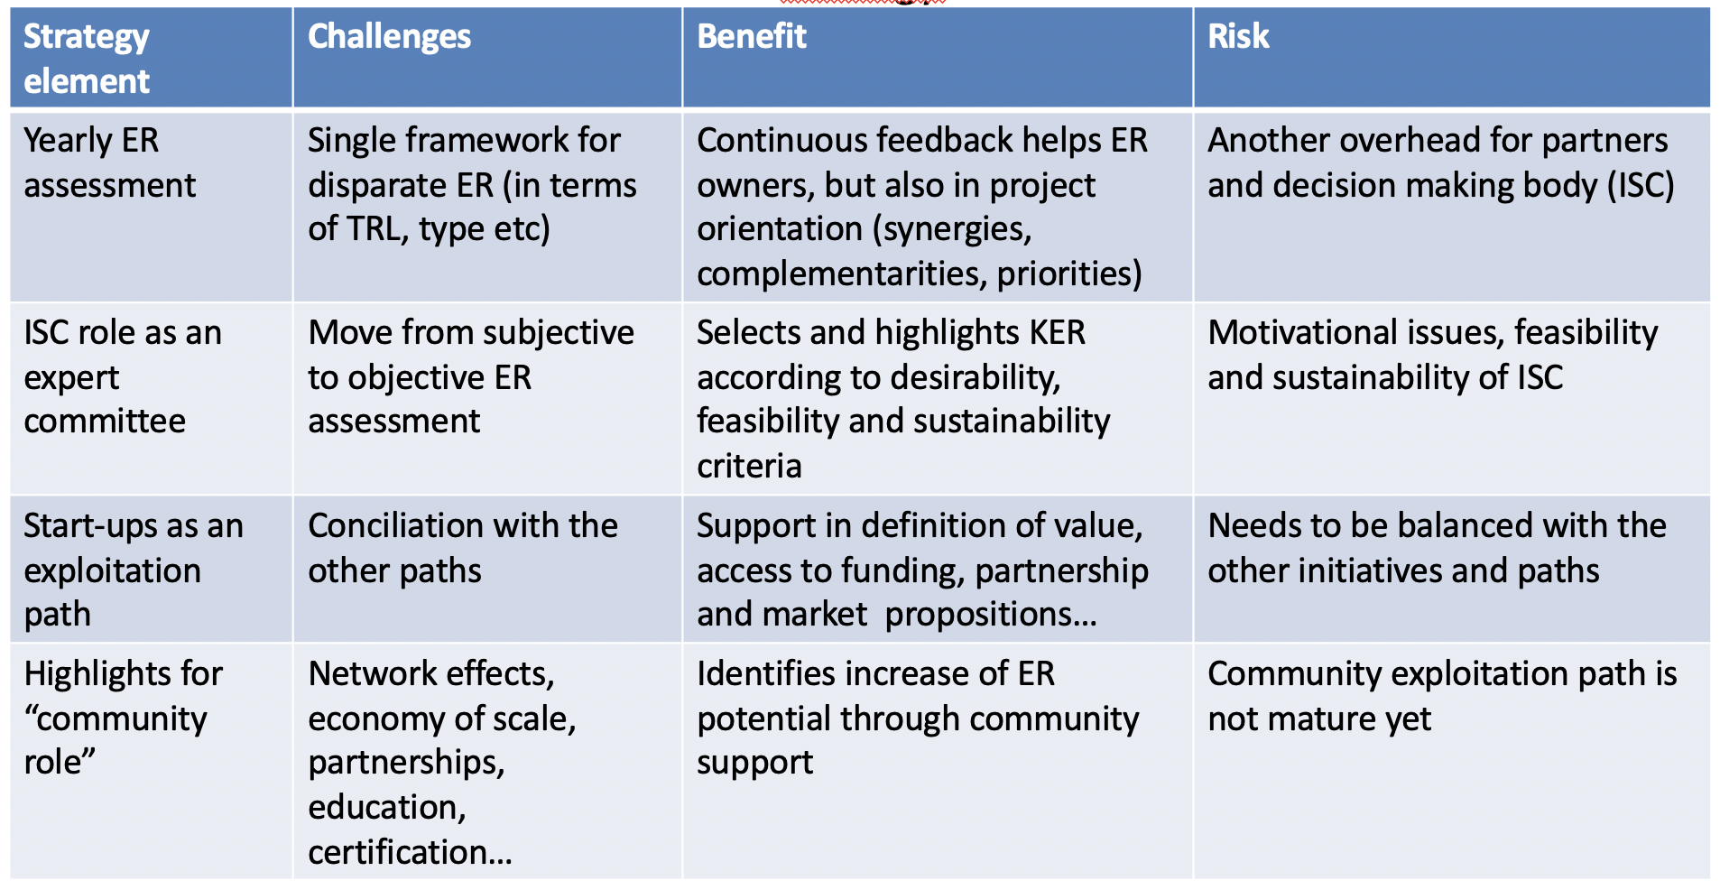
Figure 7: CONCORDIA Strategy on Innovation and Exploitation
- CONCORDIA strategy and its main elements (see Figure 7): ISC foresees yearly ER assessment, single framework for exploitation and innovation. It is important for community to have such priorities in terms of where research and where more market-oriented studies should go.
- Innovation radar or JRC as methodology applied, KYPO won prize in 2021. But still method of Innovation Radar is subjective and based on self-assessment.
- CONCORDIA is the only pilot having this exploitation path for start-ups, and this should be included in ECCC as one of possible exploitation paths for future EU project results.
- CONCORDIA’s community role differs from the other pilots, giving special importance for network effects. It was acknowledged in the last paper of ENISA about ECCC, explicitly mentioning assessment of network effects as issues for future strategic directions of ECCC. In fact, ENISA received more than 400 feedbacks and proposals from the 4 pilots and ECSO, and in fact reduced the 11 strategic directions of ECCC to 8 in its last document draft.
- During a meeting of ENISA, ECCC, ECSO and the 4 pilots, CONCORDIA was represented with members in CCN focus groups on roadmaps, governance and strategy, respectively. Feedback received from the meeting could be included in CONCORDIA’s roadmap, a responsibility that lies within T4.4.
- The ISC also discussed the transition of research to development. That is, in what extend will the ECCC interact in similar initiatives in member states, or structure of organisations existing at universities around Europe for transfer of research. Will the centre duplicate that effort at an EU level?
3. Assessment of ERs / Ranking:
- The ISC discussed the ERs that were collected using the process from last year, i.e., via surveys. The same process was applied for the collection of accelerators and incubators.
- ERs could be tangible or intangible. Partners were asked to submit or resubmit ERs giving the relation to specific defined dimensions. This information was used to do the ranking by the ISC.
- Details of all ERs collected was presented, including summaries on type, technical readiness levels, market focus, etc. (please check Section 2 for these results).
- Current ERs classified in context of technical maturity and envisioned technical maturity (something not done in 2020). Most ERs plan to increase TRL level, which is an encouraging sign. Industry sectors for applications of ERs include telco, finance, operators of digital services, e-health, automotive, any industry sector. (please check Section 2 for these results).
- Next step was to perform selection of ERs, ranking and selection of Key ERs for 2021. Thus, first there was a preselection of ERs, focusing on tangible ERs (software, services) according to a) market readiness, innovation potential, technical maturity and community orientation.
- Then, there was a survey circulated within ISC to perform ER assessment and valuation for ranking.
- Finally, the current ranking of ERs based on the surveys collected was shown and discussed (please check Section 2 for these results).

4. Next steps / ideas for strategic direction contributions
- The ISC needs to analyse the current CONCORDIA roadmap and give feedback related to the ERs and ISC activities.
- Other process activities for last year of the project will include the promotion of Key ERs, definition/collection of business models, their ranking and promotion of suitable business models to accelerators and incubators.
- The ISC needs to remind CONCORDIA partners that it can offer guidance and advice to those partners that are not skilled in handling IPR. Also, CONCORDIA is here to pilot processes for ECCC and should listen to typical problems/requests of partners. Based on these declarations and the experience in this process, the ISC should give future competence centre advice/list of typical issues, e.g., that centers should have contact point for conflict resolution, should have templates for exploitation agreements, legal contact point for patents, etc.
- The ISC will work more intensely on PR actions in 2022 and will take advantage of the CONCORDIA Delivers campaign. The ISC should also engage the incubators and accelerators that CONCORDIA partners have a reach, in order to organize workshops and seminars. The ISC should also facilitate the pitching of Key ERs to the next ISC meeting.
- The ISC also brainstormed on what else can be done with respect to ERs and T5.1. An idea was to perform clustering of ERs based on some dimension. Several directions of possible clustering were discussed such as:
  - Clustering ERs that are ground-breaking
  - Clustering ERs that are just incremental changes of existing technology
  - Mapping ERs to target groups that will be addressed with said ERs, such as consumers (citizens), special industries (business users), public bodies, or cybersecurity professions
  - Clustering ERs together if they support EU main target of Digital Sovereignty or other high-level EC priorities
  - Clustering ERs based in respect to horizontal and vertical industries
- The ISC also discussed the appropriate use of Technological Readiness Level (TRL) and Market Readiness Level (MRL), as used in other EU projects such as Cyberwatching.eu, to assess readiness of ERs to be used in the market. In fact, the ISC may propose to establish Exploitation Readiness Levels (ERL) (See Figure 8) as indicator to assess market maturity. This ERL adaption preliminary idea is to keep levels 6-9 from MRL list and adapt the first five 1-5 levels. KPIs to have an ERL proven are different, but we need to check if there are any existing indicators to reuse.
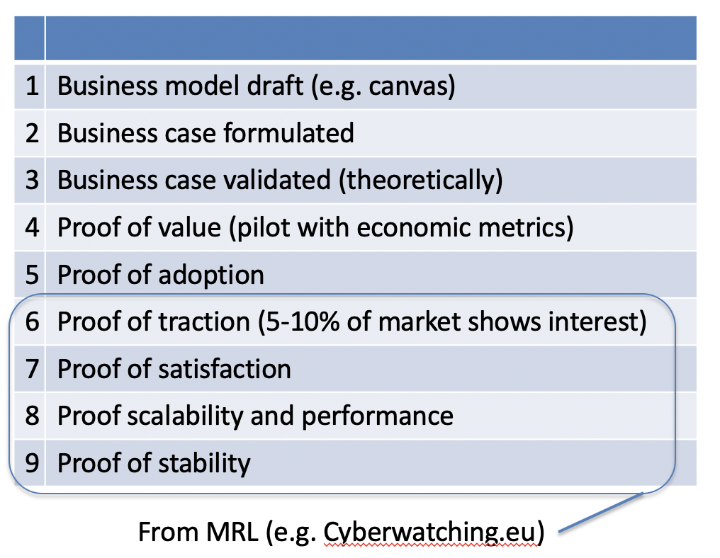
Figure 8: Proposal for Exploitation Readiness Levels (ERLs)

Annex B. Report on Piloting the C³ by CONCORDIA certification scheme – structure and deployment

Table of Contents
1 Introduction 84
1.1 The components of the certification scheme “CError! Bookmark not defined.
1.2 The pilot of the certification scheme “CError! Bookmark not defined.
1.3 The knowledge, skills and abilities 85
2 Preparation for the Exam 86
2.1 Error! Bookmark not defined.
2.2 Error! Bookmark not defined.
2.3 Error! Bookmark not defined.
2.4 Error! Bookmark not defined.
2.5 Error! Bookmark not defined.
2.6 Error! Bookmark not defined.
2.7 The application process 90
3 The implementation of the exam 90
3.1 Exam participants and results 90
3.2 Quality review 93
3.3 Practical exam evaluation 94
3.4 Final results 94
3.5 Feedback 96
Annex A. The C³ by CONCORDIA certification application 97
Annex B. Instructions to the practical exam 99

Introduction

The key component to any certification program is its scheme. The scheme consists of the standards and systems that certification programs use to determine what the requirements are for initial certification, maintenance of certification and re-certification and how individuals are to be assessed against these requirements.
As part of the CONCORDIA Education activities, the need for developing a framework in the context of CONCORDIA Cybersecurity certification was identified. The goal of the Certification Framework is to ease the process of delivering, obtaining, securing and verifying certificates for Cybersecurity skills. This certification Framework defines the principles and requirements of CONCORDIA for Cybersecurity certification.
The certification scheme “C³ by CONCORDIA” [Link] was developed based on the best practices described in the CONCORDIA Certification Framework for Cybersecurity skills. (Please note that the CONCORDIA Certification Framework for Cybersecurity skills has been in preparation and is planned to be published soon, after the completion of the pilot runs of the certification scheme).

The current document presents the model followed for the pilot of the certification scheme “C³ by CONCORDIA”

The components of the certification scheme “C³ by CONCORDIA”
This certification scheme “C³ by CONCORDIA” aims to validate the knowledge, skills and abilities, in other words the relevant competencies, of a Professional acting (or wanting to act as a Cybersecurity Consultant).
The process of defining and validating the profile for the Cybersecurity Consultant is documented in the CONCORDIA Workshop on Education for cybersecurity professionals - post workshop report – [Link]. The implemented profile was expressed in a manner compatible to both the NICE Cybersecurity Workforce Framework taxonomy [Link] and the European e-Competency framework [Link].
The certification scheme “C³ by CONCORDIA” builds upon the information of the Cybersecurity Consultant Role Profile and defines the mechanisms for its validation.
The information contained in the certification scheme “C³ by CONCORDIA” is:
- Scope of certification
- Job and task description
- Required competence
- Abilities
- Prerequisites
- Declaration of Honour
- Criteria for initial certification and recertification
- Examination Committee/ Examiners
- Requirements
- Assessment methods for initial certification and recertification
  - Section A.: Assessment method Theoretical method, written.
  - Section B.: Assessment method Practical method, simulation
- Surveillance methods and criteria
- Criteria for suspending and withdrawing certification
- Storing and Validating certificate information

The pilot of the certification scheme “C³ by CONCORDIA”
In order to test the best practices proposed by the CONCORDIA certification framework and the processes defined in the certification scheme “C³ by CONCORDIA”, a pilot examination was designed and implemented.
For the implementation of this pilot, the following assumptions were made.

The knowledge, skills and abilities
Due to the maturity of the framework, the project team selected to construct the curriculum based on the NICE Cybersecurity Workforce Framework taxonomy, although it identified 73 Knowledge and 38 Skills requirements.
Since Role Profile was identified at a medium level and keeping in mind the constraints of the examination mechanisms, the knowledge and skills requirements were prioritized based on their importance during the relevant workshop [Link].
The remaining, most important, knowledge, skills and abilities were aggregated and grouped under three main learning objectives:

- Threats – Get updated on the existing and emerging cybersecurity threats, the assets possible to be impacted, and the latest models of attacks.
- Technology – Become knowledgeable about specific technological threats, learn how to anticipate and prevent them, while developing proactive management skills.
- Economics – Get an understanding of the economics behind cybersecurity activities within your organization. Learn about risk management and information security to protect the corporate reputation and preserve customer loyalty.

The following Figure B1, depicts the knowledge and skills covered by the Cybersecurity Consultant role profile to be covered by the relevant certification scheme.

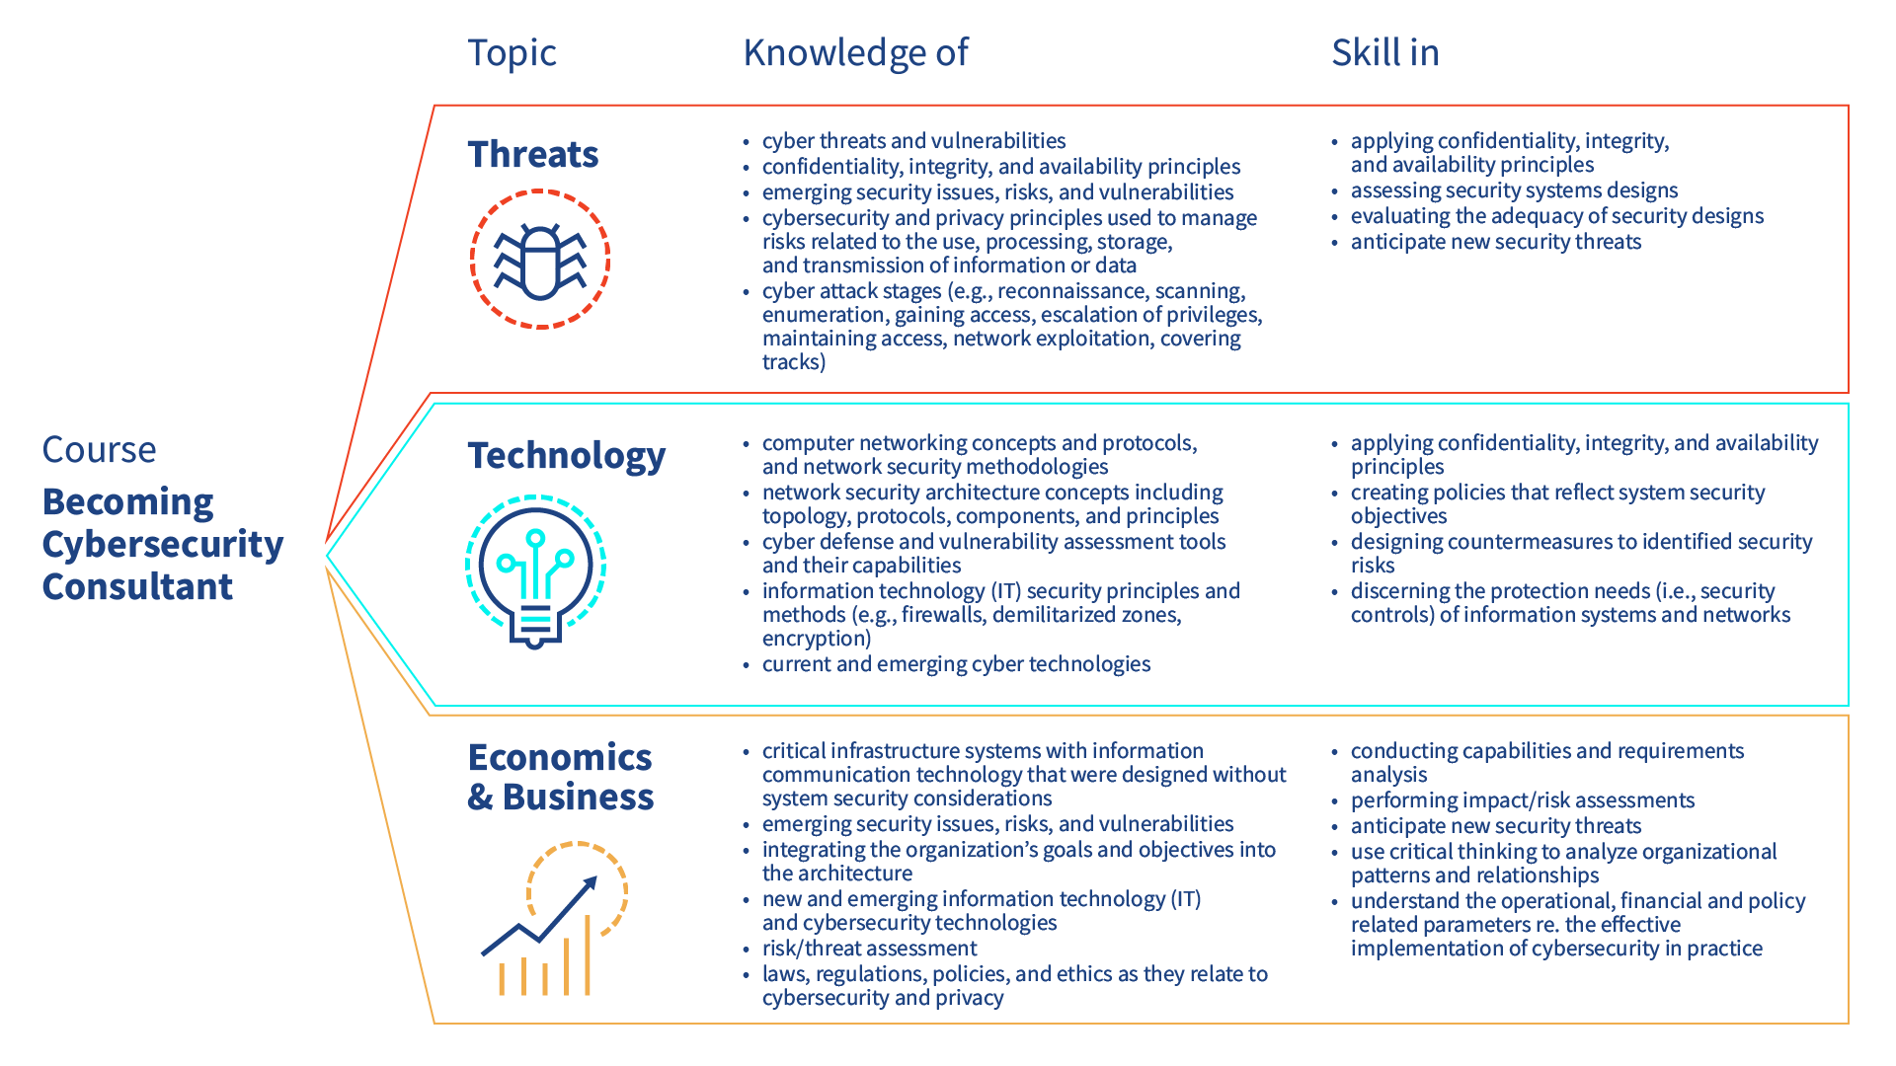Figure B1: List of Knowledge and Skills addressed under the 3 main learning Objectives.

To make sure that the produced certificate correctly reflects the level of knowledge, skills and abilities of the Cybersecurity Consultant, a set of prerequisites has been defined. Specifically, candidates for the “C³ by CONCORDIA” certificate, should already have a basic knowledge on several of the areas mentioned above. The analysis of the pre-requisites is provided in the certification scheme “C³ by CONCORDIA” [Link].

Preparation for the Exam
As mentioned in the “C³ by CONCORDIA” certification scheme, the examination is split into two sections. Section A is a theoretical multiple-choice exam, run through a specialized platform and Section B is a practical simulation like exam, ran through two separate specialized platforms.
Prior to the implementation of the pilot exam, and in order to facilitate the two sections of the exam the following steps were implemented:

Section A.1: Assessment method Theoretical method, written.
A databank of multiple-choice questions was created. The partners involved in the effort to create the databank are presented at the end of the section. The databank contains 170 questions covering content from learning objectives and formulated as to reflect all three levels of difficulty.
The level “Easy” represents questions that are related to theoretical knowledge on basic concepts and principles of the related subject. The level “Medium” represents questions that build on the theoretical knowledge of the previous questions a deeper understanding of the subject in question. Finally, the level “High” represents questions that exercise critical thinking and require deep understanding of the subject in question.
The following table B1, depicts the distribution of the questions based on their learning objective and difficulty.

Table B1: Distribution of the questions based on their learning objective and difficulty

Categories | Number of Questions | Questions per LO | Questions per Dif. Level
LO1 | 60 | 35,29%
Easy | 19 |  | 31,67%
Medium | 26 |  | 43,33%
High | 15 |  | 25,00%
LO2 | 54 | 31,76%
Easy | 18 |  | 33,33%
Medium | 24 |  | 44,44%
High | 12 |  | 22,22%
LO3 | 56 | 32,94%
Easy | 20 |  | 35,71%
Medium | 24 |  | 42,86%
High | 12 |  | 21,43%
Total | 170 | 100,00% | 100,00%

Based on the decision of the project team, all multiple answer questions followed the same format, meaning that in every case, for each question, 4 possible answers were proposed, only one of which was correct (single choice).
The activity was coordinated by EIT Digital and TÜV Trust IT GmbH, member of the TÜV Austria Group, and received substantial support in all its phases, from design to implementation, from CONCORDIA academic and industry partners: University of Milan, Italy; University of Loraine, France; University of Zurich, Switzerland; The Industrial System Institute Greece, University of Insubria, Italy; BITDEFENDER, Romania; Arthur’s Legal, The Netherlands.

Section A.2: The assessment platform.
For the implementation of the theoretical exam, the project partners performed a market survey and selected the company (and platform) ISOGRAD.
The criteria that needed to be met for the selection of the platform were the following, as derived from the principles of the relevant CONCORDIA certification framework and scheme:

- Online. The platform has to be available 24x7 for the period that the examination is active for the participants.
- Proctored. The platform or the system should have the ability either automatically or manually to monitor the activity of the participant, in order to identify and prohibit foul play.
- Random. The platform should have the ability to construct the examination by selecting questions randomly from the databank. Each participant should not undertake the same (100%) exam. The selection of the questions from the databank should be governed by a specific algorithm related to the LO and the difficulty level.
- Interactive. The platform should provide interactive messages to the participant, in case that a problem or an issue has been identified during the session.
- Results. Provisional results should be shown at the end of the examination attempt.
- Timed. The platform should have the ability to monitor the time spent per question and overall, for each attempt. Each examination attempt will only be allowed to be taken once and will only have a specific – predetermined – duration.
- Confidentiality. The information and performance of the candidates should remain confidential. Specific measures to guarantee confidentiality should be implemented throughout the entire process.
- Privacy. The personal information of all subjects should be protected in accordance with current European regulation and legislation.

Section A.3: Preparing the exam
Followingly, the ISOGRAD system was customized based on the specifications of the certification scheme “C³ by CONCORDIA”.
Specifically, all 170 questions and possible answers were inserted, and the following rules were implemented:

- The total number of questions per examination should be 50.
- The questions shall be selected from each learning objective identified the databank and from all difficulty levels following at least the percentage of selection (30% Low - 50% Medium- 20% High).
- All learning objectives will be equally covered.
- A candidate will need to score of 70% or more in order to pass this section of the exam.
- A candidate will need to score of 60% or more per Learning Objective in order to pass this section of the exam.
- Each question is awarded one mark. No negative marking is applicable.

After the questions were inserted and the rules implemented, tests were carried out by four members (EIT Digital, TÜV TRUST IT, University of Insubria and University of Zurich), of the CONCORDIA project team between the 6th of May to the 13th of May 2021.
Identified issues or improvements were communicated to the ISOGRAD team and corrections and corrective actions were implemented.
Specific texts for the introduction to the exam and the environment and for the announcement of the results were created and implemented in the system.

Section B.1: Assessment method Practical method, interactive simulation.
The practical exam involved the creation of a scenario implemented through two different platforms:

- KYPO - https://www.concordia-h2020.eu/kypo-cyber-range/
- Mooncloud - https://www.moon-cloud.eu/en/

The implemented scenario aimed to assess and validate skills and abilities of the participants within the following domains:

- Risk assessment
- Threat identification
- Vulnerabilities
- Source code analysis
- Penetration testing
- Cybersecurity Economics

These topics were selected by the project team taking into consideration the Learning Objectives presented above, the available resources, the restrictions of current solutions and the restrictions imposed by the current COVID-19 pandemic crisis.

Section B.2: The assessment platforms.
The criteria that needed to be met for the selection of the platforms for the practical part of the exam were the following, as derived from the principles of the relevant CONCORDIA certification framework and scheme:

- Online. The platform has to be available 24x7 for the period that the examination is active for the participants.
- Hands-on. The platform should provide the ability for the candidates to exercise and validate their skills and abilities in a practical manner.
- Interactive. The platform should provide interactive messages to the participant, in case that a problem or an issue has been identified during the session. Moreover, the platform should allow where possible the provision of hints, so that the process could continue. Each hint should have a specific penalty when used.
- Results. The results should be shown at the end of the examination attempt.
- Timed. The platform should have the ability to monitor the time spent per question and overall, for each attempt. Each examination attempt will only be allowed to be taken once and will only have a specific – predetermined – duration.
- Confidentiality. The information and performance of the candidates should remain confidential. Specific measures to guarantee confidentiality should be implemented throughout the entire process.
- Privacy. The personal information of all subjects should be protected in accordance with current European regulation and legislation.

Section B.3: Preparing the exam.
The project team decided to incorporate all topics to be exercised and validated in one comprehensive scenario. The scenario contained a number of virtual appliances which were implemented in the platforms. Tasks were created in each platform and a system for grading the attempts was created. Due to the nature of the platforms, no automatic grading was possible. Each attempt was manually reviewed and graded after completion. (The reasoning for the manual grading was the following: The attempt included the creation of zones and targets, executing evaluations and registering targets. Since the effort consists of multiple steps and not just an end result, the grading had to be performed manually, taking into consideration the implementation of all the correct steps).
A document containing instructions for the participants was created.

The activity was coordinated by EIT Digital and TÜV Trust IT GmbH, member of the TÜV Austria Group, and received substantial support in all its phases, from design to implementation, from CONCORDIA academic and industry partners: University of Milan, Italy; University of Loraine, France; University of Zurich, Switzerland; The Industrial System Institute Greece, University of Insubria, Italy; BITDEFENDER, Romania; Arthur’s Legal, The Netherlands.

The application process

An application for the C³ by CONCORDIA certification exam was created and dispatched on the 25th of May 2021 to all participants of the Cybersecurity Consultant course which successfully attended both the online and live webinar modules of the course.
The Application is contained within Annex A of this document.
The received applications were reviewed by the project team in relation to the certification scheme acceptance criteria.
An acceptance email was sent to the relevant participants, providing information on the timeline of the examination.

Figure B2: Acceptance email was sent to the relevant participants, providing information on the timeline of the examination

The implementation of the exam

Exam participants and results
The number of submitted and accepted applications was ten (10).
The candidates were invited via email to participate in the theoretical part of the exam. The period that the exam could be undertaken through the ISOGRAD platform was June 1st – June 14th 2021.
Each participant had the opportunity to select the desired timeslot to undertake the exam, based on her/his preference.
All participants were given access to the ISOGRAD platform and manual.
All ten candidates participated in the theoretical exam.
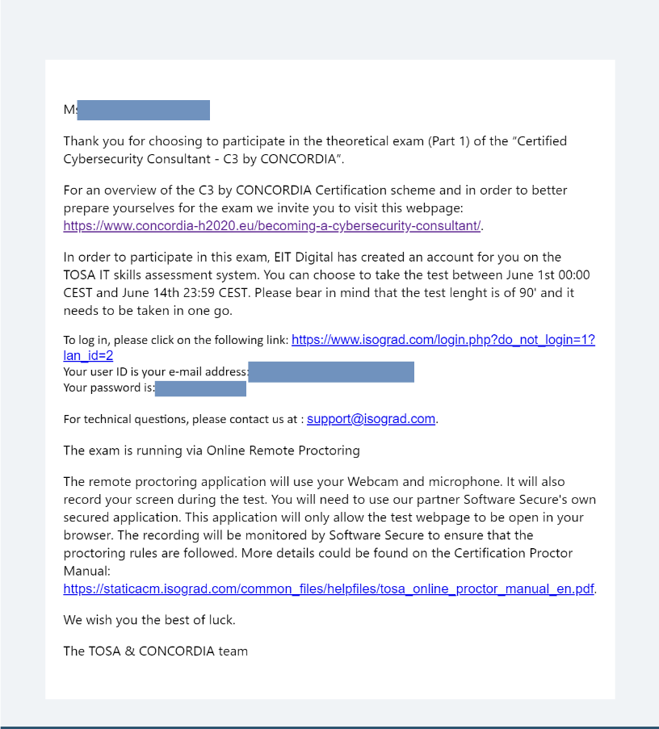
Figure B3: Invitation for the participation in the theoretical exam though the ISOGRAD system

The ISOGRAD platform utilizes an AI assisted proctoring system. The recordings and issues identified during the exam are reviewed within a period of 10 days after the implementation of the exam.
An analysis of the result is displayed to the candidate after the completion of the test, but a specific text was crafted to inform them that this would not be the final results as the review and quality review is pending.
The average score for people that passed the theoretical exam was 79.5% and the Average score for people that failed the theoretical exam was 70.5% (this is above 70% which is the threshold but, in these cases, the candidates did not achieve the minimum 60% in all sections).

For the practical part of the exam, the candidates were informed via email about the time that the platform will remain open. The period that the exam could be undertaken through the Moon Cloud and KYPO Cyber Range platform was June 1st – June 14th 2021. Attached to the informative email were relevant instructions for conducting the exams.

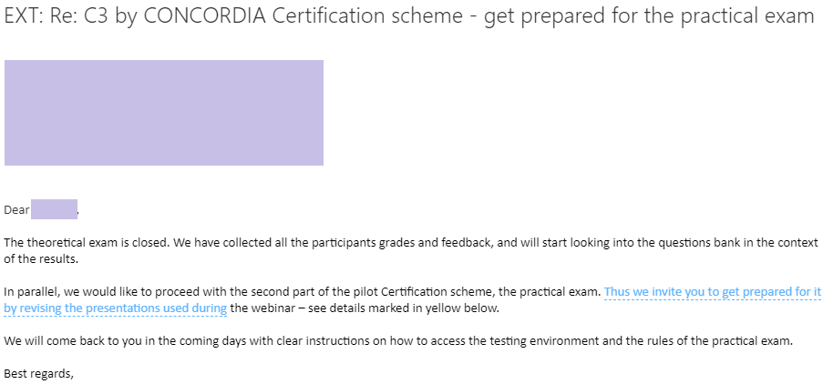
Figure B4: Invitation to participate in the practical exam part 1

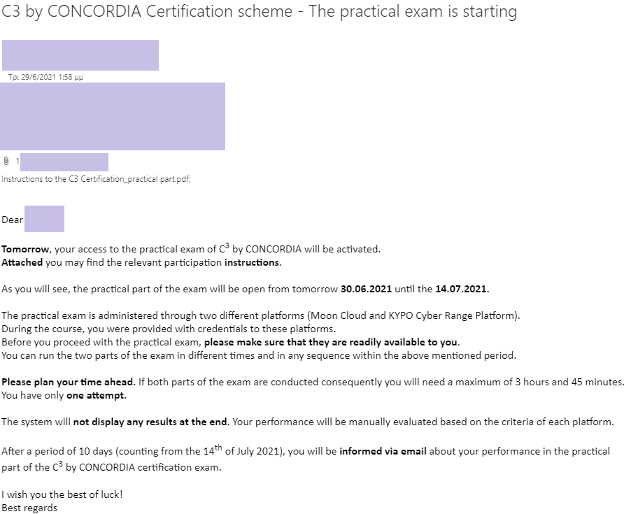
Figure B5: Invitation to participate in the practical exam part 2

The number of participants in the practical exams was 7 (out of a total of 10 applications).
KYPO CRP uses a level-based approach combining hands-on exercises with tests (single/multiple choice).
The relevant tests were evaluated with no negative points. The hands-on exercise allows 5 attempts for the correct answer. After that solution is displayed and candidate gets 0 points for the exercise.
The scoring of the activities on the Moon Cloud platform, were based on the implementation of specific tasks and on the provision of the relevant responses to questions posed in an online document.

Quality review
A quality review was performed on the questions that participated in the theoretical exam based on the performance of the candidates and their comments in the feedback section.
The quality review was carried out by TÜV TRUST IT GmbH and EIT Digital.
As it can be seen in the Table A2 below, a number of questions were not answered correctly by any of the candidates, indicating in most cases that the questions should at least be revisited and if needed be corrected / improved or replaced.

ID | QUESTION | OCCURANCE | SUCCESS | DIFFICULTY
CYBEN0010 | Question 10 | 1 | 0% | High
CYBEN0012 | Question 12 | 1 | 0% | High
CYBEN0051 | Question 51 | 1 | 0% | High
CYBEN0080 | Question 80 | 1 | 0% | Easy
CYBEN0133 | Question 133 | 1 | 0% | High
CYBEN0167 | Question 167 | 1 | 0% | Medium
CYBEN0040 | Question 40 | 2 | 0% | High
CYBEN0113 | Question 113 | 2 | 0% | High
CYBEN0106 | Question 106 | 3 | 0% | Easy
CYBEN0163 | Question 163 | 3 | 0% | Easy
CYBEN0059 | Question 59 | 4 | 0% | High
CYBEN0123 | Question 123 | 4 | 0% | Medium
CYBEN0154 | Question 154 | 4 | 0% | Easy
CYBEN0019 | Question 19 | 5 | 0% | Medium
CYBEN0121 | Question 121 | 5 | 0% | Medium
CYBEN0168 | Question 168 | 5 | 0% | Medium
CYBEN0107 | Question 107 | 6 | 0% | Easy
CYBEN0155 | Question 155 | 6 | 0% | Easy
Table B2: Questions rejected as a result of the quality review

The questions with the worst performance (e.g., 0% success in multiple occurrences) were not taken into consideration in the overall score of the participants and are now reviewed by the applicable parties.
The provisional results of the theoretical exams were re-evaluated after the completion of the quality review and the final score for this part of the exam was derived per candidate. The number of candidates that passed the theoretical exam after the quality review was eight (8).

Practical exam evaluation
After the time period of the practical exam had elapsed, the evaluation process started.
The evaluation responsible for each platform (KYPO and MoonCloud) was contacted and carried out the appropriate evaluation and scoring of the respective attempts taking into consideration the following:

- The correct completion of each prescribed action and
- The duration of each attempt.

All of the participants passed the practical exams. The Average score for people that passed the practical exam was 90%.

Final results
After the completion of the theoretical and practical exams, the participants were informed via email about their performance in the exams.

Six (6) of the participants successfully passed the C³ by CONCORDIA PILOT certification exam.
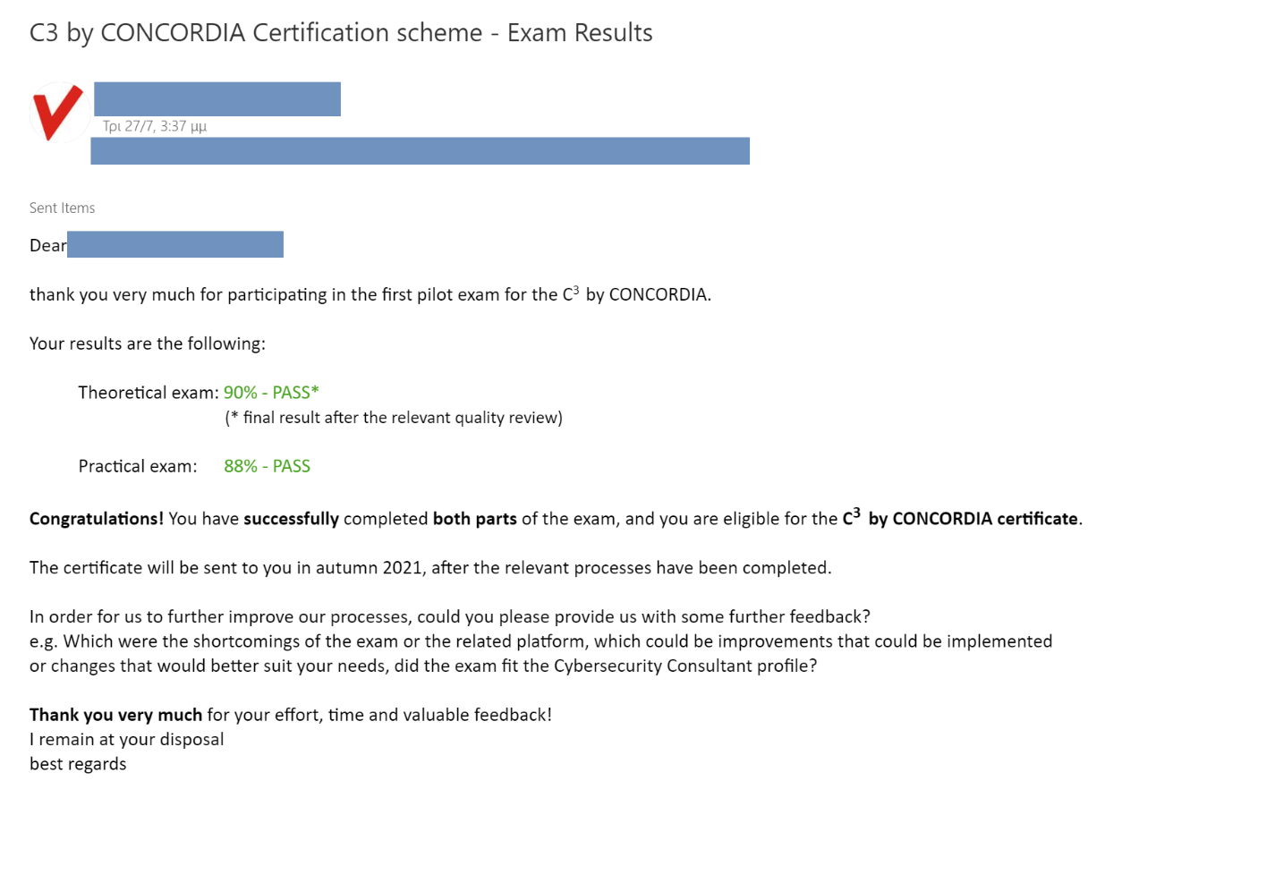
Figure B6: Communication of the results to the participants

Feedback
At the end of the exam, all participants were given the opportunity to send their comments and observations via email. All comments were collected and recorded.
The received comments can be split in the following categories:
- General comments – 3 comments
- Theoretical Exams comments – 2 comments
- Practical Exams comments – 8 comments
- Questions Related comments – 2 comments

The comments and other feedback will be reviewed by the applicable partners and improvements will be implemented prior to the next iteration of the C³ by CONCORDIA Certification exam.

Annex BA. The C³ by CONCORDIA certification application

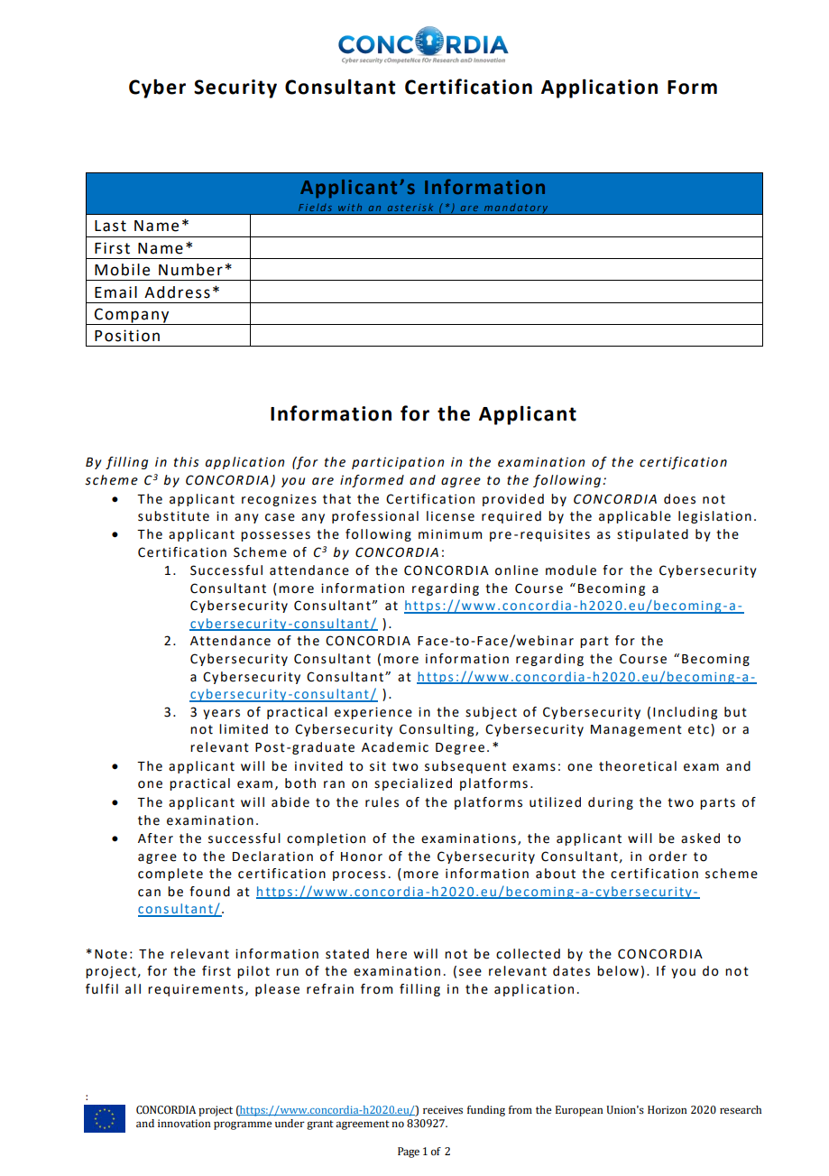

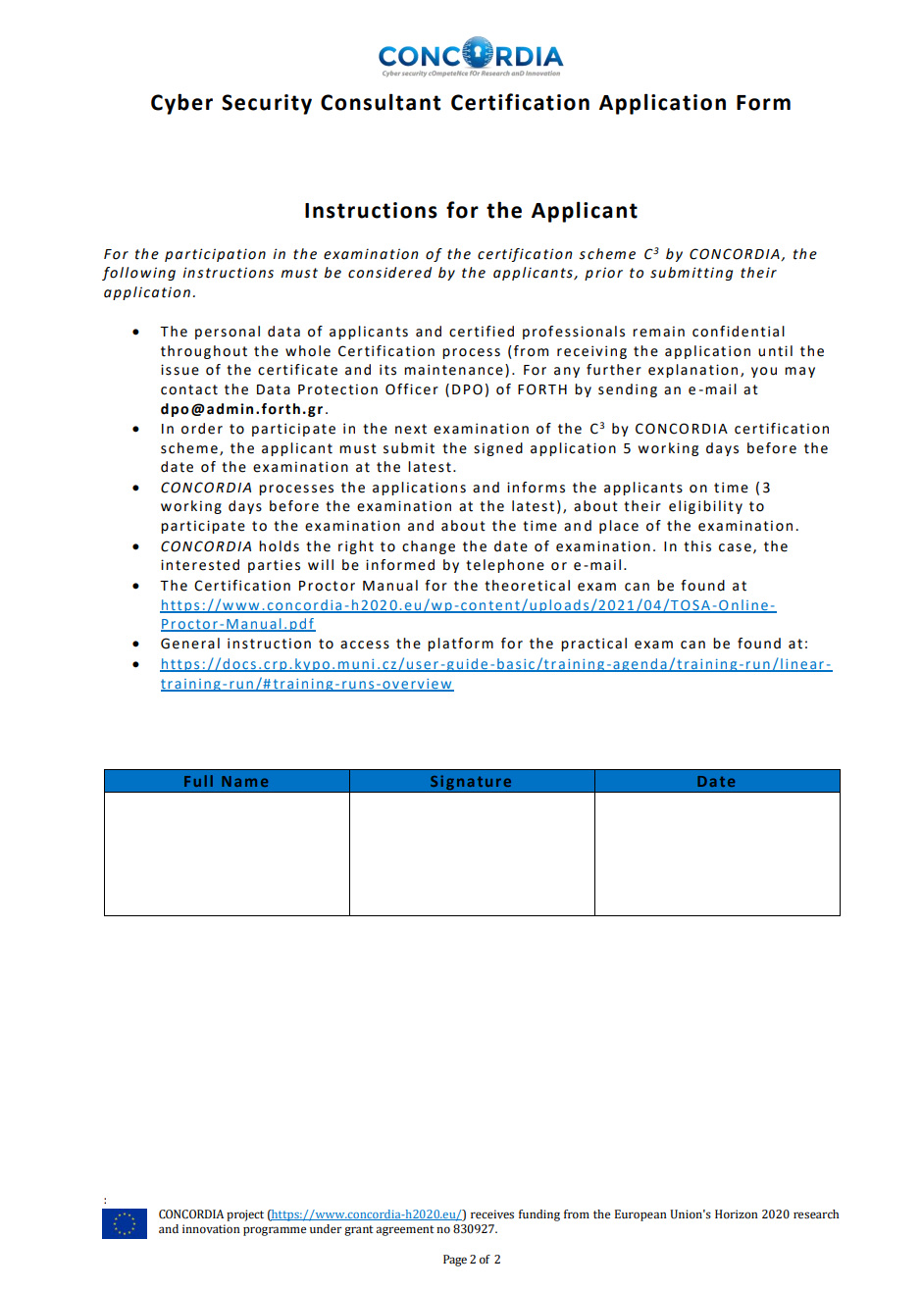

Annex BB. Instructions to the practical exam
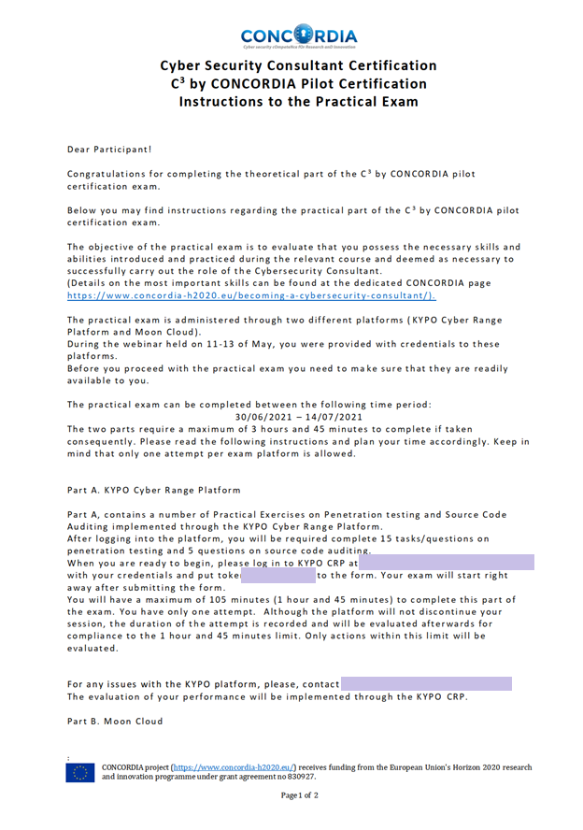

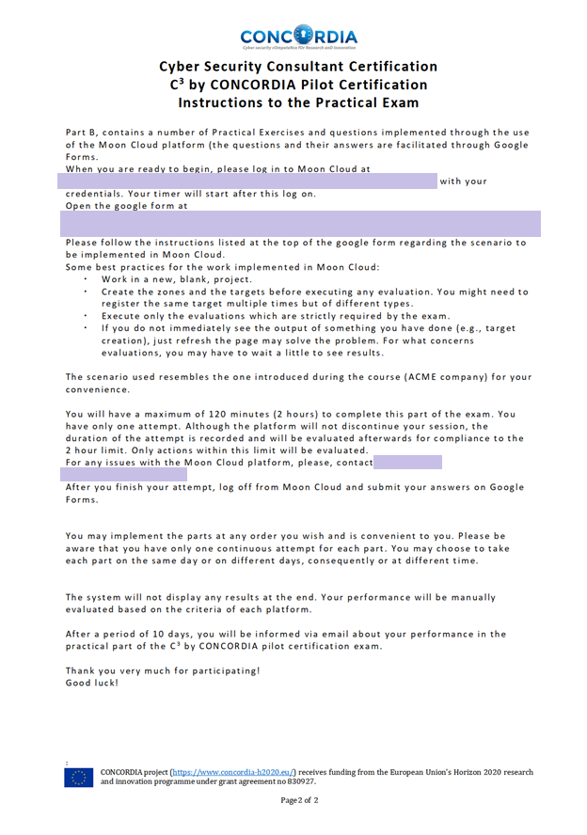

Annex C. Cybersecurity MOOC Certification Information

CONCORDIA and CyberSec4Europe projects collaborated in order to provide initial answers to the following questions:

RQ1: How do (cybersecurity) MOOC stakeholders value a certificate as a selection criterion and what should such a certificate convey?
RQ2: What challenges have current (cybersecurity) MOOC stakeholders experienced?
RQ3: What quality criteria do stakeholders want to be included in a certification scheme for addressing such challenges?

For answering the above-mentioned questions an online survey was conducted. Approval for this study was provided by one of the Ethical Advisors at Karlstad University. Survey participation was voluntary. The survey was announced in January and February 2021 via various cybersecurity mailing lists, and was thus addressing cybersecurity experts.

3.1. Study design
The online survey questions are based on a selection of MOOC quality criteria, which were published in a relevant publication, structured in categories and further processed in order to better address the objectives / questions.
The survey consisted of 72 Questions in total structured as shown in the following table:
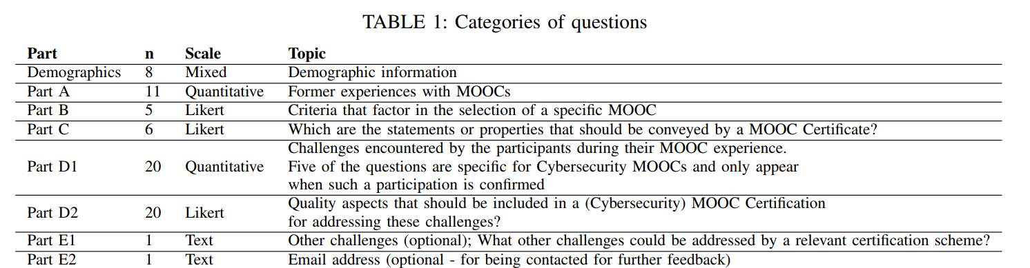

The results and conclusions drawn from the survey are included in the relevant publication¹⁶, and are also mentioned in section 4.3.1.2. Activity 1.

Figure C1: Screenshot of the first page / introduction of the survey
Figure C2: Screenshot of the announcement of the Survey outside the projects

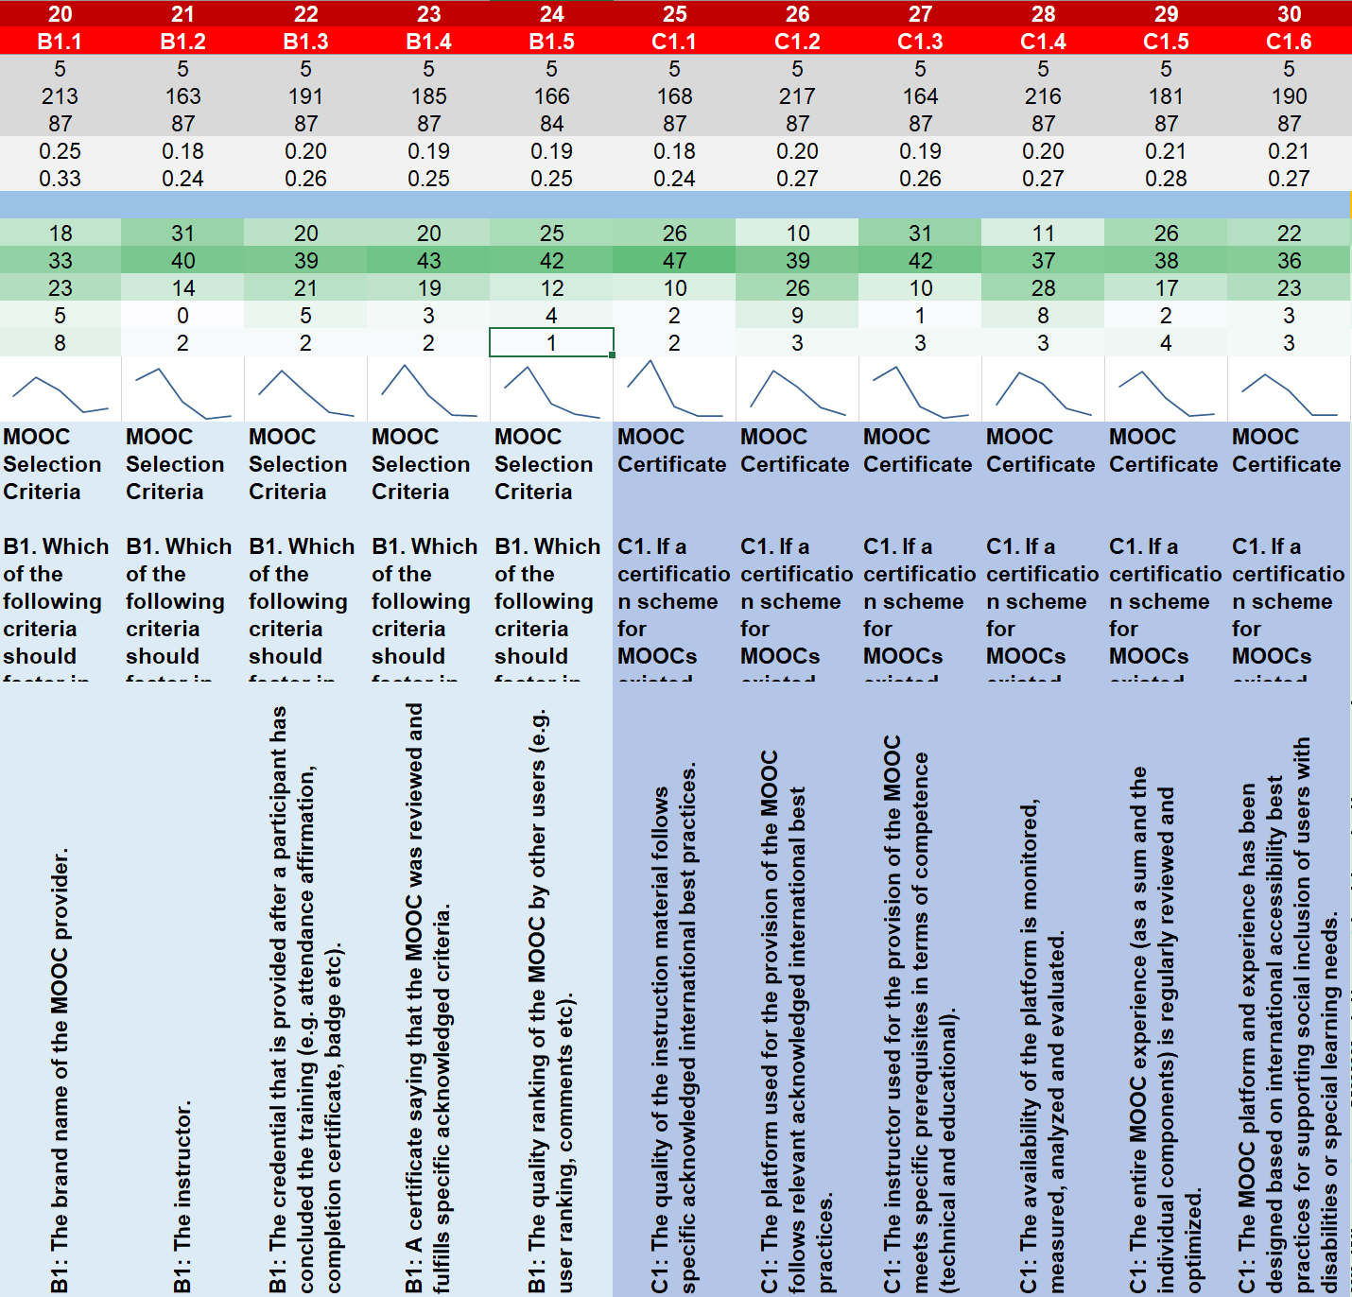
Figure C3: Screenshot of the analysis of raw data of the Survey

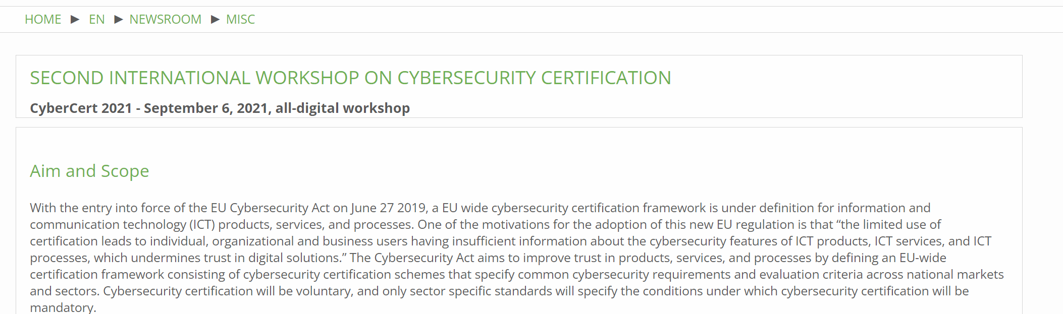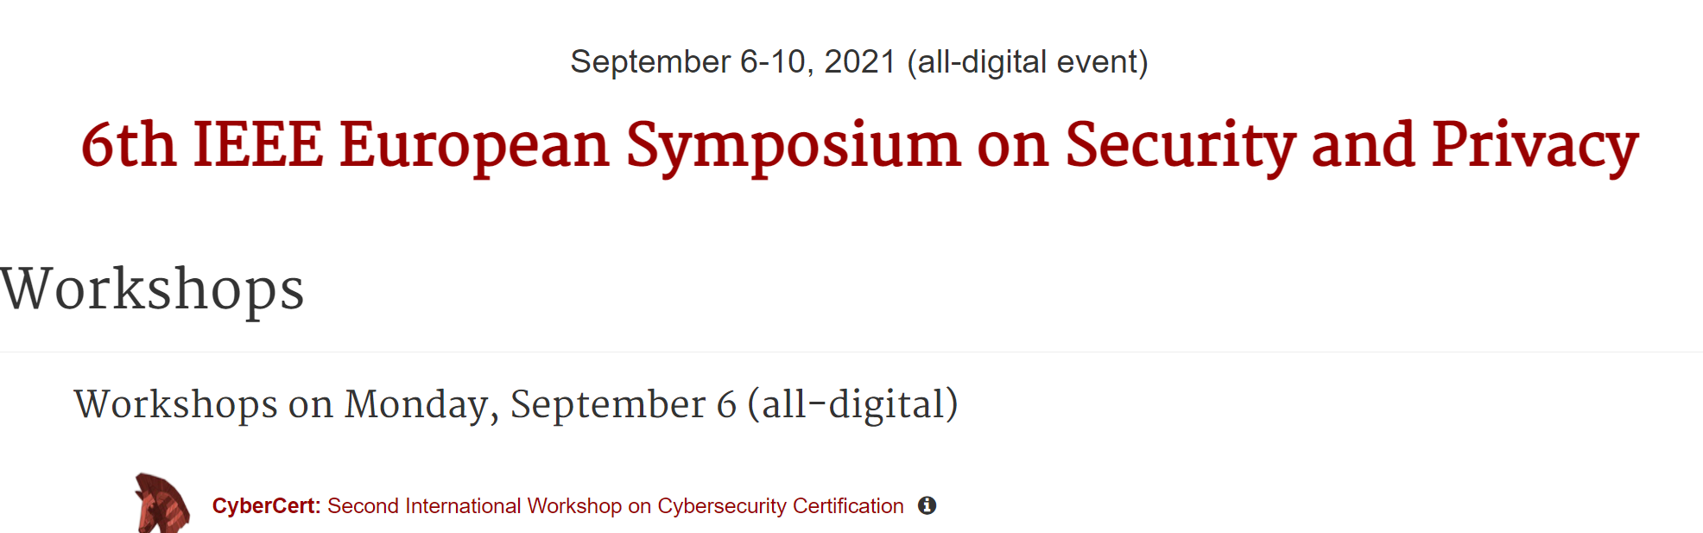
Figure C4: Screenshot of the page of the Second International Workshop On Cybersecurity Certification, 6th IEEE European Symposium on Security and Privacy

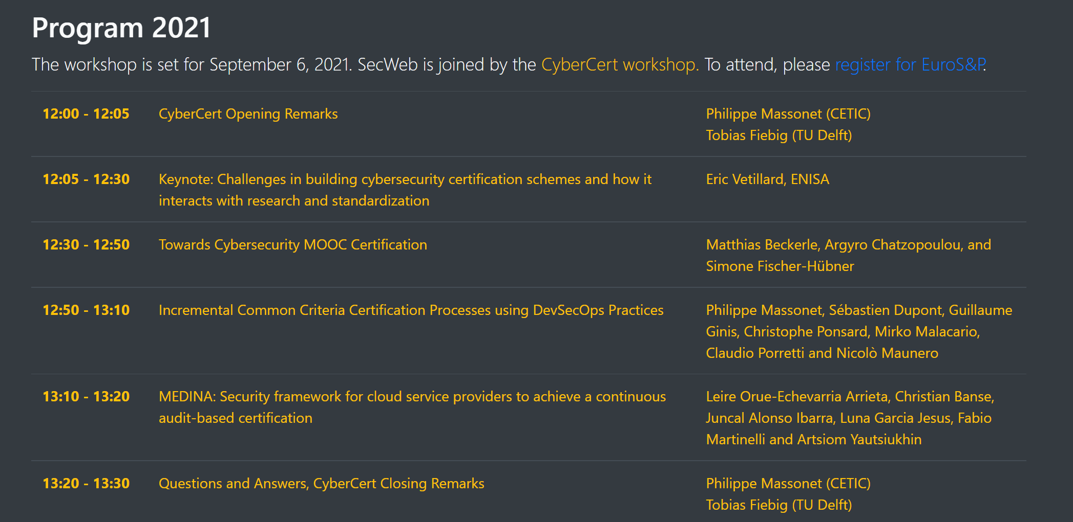
Figure C5: Screenshot of the workshop program

List of Acronyms

ANCE | National Association of Standardization and Certification
ANSI | American National Standards Institute
ASTM | American Society for Testing and Materials
CA | Consortium Agreement
CSA | Cloud Security Alliance
CSRC | Computer Security Resource Center
DIN | Deutsches Institut für Normung
DoA | Description of Action
EC | European Commission
ECCC | European Cybersecurity Competence Centre
ER | Exploitable Result
ETSI | European Telecommunications Standards Institute
EU | European Union
FDA | Food And Drug Administration
GA | Grant Agreement
GSMA | Groupe Speciale Mobile Association
IEC | International Electrotechnical Commission
IEEE | Institute of Electrical and Electronics Engineers
IETF | Internet Engineering Task Force
IoC | Indicator of Compromise
ISA | International Society of Automation
ISO | International Organization for Standardization
ITU | International Telecommunication Union
NASA | National Aeronautics and Space Administration
NATO | North Atlantic Treaty Organization
NCCOE | National Cybersecurity Center of Excellence
NEMA | National Electrical Manufacturers Association
NERC | North America Electric Reliability Center
NFPA | National Fire Protection Association
NIST | National Institute of Standards and Technology
oasis-open | Organization for the Advancement of Structured Information Standards
SAE | Society of Automotive Engineers
TRL | Technology Readiness Level
UL | Underwriters Laboratories
WP | Work Package
(The above list contains the most frequently used acronyms. More acronyms are included in line with their description as needed.)

† This project has received funding from the European Union's Horizon 2020 research and innovation programme under grant agreement No 830927.
https://www.nist.gov/cyberframework/online-learning/five-functions
TRL: https://ec.europa.eu/research/participants/data/ref/h2020/other/wp/2016_2017/annexes/h2020-wp1617-annex-g-trl_en.pdf
https://eic.ec.europa.eu/eic-funding-opportunities_en
ISO/IEC 17000:2004(en) Conformity assessment — Vocabulary and general principles.
ISO/IEC 17021-1:2015. Conformity assessment — Requirements for bodies providing audit and certification of management systems — Part 1: Requirements. https://www.iso.org/standard/61651.html
ISO/IEC 17024:2012. Conformity assessment — General requirements for bodies operating certification of persons. https://www.iso.org/standard/52993.html
ISO/IEC 17025:2017. General requirements for the competence of testing and calibration laboratories. https://www.iso.org/standard/66912.html
CEN, the European Committee for Standardization, is an association that brings together the National Standardization Bodies of 34 European countries, retrieved from the official website
https://ulstandards.ul.com/about/glossary/
CEN, the European Committee for Standardization, is an association that brings together the National Standardization Bodies of 34 European countries, retrieved from the official website
Information retrieved from the website of IEC: https://www.iec.ch/standardsdev/publications/guide.htm
NIST SP 800-63-3 under Special Publication (SP)
Information retrieved from the website of ITU: https://www.itu.int/pub/R-REC
https://www.iso.org/standard/52993.html
https://rewireproject.eu/
https://www.aceeu.org/about/project/id/39. The project website is under development.
The report is available in the deliverables section of the CONCORDIA website. https://www.concordia-h2020.eu/wp-content/uploads/2022/07/CONCORDIA-D5.4.pdf
https://eductx.org/
https://www.enisa.europa.eu/news
https://www.enisa.europa.eu/events/ENISA-CCC/enisa-ccc
https://www.enisa.europa.eu/events/trust-services-forum-ca-day-2022/trust-services-forum-ca-day-2022
https://www.enisa.europa.eu/events/cybersecurity-skills-building-a-cybersecurity-workforce
https://digital-strategy.ec.europa.eu/en/news/new-eu-cybersecurity-rules-ensure-more-secure-hardware-and-software-products
https://www.enisa.europa.eu/events/enisa-webinar-cybersecurity-skills/cybersecurity-skills-using-the-european-cybersecurity-skills-framework-to-sustain-cybersecurity-workforce
https://www.enisa.europa.eu/events/enisa-cybersecurity-certification-conference-2021/eu-cybersecurity-certification-conference
https://joinup.ec.europa.eu/collection/rolling-plan-ict-standardisation/rolling-plan-2022
https://eur-lex.europa.eu/legal-content/EN/TXT/HTML/?uri=CELEX:52021PC0206&from=EN
https://ec.europa.eu/info/sites/default/files/strategy/decision-making_process/documents/c_2022_4388_1_en_act.pdf
https://www.consilium.europa.eu/en/press/press-releases/2022/11/28/digital-finance-council-adopts-digital-operational-resilience-act/
https://ec.europa.eu/commission/presscorner/detail/en/IP_22_2985
https://eur-lex.europa.eu/legal-content/EN/TXT/HTML/?uri=CELEX:52022DC0551&from=EN
https://ec.europa.eu/info/sites/default/files/proposal_for_a_regulation_laying_down_measures_on_cybersecurity_at_euibas.pdf
https://ec.europa.eu/info/law/better-regulation/have-your-say/initiatives/13410-Cyber-resilience-act-new-cybersecurity-rules-for-digital-products-and-ancillary-services_en
This project has received funding from the European Union’s Horizon 2020 Research and Innovation program under grant agreement No 952690. (https://www.cyrene.eu/)
This project has been designed to directly meet the relevant requirements for the deployment of the Digital Service Infrastructure (DSI) defined in section 3.9 of the 2019-2020 Connecting Europe Facility (CEF) Telecom Work Programme. “Support to cooperation and capacity building for cybersecurity certification in line with the Cybersecurity Act”. https://www.a4cef.eu/about
https://opendoor.concordia-h2020.eu/2022/program.html
M. Beckerle, A. Chatzopoulou and S. Fischer-Hübner, "Towards Cybersecurity MOOC Certification," 2021 IEEE European Symposium on Security and Privacy Workshops (EuroS&PW), 2021, pp. 1-11, doi: 10.1109/EuroSPW54576.2021.00008.
REWIRE is co-funded by the ERASMUS+ programme of the European Union (Agreement Number – 621701-EPP-1-2020-1-LT-EPPKA2-SSA-B) for a duration of four years (01.11.2020 to 31.10.2024).
More information can be found at: https://rewireproject.eu/
This project has received funding from the European Union’s Horizon 2020 Research and Innovation program under grant agreement No 952690. (https://www.cyrene.eu/)
This project has been designed to directly meet the relevant requirements for the deployment of the Digital Service Infrastructure (DSI) defined in section 3.9 of the 2019-2020 Connecting Europe Facility (CEF) Telecom Work Programme. “Support to cooperation and capacity building for cybersecurity certification in line with the Cybersecurity Act”. https://www.a4cef.eu/about
The file Information Re_Standards was firstly introduced during the first year of the project as a means to depict and collect information regarding standards and standardization efforts. The structure and content of the file was described in the 1st year report.
https://digital-strategy.ec.europa.eu/en/news/new-eu-cybersecurity-rules-ensure-more-secure-hardware-and-software-products
https://www.enisa.europa.eu/events/cybersecurity_standardisation_2022/cybersecurity_standardisation_2022
https://joinup.ec.europa.eu/collection/rolling-plan-ict-standardisation/rolling-plan-2022
https://eur-lex.europa.eu/legal-content/EN/TXT/PDF/?uri=CELEX:52022DC0031
https://ramp.c3.lu/
GUIDELINES ON CONFORMITY ASSESSMENT – ISO/IEC 17024:2012. United Nations Industrial Development Organization.
https://niccs.cisa.gov/workforce-development/cyber-security-workforce-framework
https://www.isograd-testingservices.com/EN/index
S. Fischer-Hubner, M. Beckerle, A. L. Lafuente, A. R. Mart ¨ ´ınez, K. Saharinen, A. Skarmeta, and P. Sterlini, “Quality criteria for cyber security moocs,” in IFIP World Conference on Information Security Education. Springer, 2020, pp. 46–60
M. Beckerle, A. Chatzopoulou and S. Fischer-Hübner, "Towards Cybersecurity MOOC Certification," 2021 IEEE European Symposium on Security and Privacy Workshops (EuroS&PW), 2021, pp. 1-11, doi: 10.1109/EuroSPW54576.2021.00008.

